Specialist Children’s Services
Speech Sound Screening Assessment
1 | bus  b X  s X  ………bud……
Instructions:
- Ask the child to say each picture (try not to tell them the word first),
- Circle the or X to show if the child used the target sounds,
- Write down what the child actually said

1. | bus  b X  s X  ……………………………… | 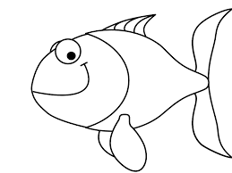  6. | fish  f x  sh x  ………………………………
2. | tap  t X  p X  ……………………………… | 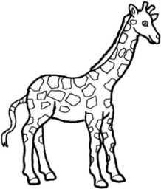  7. | giraffe  j x  r x  f x  ………………………………
3.  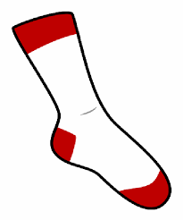 | sock  s X  k X  ………………………………… | 8. | watching  w x  ch x  ng x  ………………………………
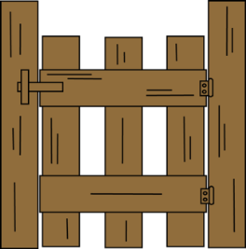  4. | gate  g x  t x  ……………………………… | 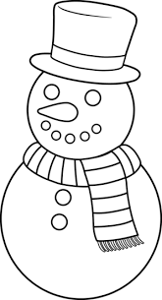  9. | snowman  sn x  m x  n x  ……………………………..
5. | lizard  l x  z x  d x  ……………………………… | 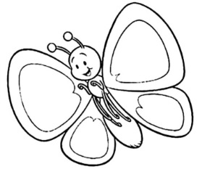  10. | butterfly  b x  t x  fl x  ………………………………

