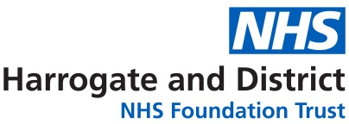

INFORMATION FOR PATIENTS

ABOUT

HAND HYGIENE

If you require this information in an alternative language or format (such as large print), please ask your nursing staff to arrange this or contact the Infection Prevention and Control Nurses on the number provided on the back page of this leaflet.

Your hands may look clean but germs that cause infections cannot be seen with the naked eye. If you could look at your hands through a microscope you would be able to see thousands of germs.

In hospital germs can live in a variety of areas and these are easily transferred by hands.

Always wash your hands with soap and warm water (or use hand wipes if you are unable to go to a sink):
- After going to the toilet/or using a commode/bedpan
- Before touching food, eating and/or taking your medication
- If they look or feel dirty
- After coughing, sneezing or blowing your nose
- Before and after handling devices such as your catheter
(if you are emptying your own bag).

If your illness makes hand washing difficult, then ask the nurses for assistance.

Hand sanitisers (hand foam)
- Squirt the hand sanitiser onto your hand and rub all over both hands until they are dry. Hand sanitisers only work on clean hands
- Your visitors can also help themselves and you by washing their hands or using the hand rub located at each ward entrance/exit; on the end of your bed and other areas throughout the ward.

Hand sanitisers are very effective however; they do not work on germs such as Clostridium difficile and are less effective at killing the viruses which cause viral gastroenteritis. Hand sanitisers will not work on dirty hands. In these situations, hand washing with soap and water is more effective.

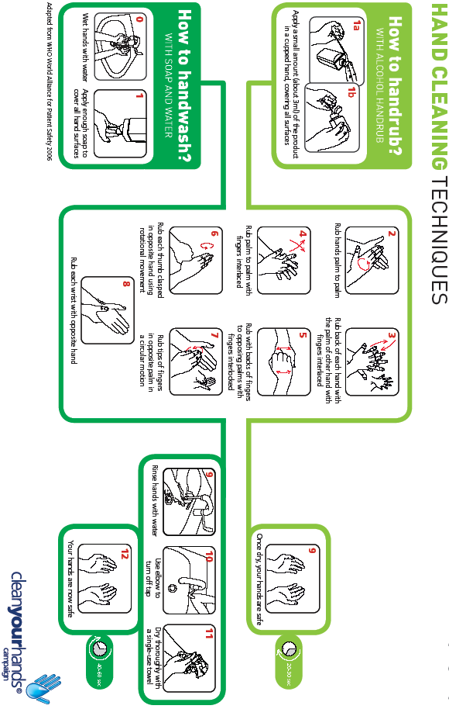

Infection Prevention and Control Department
Harrogate District Hospital
Lancaster Park Road
Harrogate HG2 7SX
01423 885959
Direct line: 01423 553112
www.hdft.nhs.uk

Version 5.0
Reviewed February 2018
New review date February 2021
Approved by HDFT IC Committee September 2013
Approved by PICG 14 December 2011

