Join the HDFT Liftshare Community today

The HDFT Liftshare website matches you up with potential sharers as a driver or passenger – www.hdft.liftshare.com

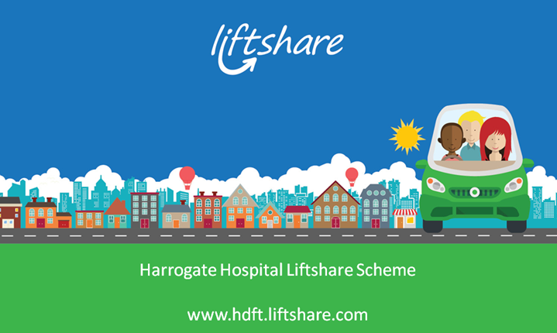

The benefits of Liftsharing
- Reduces travel costs - Liftshare calculator
- Guaranteed ride home scheme for passengers
- Priority application for an access card to the Fewston multi-storey car park (charge applies)
- Cuts congestion and pollution
- It’s flexible – simply share when you can
- It’s a great way of networking, meeting new colleagues and making friends

Save money on your commute
You can save a significant amount of money over a year. Give yourself a pay rise!
- Leeds to the hospital 5 times a week could save you £1000 a year
- Wetherby to the hospital 3 times a week - £300 a year
- York to the hospital 3 times a week - £445 a year
Calculate how much you could save using the Liftshare calculator and don’t forget to factor in car parking costs on top.

