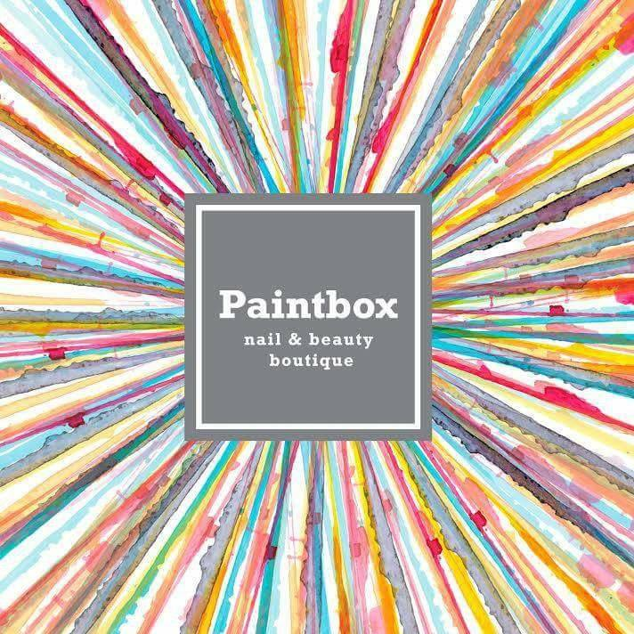

18 Mount St, Harrogate HG2 8DQ
Tel: 01423 810710
www.paintboxboutique.co.uk

Offering all staff 10% NHS discount at Paintbox Nails & Beauty.

