

**Hypnobirthing @ Harrogate**

Hypnobirthing courses run by experienced Harrogate Midwives. Held the first 2 Saturdays on the month at Saltergate Children’s Centre, Newby Crescent, HG3 2TT.

Cost £110 per course.

If you would like more information, or to book a place please contact Kathy McClune or Rachel Robson [hypnobirthing@hdft.nhs.uk](mailto:hypnobirthing@hdft.nhs.uk)

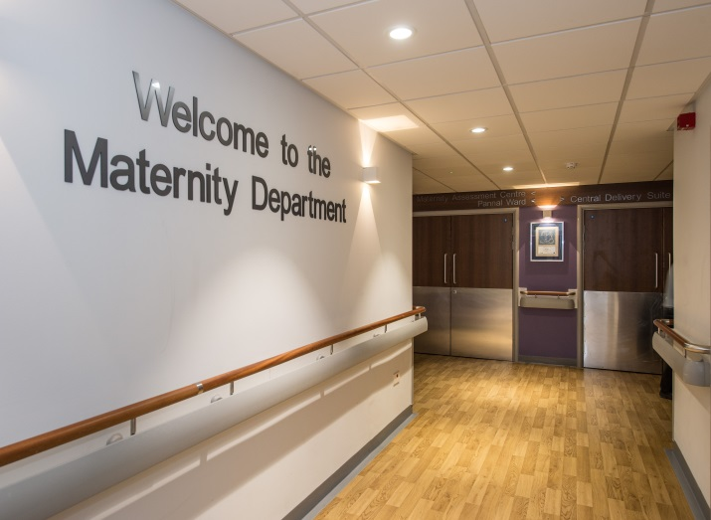

**Antenatal Breastfeeding Worskhops**

Mum only, midwife led groups, learn about breastfeeding with lots of practical advice, run from Harrogate Town Childrens Centre, Wetherby Road, alternate Fridays 10-11am.

Please take note of this number to self book **01609 535753** at a point in your pregnancy to suit you

Updated June 2018

**Please complete and post back to:**

**Community Midwives Office**

**Antenatal Clinic**

**Harrogate and District NHS Foundation Trust**

**Lancaster Park Road**

**Harrogate**

**HG2 7SX**

**By 16 weeks**

**Birth & Beyond**

**Midwife-led Parent Education & Preparation Classes**

**Everyone welcome!**

**Evening Classes:**

The classes are held in the **Antenatal Clinic** at Harrogate Hospital between **7pm-9pm** on **Monday, Tuesday and Thursdays** and will run over **three consecutive** weeks.

**Please select the classes you would like to attend and circle above your 1st preference for the day:**

* Active Birth
* Pain Relief and When Nature Needs a Hand
* Meeting Your Baby and The Early Days

**OR**

**Saturday Workshop:**

Saturday Workshops are available incorporating all three classes into one day from **9.30am-3.30pm (Limited places available, if overbooked, you will be offered an evening class place instead).**

* **Saturday Workshop at Harrogate**
* **SaturdayWorkshop at Ripon**

(Please return to address printed on reverse)

**A letter confirming the dates of your classes will be posted to you soon after your 20 week scan.**

**These classes are in high demand; if you cannot attend please let us know ASAP: parent.education@hdft.nhs.uk**

**Active Birth:**

Our Active Birth Classes discuss the stages of labour and how you can manage both at home & in hospital. Learn about key hormones & how your birthing body works. Find out more about remaining upright and active in labour whilst discovering the benefits of massage, relaxation & the use of warm water. Explore your expectations about labour & discuss the role of the birth partner.

**Pain Management and When Nature Needs a Hand:**

Discover more about your pain relief options both at home & in hospital. This course aims to offer you information for the times when nature may need a hand e.g. learn about the induction of labour & assisted deliveries.

**Meeting your Baby and Early Days:**

Discover what to expect from your new baby & how to care for him or her. Explore how relationships may change during the transition to Parenthood. Learn about the importance of Breastfeeding. Find out all about attachment & bonding, and how this affects your baby’s development. Receive practical advice including how to bathe your baby, feeding, winding & looking after yourself.

NAME: …………………………………….....

ADDRESS: .............................................…………………………………………………………….……………………………………....................

PHONE NUMBER: ...…………………….

D.O.B: …………………………………………

HOSPITAL NUMBER: ……………………

DUE DATE: ..………………………………..