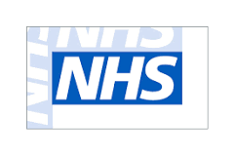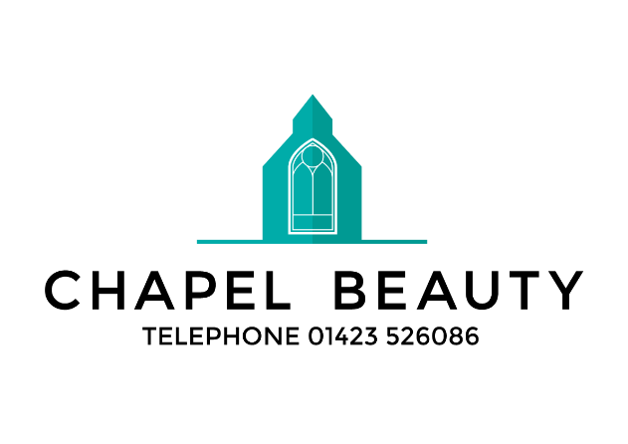

Chapel Hair & Beauty would like to offer a 20% discount to all NHS staff to celebrate your 70th Birthday.
Just show your NHS ID to reception to receive 20% off any Hair or Beauty Treatment.

It’s just a little thank you for everything you do for us!

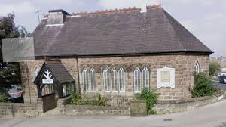

The Salon entrance is off Knox Avenue, down the steps
Chapel Hair & Beauty
The Old Chapel
282 Skipton Rd
Harrogate
HG1 3HE

01423 526086
Follow us on Facebook

Want to remember this poster? Take a photo of it

