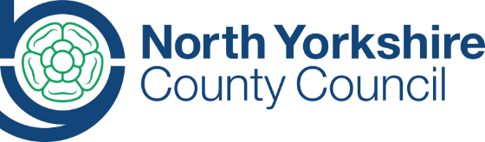 North Yorkshire County Council
County Hall
Northallerton
North Yorkshire
DL7 8AD

Tel.01609 780780
www.northyorks.gov.uk
helen.ingle@northyorks.gov.uk

March 2023

Dear Colleague,

Re: New family weight management service for North Yorkshire (Healthy Families)

I am pleased to inform you that we have a new offer of support for families in North Yorkshire who would like some help with achieving a healthy weight and healthy lifestyles.

The new service is aligned to the well-established Adult Weight Management Service for North Yorkshire. It commenced on the 1st March 2023 and is being delivered by Brimhams Active.

The service will support families remotely over a period of 6-9 months to make small changes to their lifestyles by setting goals around food and physical activity, and will signpost to physical activity opportunities in their local area. It will also help families to recognise and address the wider determinants of health and lifestyle, and will signpost families to other useful services, support and information such as around mental health and wellbeing, food insecurity/cost of living, sleep, etc.

The service is for children and young people aged 4-19 years (up to aged 25 years for those with SEND) and their families who need some help with healthy weight and lifestyles. Families must be resident or registered with a GP practice or school in North Yorkshire (those who are not will be assessed on a case-by-case basis for suitability for referral).

Families can self-refer to the service by emailing active.health@brimhamsactive.co.uk or by telephoning Brimhams Active on 01423 556106. Professionals can refer families using the referral form (attached, along with promotional flyer). Both children and parents/carers should consent to the referral and be ready to make a change.

If you have any queries, please contact us on:
Helen Ingle, Public Health Manager, NYCC: Helen.ingle@northyorks.gov.uk
Matthew O’Sullivan, Health & Wellbeing Development Officer, Brimhams Active matthew.osullivan@brimhamsactive.co.uk
Elizabeth Green, Head of Children’s Health & Wellbeing, Brimhams Active Elizabeth.Green@brimhamsactive.co.uk

Yours sincerely,
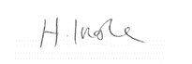

Helen Ingle
Public Health Manager
North Yorkshire County Council

