

Harrogate and District

NHS Foundation Trust

Pre-Registration Pharmacist Training

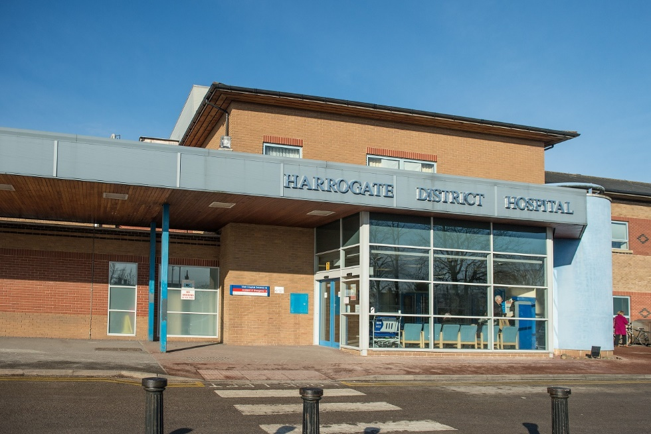

**For further information please contact one of our tutors:**

**Helen Lyon (helen.lyon3@nhs.net)**

**Bryony Shaw (bryony.shaw1@nhs.net)**

**Kate Shelton (kate.shelton1@nhs.net)**

**Introduction**

Harrogate & District NHS Foundation Trust is a forward thinking organisation. We aim to be the first choice for patients by working together for excellent health care.

It is a district hospital providing acute services to a population of 150,000. The hospital has approx. 300 beds and provides services to a community hospital, paediatrics, cancer services, general medicine, emergency department, surgery, ITU/HDU, urology and orthopaedics. The hospital has introduced electronic medicine charts across all ward areas.

**“Promoting and achieving excellence, value and safety for our patients through innovation in medicines management”**

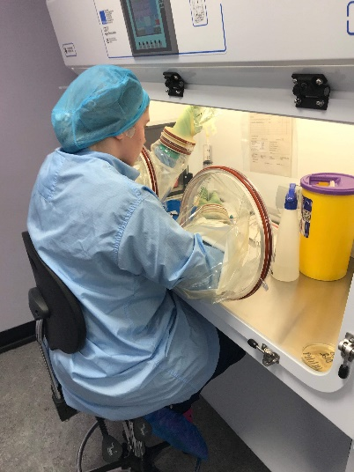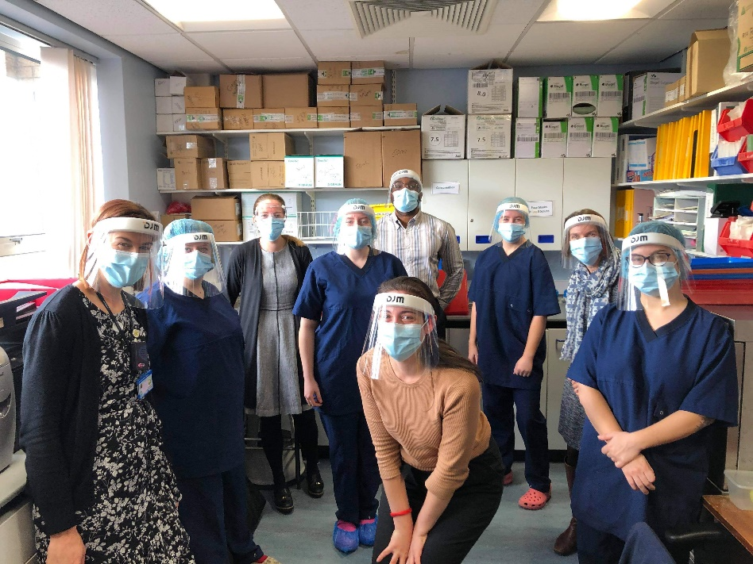

The Pharmacy department has around 60 members of staff. The services we provide comprise of clinical ward visits, ward rounds, near patient dispensing, clinics including diabetic hypertension clinics, warfarin clinics, surgical pre assessment clinics, chemotherapy counselling clinics and aseptic services. We also provide patient education services in pulmonary rehabilitation and cardiology.

As a department we provide the medicines management training to all the hospital-based nurses and we have undergraduate pharmacy students with us on placements from Bradford University.

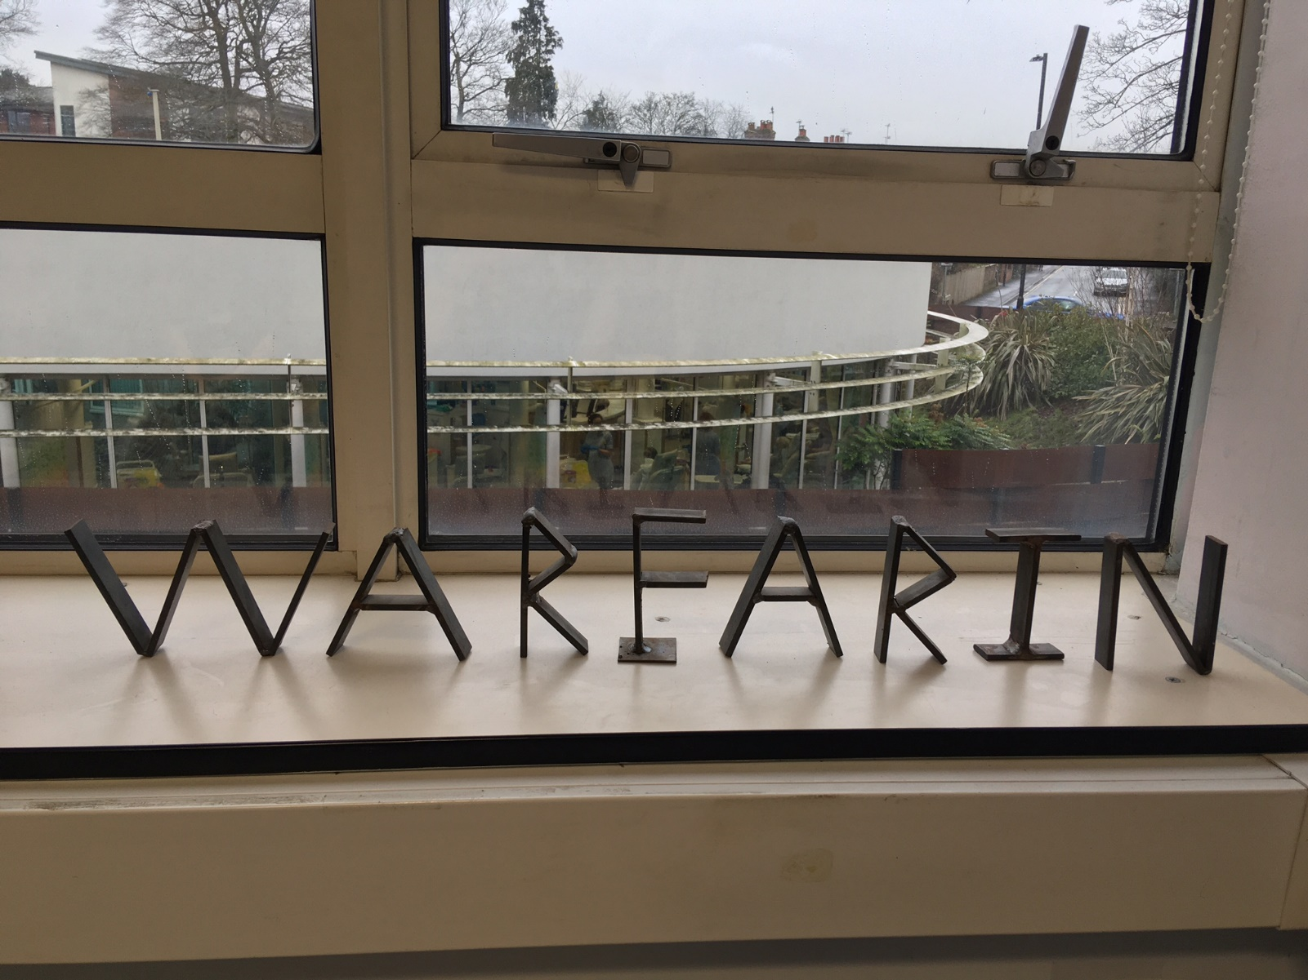

**Posts offered**

At any one time HDFT trains up to 3 pre-registration pharmacists. This consists of;

* Up to 2 pre-reg undertaking a 12 month placement at HDFT
* 1 placement for Bradford university undergraduates who are undertaking the sandwich programme
* 1 split placement with a local GP Practice.

**Meet the tutors**

Our pre-reg tutors have numerous years of experience as both clinical pharmacists and as pre-reg tutors. They are also supported by a pre-registration pharmacist manager.

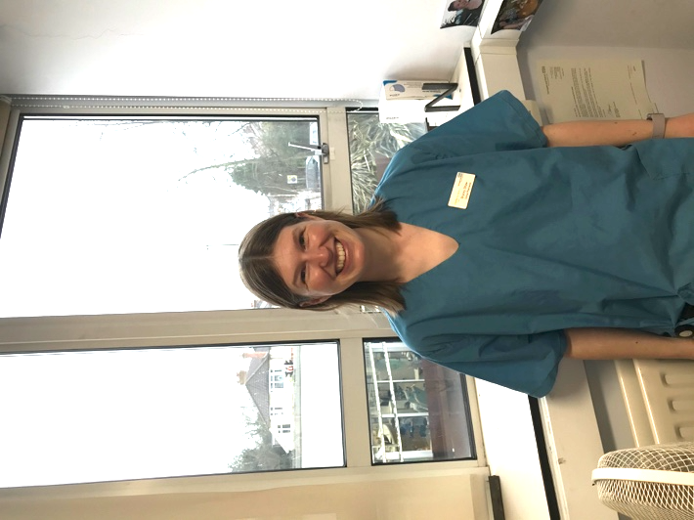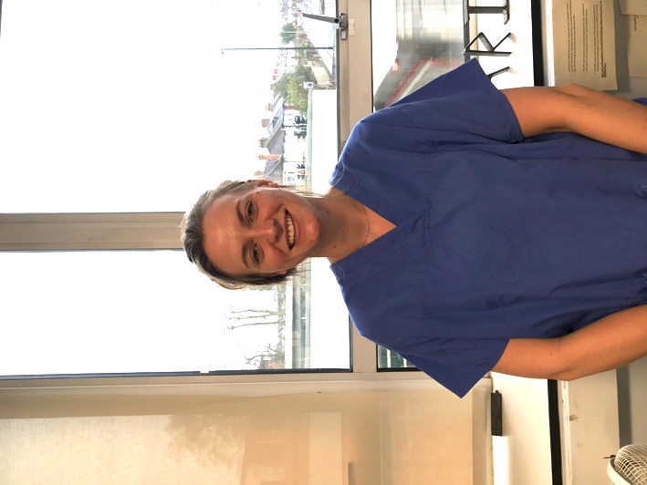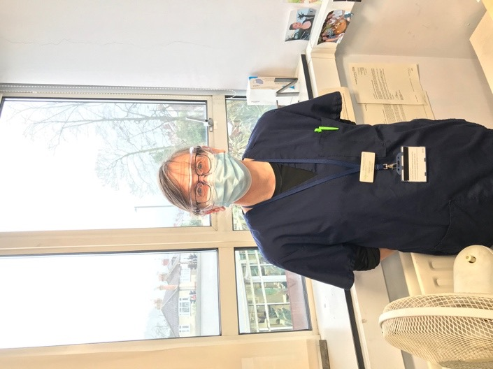

**Kate Shelton**

Specialist Pharmacist

Care of the Elderly

**Bryony Shaw**

Specialist Pharmacist

Surgery

**Helen Lyon**

Specialist Pharmacist

Clinical Trials

**Information regarding placements**

We have a well-structured timetable and training file, which covers all aspects of our hospital pharmacy. Whilst there is a structured training programme, we will be flexible to suit your interests and learning needs.

Rotations include:

* **Surgery** – orthopaedics, gastroenterology, urology and gynaecology
* **Medicine** – cardiology, respiratory, endocrinology
* **Admissions** – surgical and medical
* **Frailty** – stroke, acute admissions and rehab
* **Aseptics, Haematology** and **Oncology**
* **Outpatient pharmacy** – Lloyds pharmacy
* **Mental health** (in collaboration with TEWV Trust)
* **Paediatrics** and **Special care baby unit** and **Maternity**
* **Aseptic Unit**
* **Cross sector** – community pharmacy placement, organised Medicines Information sessions

Time will be organised for you to spend time in pharmacy led clinics and pharmacy led patient education sessions.

Opportunities to spend time with other health care professionals:

* **Specialist nurses**
* **Speech and Language Therapists (SALT)**
* **Physiotherapists**
* **Occupational Therapists**
* **Dieticians**

**Weekend/Late night working**

Hours of work are generally; 9am-5.30pm Monday to Friday.

All pre-registration pharmacists are expected to work a 5 hour shift on at least 4 weekends through the year. All pre-regs are expected to work a late night occasionally throughout the year. The hours on a late night are 10.30am-7pm

All pre-reg are expected to work at least one bank holiday / date over Easter or Christmas/ New Year.

**Things to do in Harrogate**

* Betty’s Tea Rooms
* Harrogate Turkish Baths
* Valley Gardens
* The Stray
* Lots of outdoor activities i.e. walks, climbing, mountain biking
* Lots of pubs and restaurants to choose from

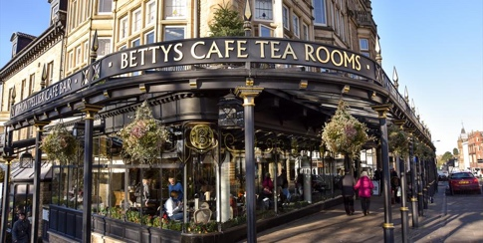

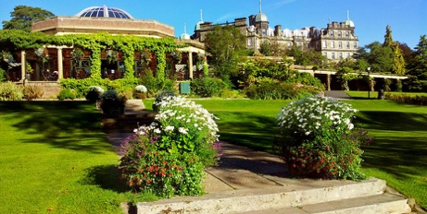

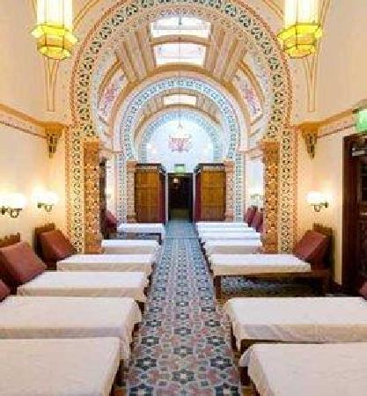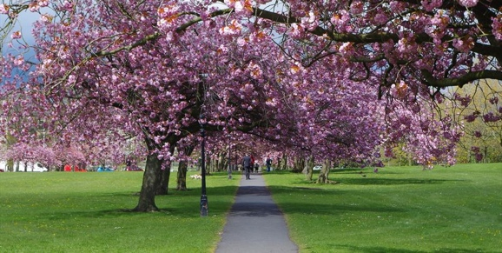

**Open days**

We do not hold open days routinely but if you would like more information about the pre-registration year or to come and look around the department please contact one of our tutors:

**Helen Lyon (helen.lyon3@nhs.net)**

**Bryony Shaw (bryony.shaw1@nhs.net)**

**Kate Shelton (kate.shelton1@nhs.net)**

**FAQs:**

* **What options are there for accommodation?**
  + The hospital has accommodation available on the complex – for more information, contact pre-reg tutors or email [hdft.accommodation@nhs.net](mailto:hdft.accommodation@nhs.net)
  + Plenty of house shares and flats to rent available on popular property search engines
* **What support will there be?**
  + Pre-reg tutors
  + Line manager
  + Band 6 pharmacists
  + Pharmacy technicians
  + Other pre-regs
  + Regional study providers – Our pre-registration trainee pharmacists attend the regional training programme at the University of Leeds.
* **Will there be other pre-regs?**
  + Yes, there are two 12-month pre-regs and two 6-month pre-regs. You may be able to be put in contact with one another – please contact a pre-reg tutor
* **What public transport links are in Harrogate?**
  + Regular bus and train service to Leeds and York
  + 30-minute bus to the Leeds/Bradford airport
  + Quick access to access the A1/M1 and M62 motorways
* **What will my timetable look like?**
  + See Page 6 for more information
  + On a Wednesday afternoon pre-registration trainee pharmacists meet their tutor, attend tutorials and have allocated directed study time – see Page 7
* **Where is the hospital situated?**
  + The hospital is situated within a mile of the town centre. Harrogate is placed between the North Yorkshire Moors and the Yorkshire Dales
* **For further details of HDFT please visit;** [**www.hdft.nhs.uk**](http://www.hdft.nhs.uk)

**Sample Pre-registration Pharmacist Timetable**

Example of Timetable: July - January

6 MONTH ROTATION Tutor: ………

|  |  |  |
| --- | --- | --- |
| **Week Number** | **Location** | |
|  | AM | PM |
| **1** | Induction | Induction |
| **2, 3 & 4** | Medicines Management Technician Team | Medicines Management  Technician Team |
| **5 & 6** | Pharmacist - Medicine | Dispensary |
| **7 & 8** | Pharmacist -Admissions | Dispensary |
| **9 & 10** | Pharmacist- Frailty + Ripon Trinity | Pharmacist -Admissions / Audit |
| **11 & 12** | Pharmacists-General Surgery | Dispensary/ Audit |
| **13 & 14**  **(Progress Review 1)** | Pharmacist - Orthopaedics | Pharmacist - Surgery |
| **15 & 16** | Mental Health | Mental Health |
| **17 & 18** | Pharmacist- General Surgery inc ITU | Lloyds Out-Pharmacy |
| **19 & 20** | Pharmacist –Admissions inc. Emergency Department | Dispensary |
| **21 & 22** | Pharmacist- Medicine + Paediatrics | Pharmacists- Surgery |
| **23 & 24** | Dispensary | Dispensary |
| **25 & 26** | Aseptics | Aseptics |

**Tutorial Sample Timetable**

**PRE-REGISTRATION PHARMACIST TUTORIALS**

**TIMETABLE 2020**

**Wednesday afternoons from 2 pm – 5pm Fewston Meeting Room**

|  |  |
| --- | --- |
| Date | Topic |
| 5th August | Drug Histories (optimise booklet) |
| 12th August | Professionalism |
| 26th August | Prescription screening |
| 2nd September | Interpreting blood results |
| 9th September | Quality improvement projects |
| 16th September | Respiratory Case Studies |
| 23rd September | Antibiotic therapy (from 3pm) |
| 30th September | Drugs in renal disease |
| 7th October | Cardiology case studies (from 1:30pm) |
| 14th October | Errors/Accuracy checking |
| 21st October | Elderly Care |
| 28th October | Mental Health |
| 4th November | Anticoagulation (from 1:30pm) |
| 11th November | Regional study day |
| 18th November | Neurological disorders |
| 25th November | Regional study day pre-work |
| 2nd December | Health & Safety/IT chemotherapy |
| 9th December | Regional study day |
| 16th December | Endocrine/Insulin |
| 6th January | Cancer and chemotherapy |
| 13th January | Common drugs Quiz |

The timetable may be subject to change.

The Fewston Meeting Room is booked from 2pm-5pm every Wednesday afternoon for use by pre-registration pharmacists.

This protected time and space allows us to deliver the in-house tutorials and provides study time.

Tutorials should last no more than 1-1.5 hours to allow time for evidence writing/study before/after.

Pre-registration pharmacists are expected to check in with the dispensary at 5pm to lend a hand if needed.

Attendance is compulsory for all pre-registration students.