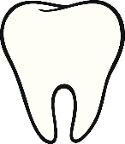 Social Story : A trip to Cornlands Dental Clinic

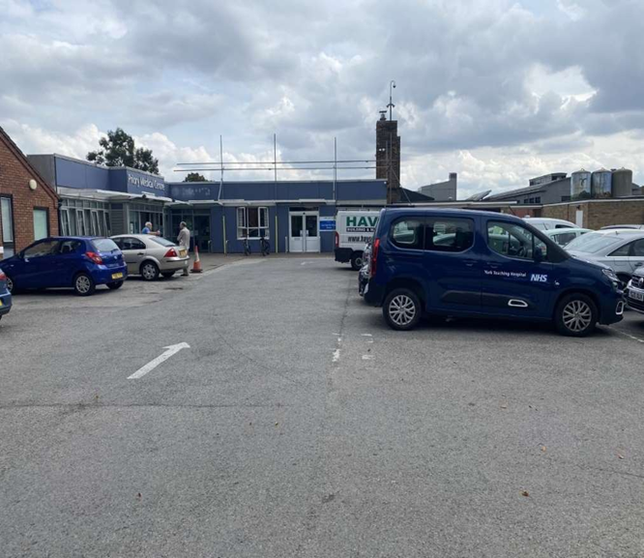 | I will arrive at Cornlands Dental Clinic
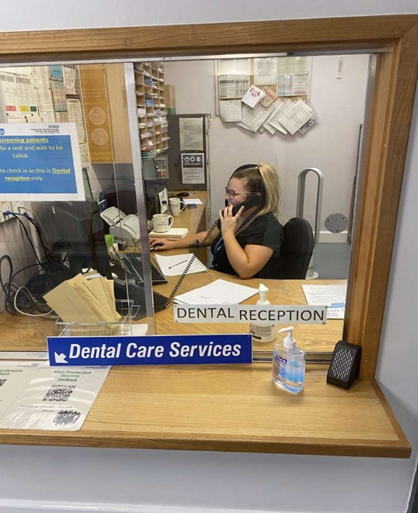 | I can say hello to the receptionist
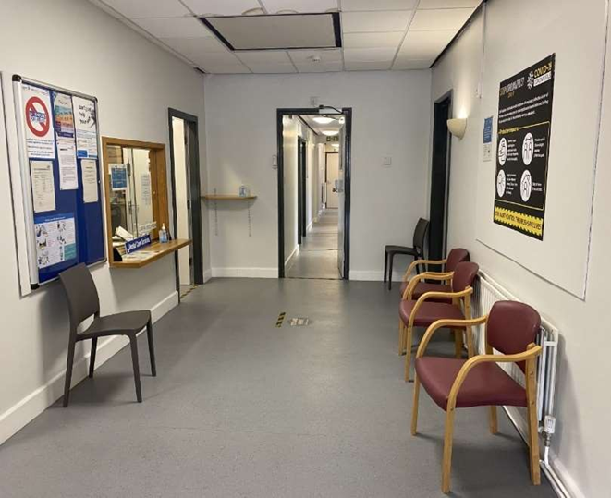 | I will sit in the waiting room
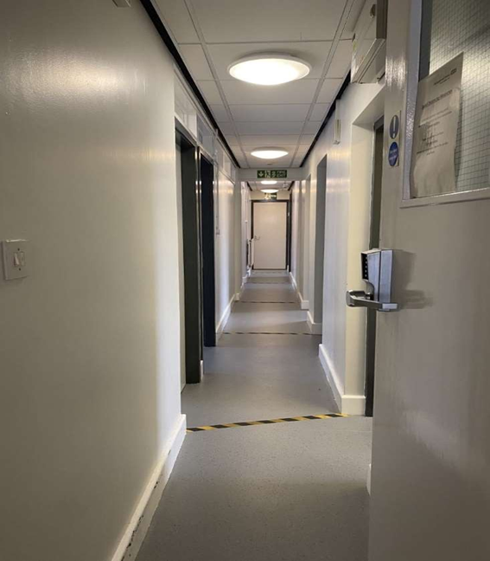 | The dental nurse will ask me to walk into the dentist’s room
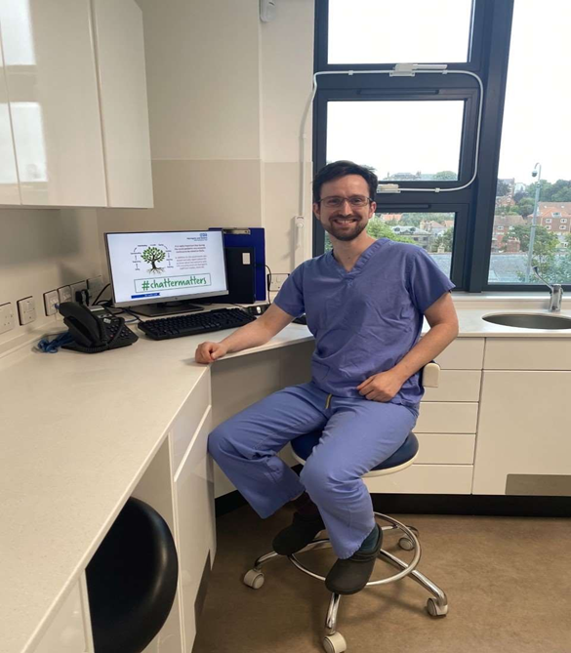  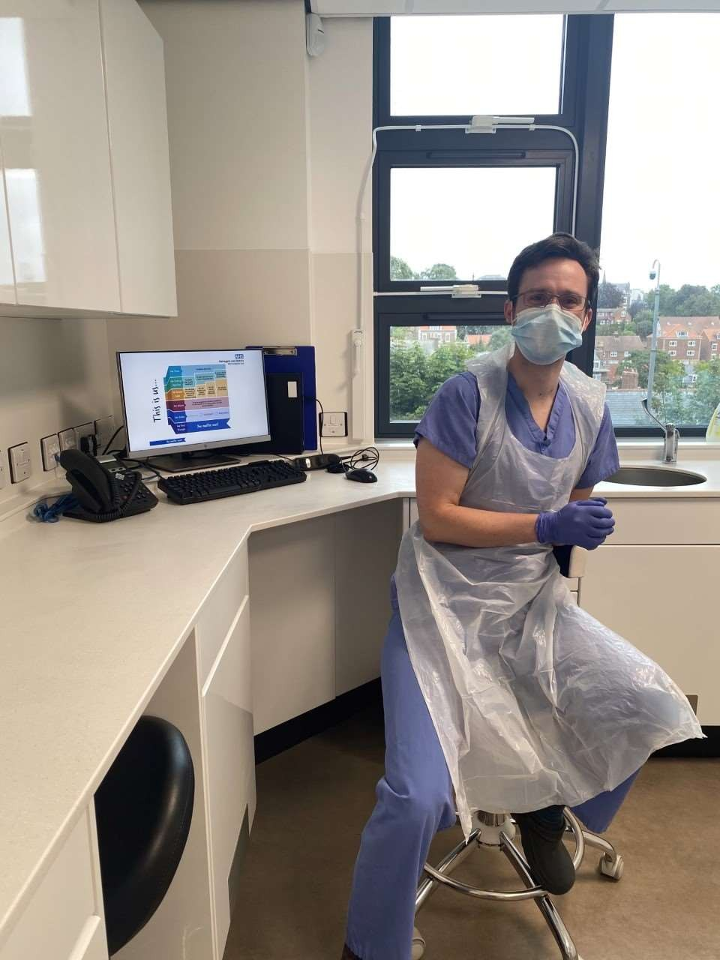 | The dentist will say hello to me. This dentist is called Toby  The dentists and nurses wear aprons, masks and gloves to keep everything clean.
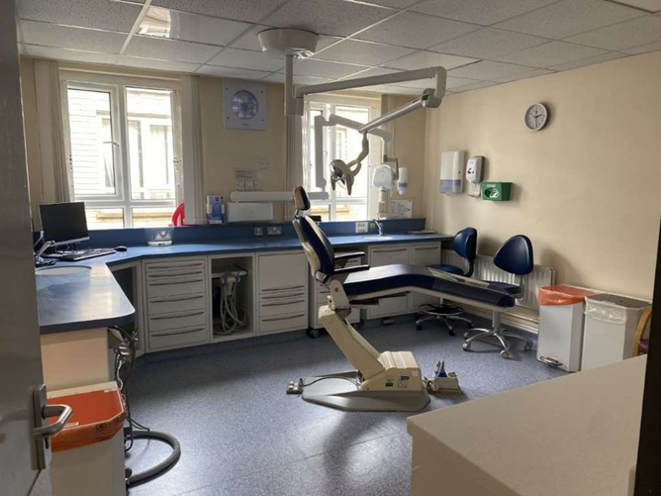 | I will sit in the big chair.  I can rest my head on the headrest
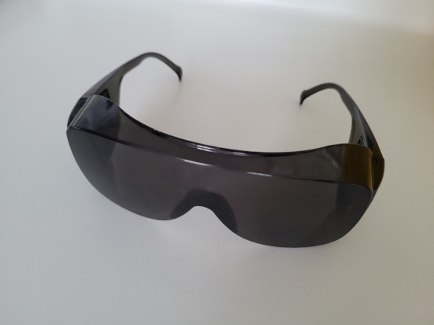 | I can wear sunglasses because the light is bright.
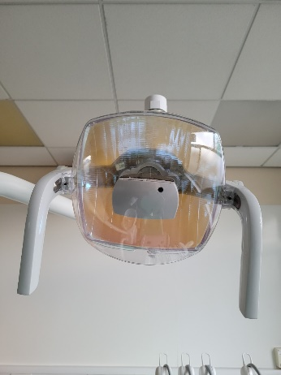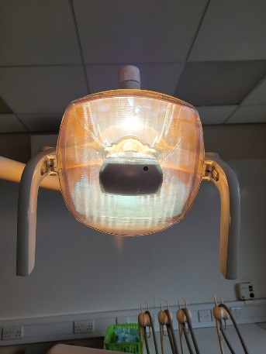 | The dentist will turn the bright light on to see my teeth.
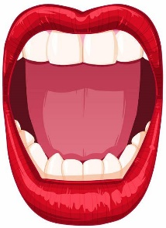 | I will open my mouth and keep my head still
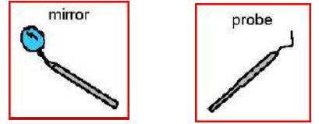  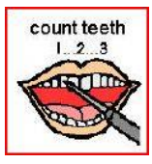 | The dentist will look at my teeth with a mirror and a probe.  The dentist will count my teeth.
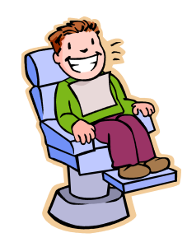 | Then I can close my mouth and sit in the chair.  The dentist will talk about my teeth.
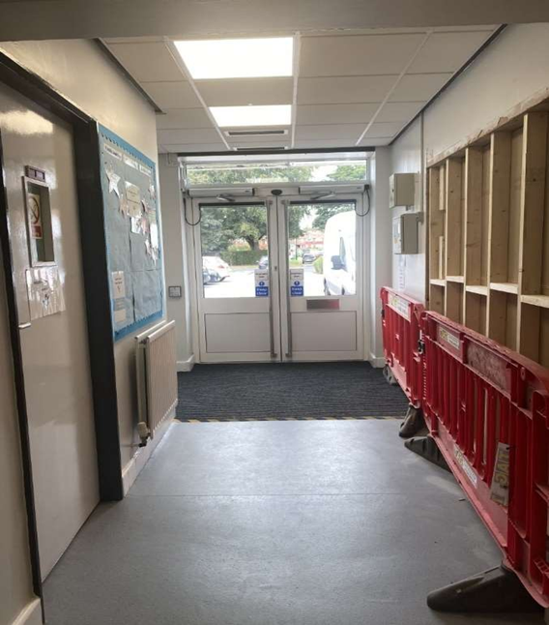 | The dentists and nurses will say goodbye and I will leave Cornlands Dental Clinic.

