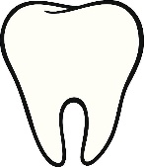 Social Story : A trip to Selby Hospital Dental Clinic

|  |  |
| --- | --- |
|  | I will arrive at Selby Hospital Dental Clinic |
|  |  |
|  | I can sit in the waiting room |
|  | The dental nurse will ask me to walk into the dentist’s room |
| + | The dentist and nurse will say hello to me.    The dentists and nurses wear aprons, masks and gloves to keep everything clean. |
|  | I will sit in the big chair.  I can rest my head on the headrest |
|  | I can wear sunglasses because the light is bright. |
|  | The dentist will turn the bright light on to see my teeth. |
| See the source image | I will open my mouth and keep my head still |
|  | The dentist will look at my teeth with a mirror and a probe.  The dentist will count my teeth. |
|  | Then I can close my mouth and sit in the chair.  The dentist will talk about my teeth. |
|  | The dentists and nurses will say goodbye and I will leave Selby Dental Clinic. |