Bottom Wiping

Many children with co-ordination problems have difficulty with bottom wiping and the process of going to the toilet. This can often cause high levels of anxiety for both child and parent. The following strategies can be used to learn bottom wiping and assist with toileting.

It can be really helpful to try to work out which part of the process is a challenge to your child. There are many stages to the process.
Habits
- Encourage your child to get into a rhythm of going to the toilet so they don’t feel rushed. After a meal there is a reflex that stimulates the bowel, so this may be a good time to try and set up a routine. Encouraging your child to go after breakfast may reduce the anxiety of needing to go at school.
- Be aware of the impact of your child’s diet on their stools and ability to sense they need the toilet. Avoiding drinking can cause constipation. The fibre in fruit and vegetables makes stools bulkier.
How to sit in the Loo
- Support your child to sit in a good position on the toilet, if your child has poor balance they may benefit from a children’s toilet seat which helps them to perch more easily. If your child’s feet don’t touch the floor they would benefit from a step under their feet to help them maintain their posture.

The environment and ‘equipment’
- The environment needs to be comfortable and private for people to go to the loo. Consider the temperature, any smells (good or bad in the bathroom), how much echo there is in a room etc.
- Using toilet paper can be tricky for some people, so it’s valuable to check that your child is able to reach the roll, tear off an appropriate length, fold it and so on.
- Wet wipes are good to use when learning bottom wiping as they wipe more easily and cover a larger surface area. Some children find them to be quite cold though.
Finding the best position for bottom wiping
- Some Children find that they can sit on the seat, lean to one side and reach to wipe from this position.
- Other children will stand to wipe, but putting one foot onto a footstool can help them to reach. These children may also like something to hold onto though; this could be the side of the bath maybe.
Going to the toilet away from home
- Plan ahead for using public toilets as they can present more challenges. They can often be cold, be set up differently to home and have noisy hand driers. Talking about what to expect before you go in can help and maybe having a supply of toilet wipes to take with you.
- At school, it is valuable to have a discrete conversation with staff who are most likely to support your child and make arrangements such as keeping your child’s wet wipes in the toilet for them to use.
Dressing and Undressing
- Getting undressed independently may be difficult for your child, encourage and practice the fastening on your child’s trousers. Ask your OT for additional strategies if your child struggles with dressing.
Making learning to wipe your bottom fun
- Some children struggle to do things behind their backs as they are not able to see what they are doing. Playing games which encourage them to pass objects behind them such as passing a beanbag or ball between their hands behind their backs can be helpful. try getting your child to reach for objects that are passed from behind them through their legs e.g. balloons, balls or bean bags.
- You could try putting stickers on to the back of their clothes and get them to reach and peel them off.
- In the bath practice wiping your bottom with a flannel, emphasise wiping “up and away”, rather than wiping around.
- Try letting your child use a small hand held mirror. They can check to see if their bottom looks clean.
- Some people play games which encourage the child to be able to wipe their bottom. You could practice bottom wiping by playing the ‘target practice’ game
- Laminate a picture of a target (last Page)
- Place a small amount of chocolate spread/ baby lotion in the centre of the target
- Encourage your child to tear off 4 pieces of toilet roll at a time- placing one hand on top of the toilet roll and one hand around the piece they want to pull off.
- Encourage your child to fold the paper in half and in half again. Try this on the table first and then on your child’s leg.
- Encourage your child to use ‘pinchy fingers’ to do one pinch of the toilet roll on the target. Use the target as a guide- give your child a score according to how close they can stay to just keeping the chocolate spread on the centre of the target.
- After one pinch/ small wipe encourage your child to look at the paper and hideaway anything they can see by folding the paper in half.
- Continue until the target is clean/ your child needs a new piece of toilet paper.
- Once your child has mastered this independently without you helping them physically or giving verbal prompts play the same game but hold the target behind your child’s bottom.
- Practice wiping tables /trays /surfaces using the dishcloth and the ‘scoop and lift’ technique.

Bottom wiping is often a difficult and embarrassing topic to talk about. Often children do not realise the purpose of the target practice game. Once they have mastered this they may need prompting to transfer this skill to bottom wiping. It’s important to help your child to practice this skill independently, allow them to try wiping first before helping them.

When your child is practicing it may be helpful to including washing hands within the routine of going to the toilet.

Target Sheet (please laminate)

Toileting
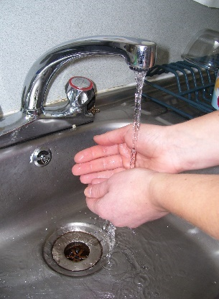
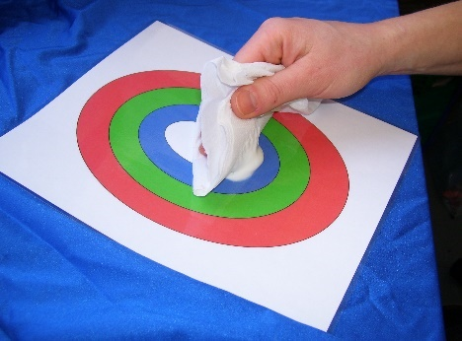
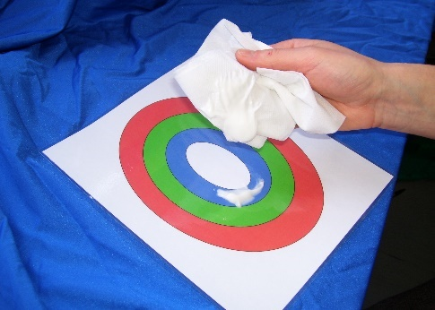
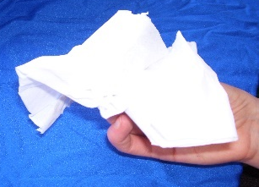
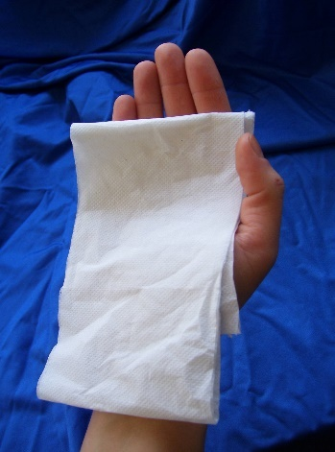
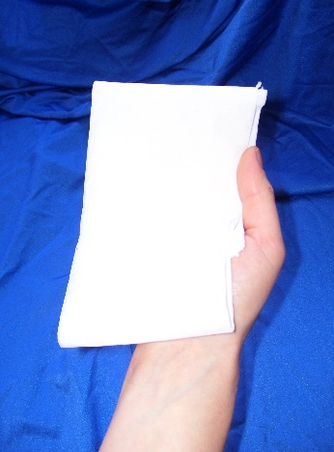
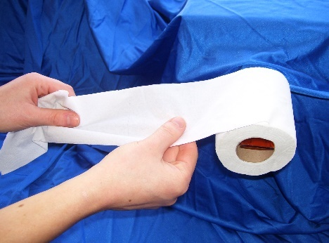
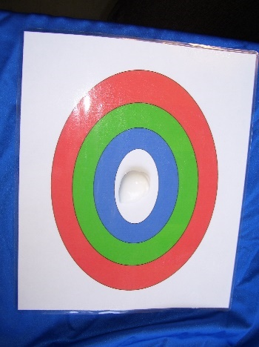
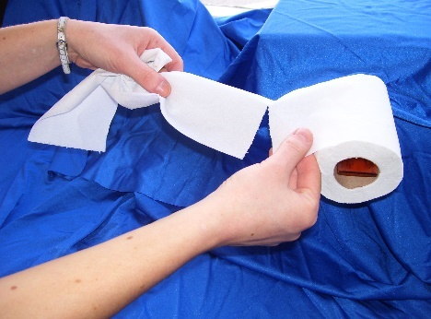
Clean

Now wash
hands

Not clean? Try again
Scoop and...
lift
Look and check if paper is clean
Make sure your hand and fingers are covered with the paper!
Cover your hand and fingers, pinch the paper with your thumb
Pull the paper slowly
Get your target ready
Hold the roll and tear slowly

