Core Stability Activities

Ideas to help strengthen your core muscles
The core muscles are the ones which help to support the body when siting, standing and taking part in a wide range of day to day activities. Without a strong core, we can all slump in our seats, stoop when we walk, get tired when we exercise and can hurt ourselves if we do too much.

Core muscles are the ones in your abdomen, hips, back, bottom, and legs, and it’s necessary to work all of these muscle groups to build a strong core as is at the centre of the body’s power, coordination, and stability.

So, strong core muscles are important to everyone. We can build these muscles by participating in a huge range of day to day activities that we enjoy. Choose something which you think that you might enjoy and which is age appropriate. These might include:

- Swimming
- Climbing / bouldering
- Playing in the park
- Martial arts / tai chi
- Dance – street, Latin, ballet, any type in fact
- Horse-riding
- Playing sport such as tennis, football etc.
- Pilates
- Walk like an animal (bear, snake, monkey, elephant etc.)
- Play balance games: balance on a beam or on a wobble board.
- Play tug of war
- Bounce on the trampoline
- Any activity where you have to reach above your head. This might include helping with jobs around the home, (i.e. hanging out washing, putting shopping into cupboards) or games and activities (i.e. basketball, volleyball).
- Trampoline Jumping

It is really helpful to do some exercises to help build the stability in these muscles even more. Below is a list of ones to try:

Bridging
Lie on your back on the floor. Bend your knees and have your feet on the floor. Lift your bottom up whilst keeping your head and shoulders on the floor. See how long you can hold this by doing a best of 3.
When this gets easy, put your feet up onto a gym ball to make it harder!

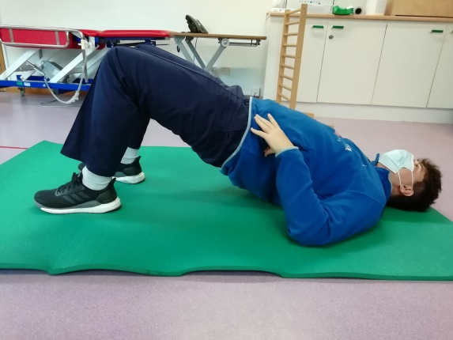

Crab
Sit on the floor with your hands behind you and your feet on the floor. Lift your bottom up so that it is not on the floor.

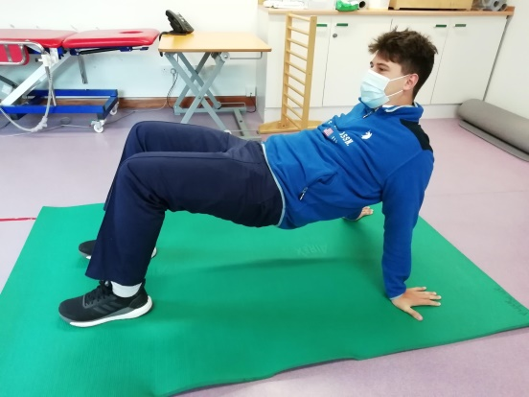

Try to do some sideways walks!

Leg and Arm Reach
Begin on hands and knees. Extend the left arm in front and the right leg behind for about 10 seconds. Return to all fours and then repeat with the right arm and left leg. You might need to start with one arm and one leg to develop stability. This needs to be done with opposite body sides as raising the arm and on the same side does not exercise the core.

Air Kicks
Lie on your back and prop up on the elbows. Bring the legs to the chest in the ready position. Throw a large soft ball at their feet and they have to kick the ball away. . Make sure that you use both feet together and try to encourage them to return the ball to you rather than kicking it off at an angle.

Superman
Lie on your stomach and lift your arms up in the air. Your chest should be off the floor. Try lifting a ball or toy up and down in this position.

When you can do this, try lifting your feet up too!

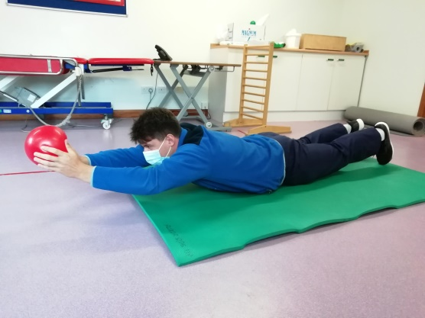

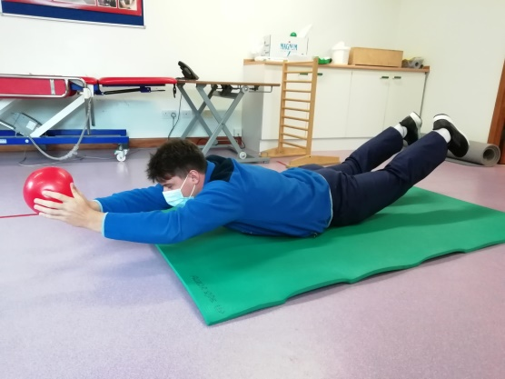

Knock Over!
There are two ways to do this:
- Use a gym ball to sit on when you are doing activities such as watching TV
- Kneel up on the floor and get a friend to through balloons for you to bat back to them. As you get stronger try using a range of different sized and weighted balls.

Plank
Lie on your front on the floor. Place your hands on the floor at shoulder level and have your toes on the floor. Push up so that your whole body is off the floor. If this is too hard, bend your knees so that make straight line with your body from your knees to the top of your head.

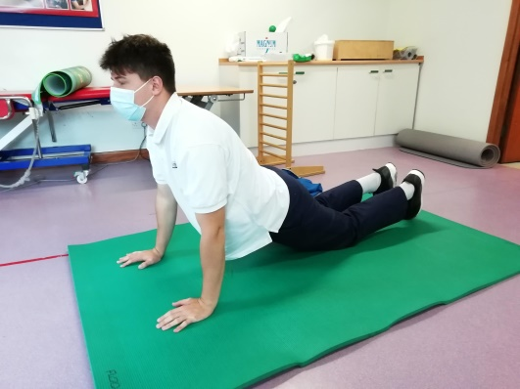

When you can do this try putting your forearms on the floor and doing the plank!

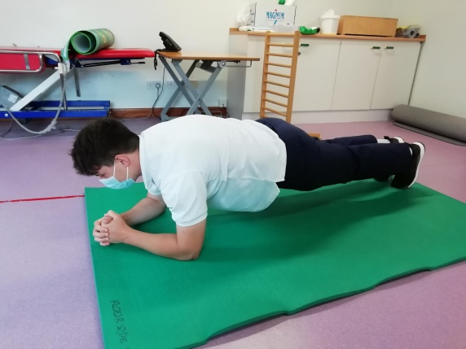

When you can Plank, you can try…Knee Crosses
Start in the plank position with arms and legs straight. Then bring the right knee up to the chest and towards the left side. Return to the starting position and then use the left leg. Try to use slow and controlled movements rather than rushing.

Wheelbarrow walks
Try doing wheelbarrow walks with someone holding your feet whilst you walk along.

