Dressing Skills Programme
Getting dressed involves fine and gross motor skills, organisation, sequencing, balance, and coordination skills. Children require the ability to use both hands together and an awareness of body parts. Children need to practice these skills before being able to dress independently.
Take time each Day
- Make time each day to practise dressing skills for 10 – 15 minutes.
- Minimize distractions and interruptions e.g. turn off TV and radio, find a quite space in the house where you and your child can relax and focus.
- Dress in the same place each day.
- All children learn to undress first, so start by asking your child to remove easy clothing first such as loose-fitting pyjamas, socks, jogging bottoms.
- Next step is to dress using loose-fitting items of clothing
- Finally, trying to put on more difficult items of clothing e.g. tights, leggings, shirts.
- Remember to give your child opportunities for practice each day.
Things to try
- Always demonstrate the dressing technique first and talk through what you are doing.
- If your child struggles with balancing complete tasks while sitting down.
- Try dressing in front of a mirror, it may help your child, they can also check clothes are on correctly.
- Make it fun practice dressing up with fancy dress costumes or make a game of practicing dressing skills.
- During play put outfits on dolls or teddies and name body parts.
- Use a reward chart to increase your child’s motivation.

Methods of learning to dress
Backward chaining is used for teaching skills by breaking them down into small steps. The adult begins the task and the child completes the last step. The order of the steps remains the same each time and as the child gets better the adult then does less of the task.

The table below shows some dressing activities broken down into steps. If the dressing activity for your child is not shown, start by writing down the steps.

Putting on trousers.  - Pick up trousers by waistband  - Lower trousers and lift up one leg  - Put one leg into trouser hole  - Then other leg into trouser hole  - Pull trousers up to knees  - Stand and pull trousers to waist | Putting on a jacket.  - Pull jacket onto right shoulder.  - Slip right arm up through right arm hole.  - Reach with left arm to pull jacket around.  - Pull jacket onto left shoulder with right hand.  - Hold collar of jacket with right arm.  - Push left arm through left arm hole.  (left and right can be swapped over)
Putting on socks.  - Hold sock by edge with both hands.  - Push toes into sock.  - Pull sock to ankle.  - Lift foot and pull over heel.  - Pull sock up leg. | Putting t-shirt on.  - Gather material of t-shirt at neck.  - Pull t-shirt over head.  - Push one arm through the arm hole.  - Then push other arm through.  Then straight/pull down t-shirt.

The last step is where the child starts with this activity. The adult completes the other steps and the child learns to complete the last part of the task. Once your child is independent in completing the last step, get them to do the last two steps, you continue this process until eventually your child has mastered the whole task.

Forward chaining is where the child starts the task first e.g. putting t-shirt overhead and the adult helps with the later stages.

Hints & Tips

- Your child will need to use their strongest arm/leg to dress the other arm/leg first.
- Socks with coloured heels and toes make it easier to work out the correct way around.
- Transitions for seasons may take time: discuss it, prepare for it, and use social stories to explain
- Organise drawers and closets to help enable a child to choose their own clothing
- The backward chaining technique can be used for lots of daily living tasks such as brushing teeth, hair washing etc.

Visual Schedules
Visual schedules can help your child to independently dress with minimal support. They can be used at home and school and may be helpful to break activities into smaller pieces.
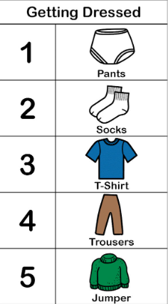
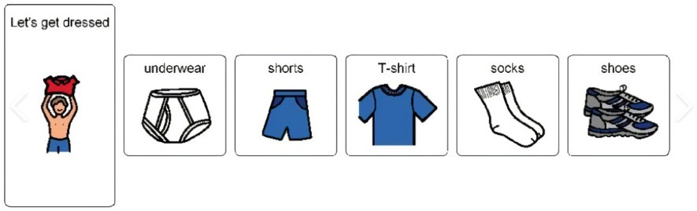
Below are two examples of dressing visual schedules, they can be used on coloured backgrounds, are portable to carry around the bedroom. They can be tailored to your child’s specific needs to support at home or in school and for every season e.g. summer, winter.

Another way to visually support your child is to lay out their clothes ready for the next day. Your child can help pick the clothes they would like to wear. It is easier if you lay them out in a line rather than putting them on top of each other, line e.g. pants, socks, shorts, t-shirt.
Right Way Round
Children will often put clothes on back to front or inside out. Some children find the task of turning clothes the right way round challenging and it is a good idea to start teaching your child this skill before they start school.
If your child makes a mistake whilst dressing, ask them questions to help problem solve or to work out what went wrong. Do not fix it for them. Next time they might get it right without your help.

Jackets and Coats
There are many different strategies for teaching your child to put on their jacket or coat.

- See backward chaining chart for first method.
- Chair method
  - Drape the coat over the back of a chair with the lining facing outwards and the sleeves freely hanging.
  - The child stands with their back to the lining and puts each arm in turn into the sleeves.
  - The child bends down to get the coat onto their shoulders and then moves up and away to release the coat.

- Floor flip method
  - Child lays coat on floor with lining facing upwards. The child stands with the hood by their feet.
  - Child bends down place’s hands in arm holes
  - Child then flips the jacket over head and push hands through arm holes.
  - See video link https://youtu.be/3wRKDeKbAcI

- Superhero method
  - Put jacket over both shoulders (making a cape, like a Superhero)
  - Slip right arm through arm hole
  - Slip left arm through arm hole
  - This method is fun and supports engagement.

Zips
Zips are usually the first fastenings that children learn to do. Their first zip is usually on their jacket. Children learn to unzip before zipping.

- Start by practicing opening and closing zips on pencil cases and bags.
- Encourage your child to unzip and unlatch the zip.
- Teaching zipping
  - Show your child using a step-by-step demonstration using the same language each time.
  - Use a backward Chaining method.
    - Adult latches the zip, pulls the zip up halfway and holds the bottom of the zip. Child then uses a pincer grasp to pull the zip up.
    - Adult latches the zip, pulls the zip up a little. Child then holds the bottom of the zip and uses a pincer grasp to pull the zip up.
    - Child latches the zip, uses a pincer grasp to pull the zip up. Children will need help to put the zip together to start with. Some children will require hand-over-hand technique where you guide your child’s hands through the activity.
Hints & Tips
- Attach a zipper pull, keyring or ribbon to the zip to make it easier for your child to grasp.
- When buying clothing with a zip, test the zip thoroughly for ease before you buy.
- Zips on skirts are tricky, to make it easier for child, get them to twist the skirt round so they can see what they are doing. Once the skirt is zipped up, twist it back round.

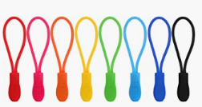

Buttons
- Start by teaching your child unbuttoning first it is easier.
  - Start with big buttons before smaller buttons.
  - Buttons that are different colours to the item of clothing are easier.
  - Practise unbuttoning different items of clothing.
  - Using clothes that are well worn helps.
  - Practise using clothes on teddies and dolls.

- Teaching buttoning
  - Start practicing with larger, flat buttons.
  - Ensure the buttonhole is large enough for the button to fit through easily.
  - Using clothes that are well worn helps.
  - Show your child using a step-by-step demonstration using the same language each time:
    - Pinch the button, using thumb and index finger
    - Push the button through the buttonhole.
    - Pull the button, using thumb and index of other hand.
  - Tell your child what to do, pinch, push, pull, it is easier if your child can see what they are doing,
    - Laying clothes flat on a table.
    - Hanging clothes on the back of a chair.
    - Sitting in front of a mirror.
  - It may help to break the task into smaller pieces,
    - Start by pinching the button and pushing part way through the buttonhole and ask your child to pull the button the rest of the way.
    - Help your child push the button into the hole and you (parent/carer) to pull through.
    - Put these two parts together.
  - Some children will require hand-over-hand technique, this is where you sit behind your child and guide your child’s hands through the activity.

- Tips for school shirts
  - Allow your child to do up those buttons which they can see e.g. at the bottom of a shirt.
  - It is easier to line up the bottom of each side of the shirt.
  - Limit the number of buttons your child must do, building up to completing all the buttons (backward chaining method).
  - Encourage your child to undo the top few buttons when taking off a shirt and then remove over the head. This limits the number of buttons they will have to button when putting back on.
  - Top buttons are always tricky to do as children can not see what their fingers and hands are doing.
Activities to support dressing
Practising fine motor activities can support development of techniques and skills required for dressing.

Bilateral activities encourage your child to use both hands together, for example, clapping games, catching a ball.

Pincer grasp activities encourage your child to use thumb and index finger together, for example picking up raisins, or sticking pompoms in a pot.

Try some of these activities:-
- Posting coins into a money box or buttons into a tub with slot cut into top.
    - Start with large buttons and a large slot.
    - Then move on to try smaller buttons in the large slot.
    - Next small slot and small buttons.
    - Use slots at different angles
- Thread large beads onto pipe cleaners, then onto string and finally practice threading smaller beads onto lace.
- Create lots of shapes in felt and cut a buttonhole into the middle of each. Sew a button onto a long piece of ribbon and practice threading through the buttonholes and taking the felt pieces off the button.

