Shoes and Tying Laces
Learning to tie shoelaces is important as it is a key activity in daily living skills, however tying shoelaces is a hard task to learn, children need to independently put shoes on before they learn to tie laces. Children can take shoes off before being able to put them on. By 2 years of age children can usually pull-on wellies and slippers.
Take time each Day
- Make time each day to practise for 10 – 15 minutes.
- Minimize distractions and interruptions e.g. turn off TV and radio, find a quite space in the house where you and your child can relax and focus.
- Practice in the same place each day.
- Make time to practice, don’t wait until you are about to go out.
Shoes
Children might get confused between their left and right shoe. To help promote independence you can try:-
- Keeping the shoes in the correct position.
- Cut a large sticker in two and place half in each shoe. The child can then place the stickers together to make a whole picture.
- Mark the inside border of each shoe with indelible ink. The child can then place the two marks together.

Putting shoes on:-
- It might be easier for your child to sit in a comfortable, balanced position with their back against something. They could sit on a chair or bottom step of stairs.
- Slip shoe over toes, holding the tongue of the shoe and wiggle toes inside.
- Place index finger inside the heel of the shoe and pull the shoe the rest of the way over their foot.
- Place shoe/foot on the floor and stand up to push foot down into shoe.
Tying Shoelaces
Shoelaces are best learnt using a forward chaining method i.e. the child learns the first step first. It is helpful to master the first step before moving onto the next. This technique is useful as you are in effect teaching a series of knots and your hands do not have to perform as many different moves.

Teaching your child to tie shoelaces.
- First lace a shoe/ trainer with different coloured laces.
  - Flat laces are easier to tie than round laces.
  - Ensure that the laces are long enough to comfortably tie a bow.
- Initially practice by placing the shoe on your child’s lap or a table, heel of shoe closest to body.
  - If your child finds this tricky, try tying the lace around their upper leg first so they can see what they are doing.
- Then break the task into three stages
  - The first Knot
    - Hold black lace in one hand and white in the other hand
    - Cross over the laces
    - With the top lace (black) take it over then under the bottom lace (white)
    - Then pull tight
  - Making a loop
    - Make a loop with each lace holding between thumb and finger.
      - Encourage your child to make a medium sized loop and hold lace together at base/bottom.
      - For younger children you could call the loops rabbit ears.
    - Some children struggle with this stage and might need to practise making loops.
    - Try making the loops and let your child finish stage c.
  - Crossing the loops
    - Do not let go off the loops
    - Cross over the loops
    - Find the cross
    - Take the top loop over then under the cross
    - Then pull tight
  - Repeat to make a double knot.
- When your child can tie the shoelace move onto tie their shoes on their own foot.
  - Sitting on a chair with their foot on the edge of a chair
  - Half kneeling on the floor.
  - Stood on one leg with other leg resting on chair or stool.

See visual prompt sheet 6 steps to successful shoelace tying.

Hints & Tips
- Use different coloured laces as a visual clue
- Try and avoid using the words ‘right’ and left’ and use colour of the laces.
- There are lots of different ways to tie shoelaces. You need to find a method that is easy for your child. The video link demonstrates 4 different methods of tying laces, https://www.youtube/watch?v=3TMZVWNDu90
- Ian's Shoelace Site – Shoe Lacing Methods (fieggen.com) has lots of different methods to tie shoelaces and advice on stopping them coming undone.
- Alternatives to shoelaces include – using Velcro fastenings, elastic laces, springy spiral laces, magnetic laces, or slip on shoes.

Activities to support skills
Practising fine motor activities can support the development of techniques and skills required for shoelace tying.

Bilateral activities encourage your child to use both hands together, for example, clapping games, catching a ball.

Pincer grasp activities encourage your child to use thumb and index finger together, for example picking up raisins, or sticking pompoms in a pot.

Try some of these activities:-
- Ripping paper/card to increase hand strength needed when tightening the lace
- Threading beads onto a string
- Paper weaving, constructional toys, sewing games (you can help understand how the lace goes behind and is posted through)
- Tying bows with ribbon as this is less likely to slip
- Dressing dolls/teddys give a good opportunity for practice
- Obstacle courses - practicing concepts of under, over, around and through. Try copying these in a sequence.

6 Steps to successful shoelace tying
3
1
2
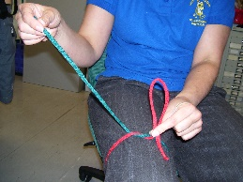
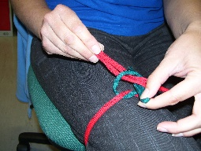
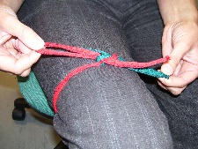
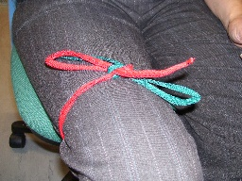
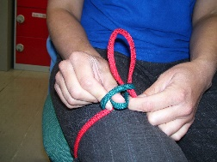
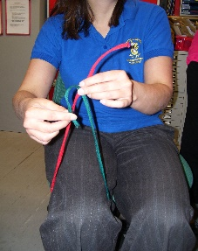
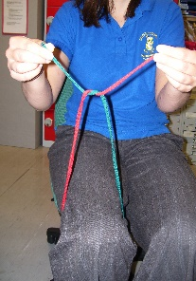
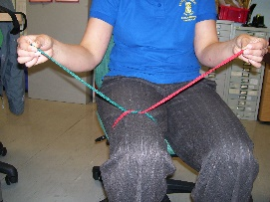
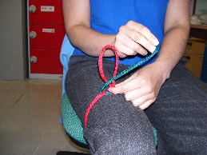
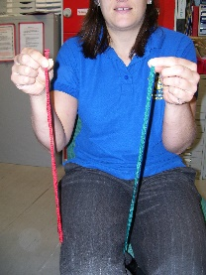
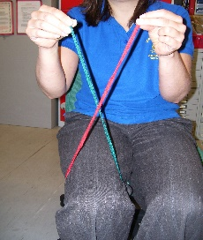
6. Make a loop ‘tree’ at the base right next to the knot - on the right-hand side if you’re right handed, left hand side if your left handed. Not too big not too small but a medium sized loop ‘tree’.
9. Pinch the ‘rabbit’ as he comes through the hole. Pinch the top of the ‘tree’ – one loop and then slowly pull.
10. If the lace is still loose, give the loops a wiggle.
Finished!
8. The ‘rabbit’ bends in the middle to go through into his hole. Your thumb should already be there to meet him.
3. Pass the end of the top lace ‘UNDER THE BRIDGE’.

4. It should look like this.

5. Pull it tight.
7. Take the other lace ‘the rabbit’ by its middle and take it all the way around the front of the loop ‘tree’ until it gets to the back of the loop ‘tree’.

1. Make sure your laces are equal length.

2. Cross over the two lace ends ‘X FACTOR’.
Try tying the lace around your upper leg first so you can see what you are doing. When you have mastered this then you can move onto shoes!

