Domino’s

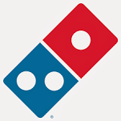

50% Discount off your order.

Only available on collection on production of your staff ID badge.

