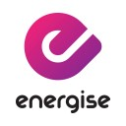

Corporate membership at York Council’s Fitness Centre

Energise
Cornlands Road,
York
YO24 3DX
Tel: (01904) 552424

A corporate membership scheme for all NHS staff, is currently £28.00 a month by direct debit, and includes unlimited gym, swim and fitness classes. Staff will need to show their most recent wage slip when they enrol as a member, either in the centre or on line. You will also need to call and book an induction session for the gym.

