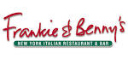

20% Discount off your bill.

20% discount applies to the food bill only, and is only valid when 2 main courses are purchased from the Main Menu on production of your staff ID badge.

It cannot be used in conjunction with any other offer or discount promotion including lunch/set menus. It excludes Mondays 5pm-11pm and is valid at any Frankie & Benny’s or Little Frankie’s restaurants excluding Airports.

