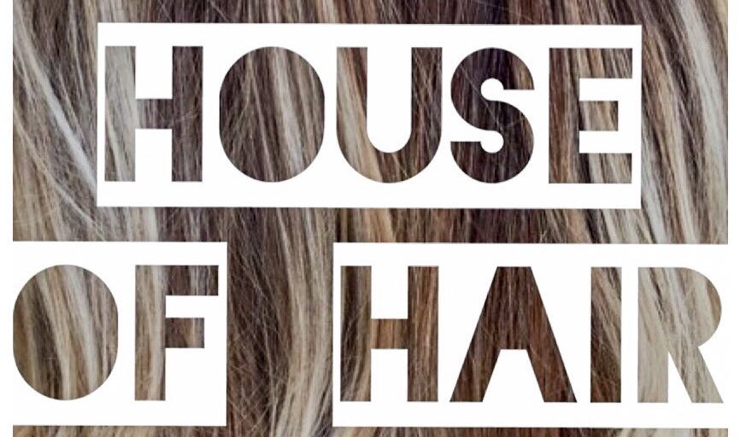

8 Knaresborough Road
NHS DISCOUNT 15%
VALID WITH PRODUCTION OF STAFF ID.
First visit promotion save £10 with a £30+ spend, £5 discount on a spend over £15.
01423 313880 www.houseofhairharrogate.co.uk 

