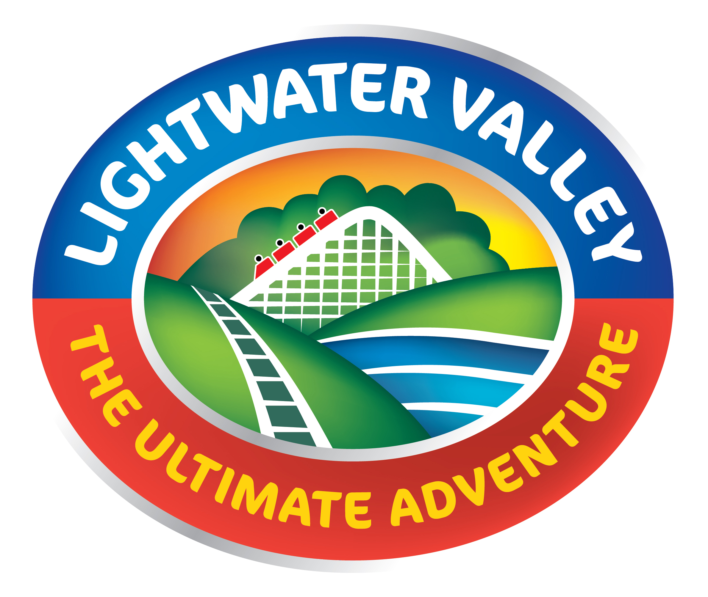

NHS discounts of booking online £18 per person for up to six people or £24 per person on the day.

www.lightwatervalley.co.uk

NHS ID badge must be produced on the day.

*please note current prices valid until 4 November 2017. New offers to be updated soon.

