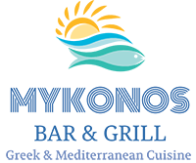

Mykonos Restaurant Harrogate offers a discount to HDFT employees from their A la cart (main) menu Sunday to Thursday12:00-22:00
A table must be booked in advance and staff ID badge provided on arrival.
The discount will apply for guests as well as HDFT staff. The whole discount for each group will be 20% of the total bill maximum £30 discount.
The discount is not to be used on any set menus or in conjunction with any other offers.
Mykonos Bar & Grill
Greek & Mediterranean Cuisine
4 Mayfield Grove
Harrogate
HG1 5HB
Tel: 01423565151
Email: contact@mykonosbarandgrill.co.uk
Website: www.mykonosbarandgrill.co.uk
Facebook page: Mykonos Bar & Grill

