The Newton Grange
Brasside Durham
DH1 5SA
Tel: 0191 384 4708.
www.newtongrangepub.co.uk

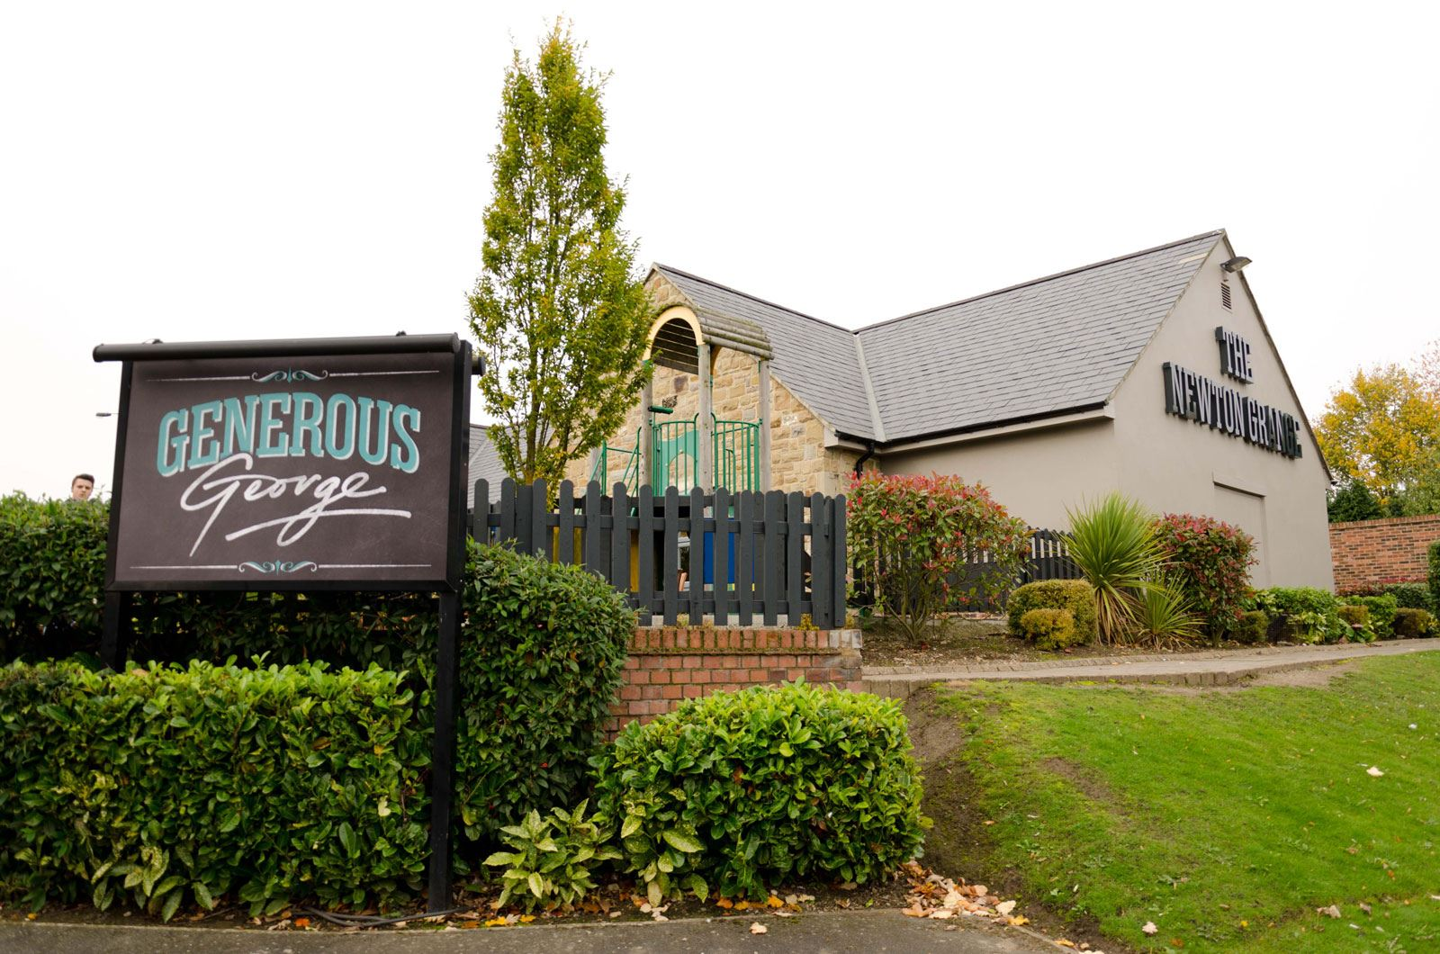

Newton Grange offers NHS staff 20% discount off food, all day every day.
Must produce staff ID badge to take up this offer.

