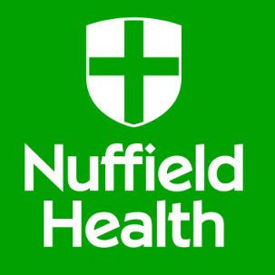

Nuffield Health are offering the following gym membership options with NHS Staff discount

- 3 month option, £20 to join and £70 per month (normally £78 per month)
- 12 month option, £20 to join and £65 per month (If people join on 12 month option they get February for free) (normally £72).

