**The**

**Complementary Therapy**

**Service**

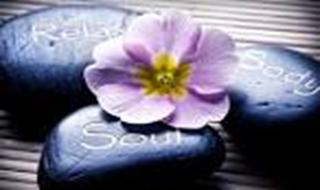

**INFORMATION FOR PATIENTS**

**ABOUT**

**Complementary Therapy in Cancer Care**

**Appointments**

**Available by Referral**

**Monday, Tuesday, Wednesday and Thursday**

This information is available in other formats on request. Please ask your nursing staff to arrange this

**The Complementary Therapy Service**

The Sir Robert Ogden Macmillan Centre offers a comprehensive range of complementary therapies to people affected by cancer. The service is available to patients and carers, free of charge and is provided by a fully qualified professional employed by Harrogate and District Foundation NHS Trust.

Complementary Therapies are used alongside conventional medical treatments such as; surgery, chemotherapy, radiotherapy and hormone treatments. It is important to remember that complementary therapies are not a cure for cancer or used instead of conventional cancer treatment. They may help to relieve some of the physical and emotional problems associated with a cancer diagnosis or the side effects of treatment.

There are a wide range of Complementary Therapies available, all of which offer different ways of helping people. Complementary therapies are suitable for most people, but for some medical conditions complementary therapies should be avoided or changed to suit your personal needs. If you are considering having complementary therapies ask the healthcare professional looking after you to make a referral to the service.

Each session will include a full consultation with the therapist to discuss your health and wellbeing to ensure the therapy is appropriate for you. It is important to be honest with the therapist about any health issues you may have. Please bring an up to date list of the medicines that you are taking.

An individual confidential record file will be kept with any relevant notes for future treatments. At each visit the therapist will discuss any changes in your health and the effect of the last treatment. You will be asked to sign to agree that you have been given information about the treatment that you are to receive, the aftercare advice for after the treatment and that you consent to the treatment.

Most sessions are approximately one hour, but can be shortened if you wish. If at any time during your treatment you wish to stop, please let the therapist know.

If you are unable to get to the centre for your treatment please let our therapist know as soon as possible. If you have been admitted to a ward at Harrogate District Hospital the therapist may be able to treat you whilst you are in hospital.

All therapies are regularly evaluated. Evidence suggests that the therapies described can contribute to improving physical and psychological wellbeing.

**The Complementary Therapies we offer;**

**Reflexology**

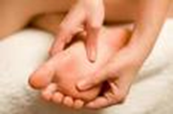

A completely safe and natural healing science which treats the whole person. Promotes deep relaxation and a sense of wellbeing. Gentle pressure is applied to reflex points on the soles of the feet or the palms of the hand.

**Reiki (pronounce ‘Ray Key’)**

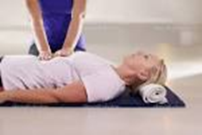

‘Chi’ energy is channelled to restore a sense of wellbeing. The treatment is gentle, supporting and non-invasive and offered on the clothed body. It has been documented cancer patients have reported feeling less distress and discomfort when Reiki is part of their care plan.

**Therapeutic Massage**

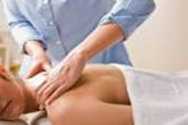

Deep relaxing touch therapy used with oil. Works towards mental and physical relaxation

Beneficial for alleviating muscular aches and pains in the back, neck and shoulders. It can energise the whole body.

**Bowen Technique**

The Bowen Technique is a hands-on therapy

that is applied with fingers and thumbs on precise points on the body. It is a gentle and subtle treatment and believed to prompt the body to repair and balance itself. You do not have to remove any clothing for this treatment.

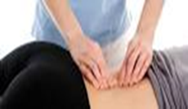

**Daoyin Tao (Chinese face, neck and shoulder massage)**

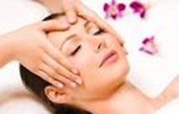

A gentle therapy which accesses the accupoints of the face, neck, ears, scalp and shoulders. It allows a deep sense of relaxation and wellbeing throughout the whole body.

**Auricular Therapy**

Auricular or ear seed therapy, has been demonstrated to considerably improve some of the side effects of hormone therapy such as hot flushes, night sweats, sleep problems, anxiety and depression, racing heart and palpitations. Tiny seeds from the Vaccario plant are applied with sticky tape applying direct pressure to acupoints.

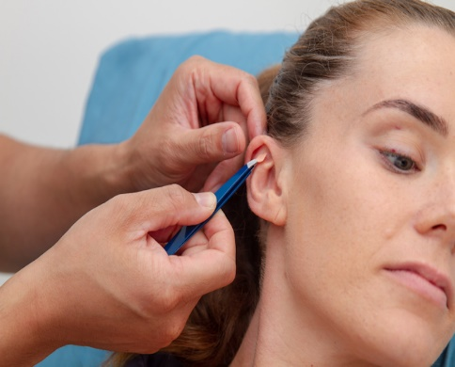

**Scar Tissue Therapy**

A method of non-invasive physical therapy developed to treat scar tissue, fibrosis and adhesions after surgery or injury using specialist scar massage, fascial release and self-care information to promote healthy recovery

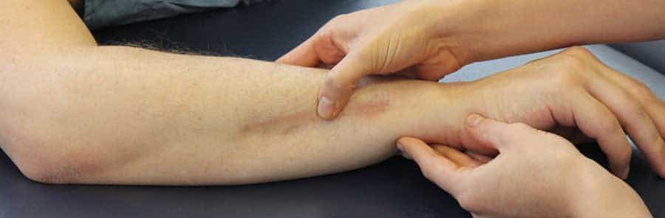

**Group Relaxation Sessions**

Whenstress goes unchecked, it can not only affect your quality of life, but it can also influence your physical wellbeing. These relaxation sessions work through breathing techniques, progressive muscle relaxation and guided visualisation, giving you techniques you can use at home to help calm, ease anxiety and improve sleep patterns.

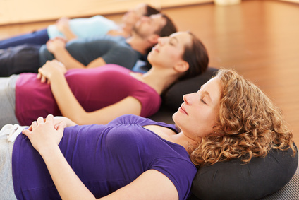

**For more information Contact:**

**Julie Crossman**

**Complementary Therapy Practitioner**

**Reflexology, Therapeutic Massage, Daoyin Tao,**

**Reiki, Bowen Technique, Scar tissue Therapy**

The Sir Robert Ogden Macmillan Centre

Harrogate District Hospital

1 Willaston Crescent

Harrogate

HG2 7BF

Direct Line 01423 557963

Email: hdft.cancerinformation@nhs.net

www.harrogatecancerservices.nhs.uk