

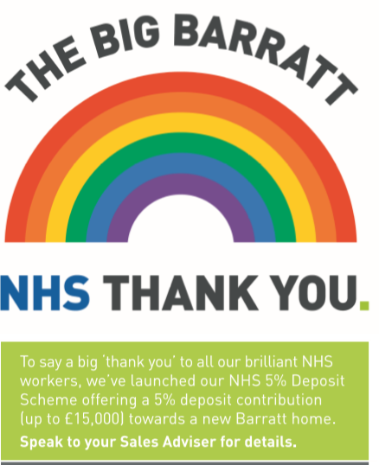

The below links will take you their Facebook page and also the terms and conditions page for the Scheme.

https://www.facebook.com/barratthomesuk

https://www.barratthomes.co.uk/offers/nhs-deposit-contribution/

