



# Patient and Carer Information

ABDOMINO-PERINEAL EXCISION OF THE RECTUM FOR LOW RECTAL CANCER



# Please read this leaflet carefully. It is important that you take note of any instructions or advice given. If you have any questions or problems that are not answered by the information here, please ask your doctor or nurse.

**INTRODUCTION**

Your Consultant has explained to you that you have a cancer in your rectum. This leaflet helps to explain the type of operation you are going to have.

* Why you are having this operation.
* Risks associated with the operation.
* Recovery from the operation.
* Future care.

# What is Cancer?

A cancer is a growth of abnormal cells in an area of the body. In your case this growth of abnormal cells has occurred in the lower part of the rectum, very close to the anus (back passage).

If this cancer is not removed, it can spread to the rest of the body and become life threatening.

# What is the rectum?

The rectum is the last 15cms of the lower end of the bowel, which goes down to your anus (back passage).

The rectum stores solid waste (stool) until it is ready to leave the body through the anus. Around the anus is a ring of muscle called the anal sphincter. This sphincter opens and closes and helps to control the flow of waste from the rectum.

The treatment for rectal cancer is surgery.

Rectal cancers can also be treated with radiotherapy, chemotherapy or both. This can be done before or after surgery.

# What is chemotherapy?

Chemotherapy is drug treatment and can be given intravenously or orally. Chemotherapy can be given at the same time as radiotherapy or on its own.

# What is radiotherapy?

Radiotherapy is X-ray treatment and is given on separate occasions over a few days or weeks. Radiotherapy is given at St James’s Hospital in Leeds. You may receive radiotherapy alone or with chemotherapy.

# Will I get these treatments for my rectal cancer?

Receiving radiotherapy and chemotherapy before surgery will depend on the results of your scans. Your results will be discussed at our Multi-disciplinary meeting (MDT), where all the specialist doctors are present, and the most appropriate treatment will be recommended and then discussed with you in clinic.

# What type of operation will I have?

The operation is called **Abdomino-Perineal Excision of Rectum.**

This operation involves making an incision or cut in your abdomen. The incision will be either laparoscopic ‘keyhole’, or open, the surgical technique will be discussed with you by your surgeon.

It involves removing the rectum and the anus through a combined abdominal and perineal (through the back passage).

Due to the cancer being very low in the rectum and near the anal sphincter muscles, the back passage (anus) must be removed and stitched. This is called the perineal wound.

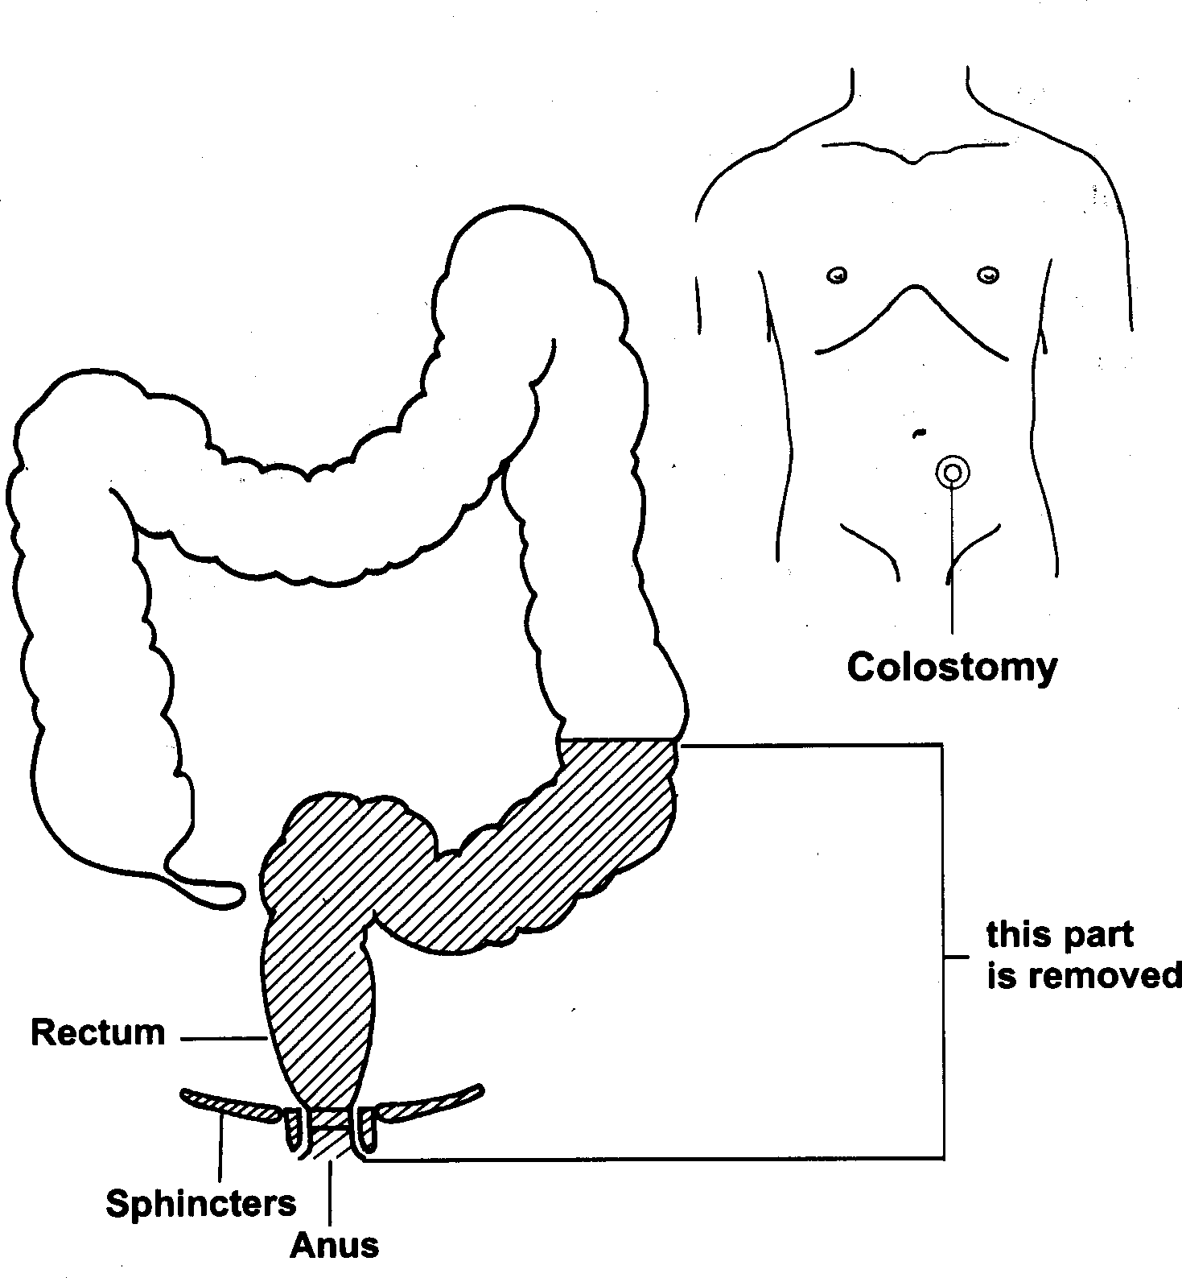A permanent colostomy (stoma) will be formed.

# What is a colostomy?

A colostomy (stoma) is when part of the large bowel is brought to the surface of the abdomen and is covered by an appliance (a bag). Your bowel motions empty into the colostomy bag

The stoma nurse will see you before your operation and explain the implications of having a stoma.

* Chest infections. This affects about 1 patient in 15.
* Wound infection affects 1:10 patients
* Pain or discomfort around the wound
* Blood clot forming in the leg (DVT =Deep Vein Thrombosis)
* Damage and bruising can occur to the nerves that control the bladder and sexual function. In men there is a 10 – 15% risk of impotence and erectile dysfunction.
* Vaginal stenosis as a result of radiotherapy treatment
* The perineal wound (the back passage) could open up. This is not uncommon if you have undergone radiotherapy prior to surgery, and the appropriate treatment will be discussed with you.

Precautions are taken to reduce the risk of complications. In particular, antibiotics are used to reduce the risk of infection and special medication and stockings are given to reduce the risks of blood clots.

# How long will I be in Hospital?

You will stay in hospital for 7 – 14 days, but this does depend on how well you recover from the operation.

# What will happen immediately after the operation?

You will have received an information leaflet on the enhanced recovery, and this gives more detail of your expected recovery.

# How long will it take to fully recover from the operation?

It can take 6 – 8 weeks for the muscles and tissues to fully heal. We advise you to avoid any activity that may put a strain on your abdomen as this may cause problems and delay healing.

Most people tend to be off work between 6 and 12 weeks, maybe even longer depending on their type of work. The stoma care nurse will arrange to see you at home. Usually you can drive again about a month after surgery.

As your energy levels and stamina improve, you will gradually be able to resume many of your normal activities

# How will the treatment affect my sex life?

Depending on the extent of the surgery, men may have changes in their sexual function i.e. erectile dysfunction, due to damage to the nerves supplying the penis, and bladder problems due to nerve damage supplying the bladder.

Women can experience vaginal narrowing (stenosis) which is caused by the radiotherapy

Cancer treatments can affect body image and the way you see yourself sexually. Because of these feelings and symptoms, your desire for sexual intercourse may be very low. It is normal to feel like this. If you have any concerns or questions, talk to the specialist nurse or your doctor about them in confidence.

**Colorectal Clinical Nurse Specialist Team**

Lindsay Conner (Team Lead)

Bethany Milner (CNS)

Lucy Woodward (CNS)

Caroline Bolton (Cancer Care Coordinator)

**Monday to Friday**

**8.30 am – 4.30 pm**

**Tel: 01423 553340**

Some useful contact numbers for further information and advice on rectal and bowel cancer:

# The Sir Robert Ogden Macmillan Centre

Provides Patient Information, Health and Wellbeing and Financial Benefit support services Tel: 01423 55 7317

# Macmillan Cancer Support

Provide Free Information and Support to patients and carers affected by all aspects of a cancer diagnosis.

Tel: 0808 808 00 00

# Colon Cancer Concern

Free fact sheets covering diet, diagnosis, terminology and treatment. Tel: 020 7381 4711

# Digestive Disorders Foundation

Provide information leaflets on all bowel disease including cancer. Tel: 020 7486 0341

# British Colostomy Association

Gives information regarding stomas, products and colostomies. Tel: 0800 328 4257

If you require this information in an alternative language or format (such as Braille, audiotape or large print), please ask the staff who are looking after you.