



# Patient and Carer Information

BOWEL CANCER



# Please read this leaflet carefully. It is important that you take note of any instructions or advice given. If you have any questions or problems that are not answered by the information here, please ask your doctor or nurse.

**INTRODUCTION**

In this leaflet we try to answer some questions or concerns you may have following your recent meeting with your consultant. If you have any other question s after reading this leaflet the colorectal nurse specialist will be happy to go over these with you.

If you have any questions or queries after reading this leaflet, the colorectal nurse specialist will be happy to go over these details with you. Please refer to the back page of this leaflet for contact information.

# What is a tumour/growth in the bowel/rectum?

The doctor has explained that you have a growth or tumour, in your bowel or rectum and could be cancer.

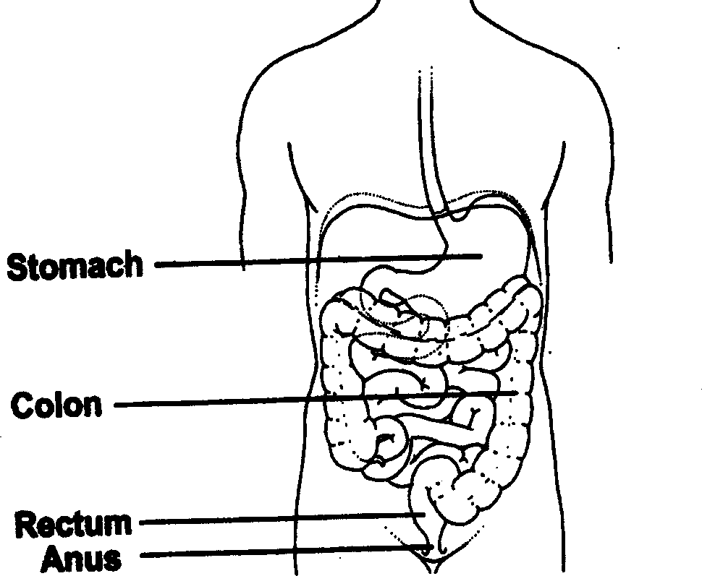

# What is a cancer?

A cancer is a growth of abnormal cells in an area of the body. In your case this growth of abnormal cells is in the bowel or rectum.

If this cancer is not removed it can cause local problems within the bowel or rectum, and eventually spread to the rest of your body.

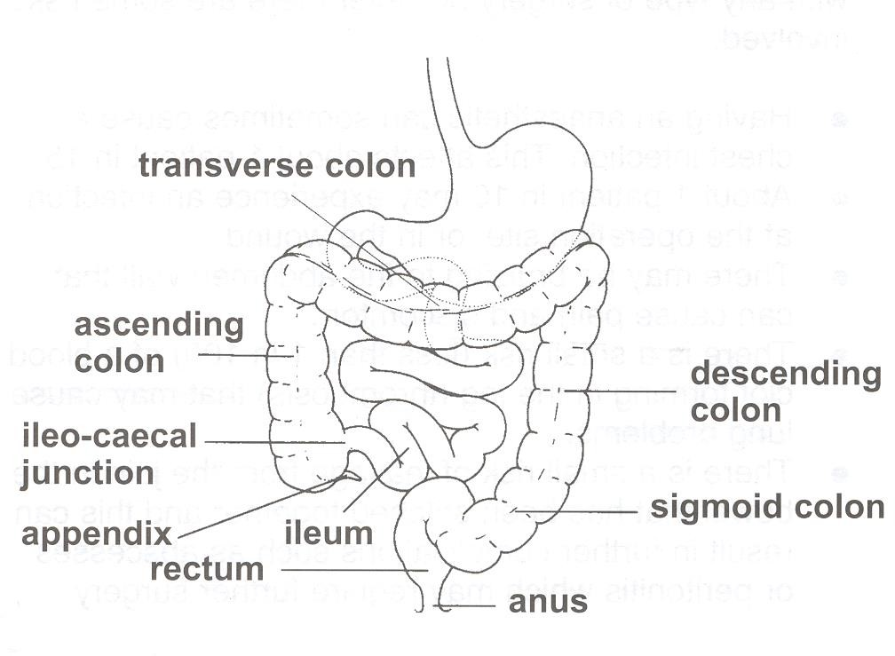

# How is the bowel or rectal cancer treated?

The usual treatment for a bowel or rectal cancer is surgery. This involves having an operation to remove the tumour.

# Are there any alternatives?

The mainstay of treatment is surgical but bowel and rectal cancers can also be treated with radiotherapy and/or chemotherapy treatment. This can be either before or after the surgery.

# What is chemotherapy treatment?

Chemotherapy is a form of drug treatment. This is given into a vein as an outpatient at St. James’ Hospital in Leeds or on the Sir Robert Ogden Macmillan Centre here at Harrogate District Hospital.

# What is radiotherapy treatment?

Radiotherapy is x-ray treatment given at St. James’ Hospital in Leeds. This treatment is given over a few days or a few weeks, depending on your rectal tumour.

Your consultant and specialist nurse will discuss with you what treatment will be the most appropriate for you and your tumour.

# Will I need to have any tests before treatment?

You have had some tests/investigations, which helped the doctor to diagnose your tumour or growth.

Before surgery or treatment, the doctor may organise further scans, or tests to be done. These are routine and allow the doctor to examine the rest of your body.

# What type of operation will I have?

The operation is dependent on where in the rectum or bowel your tumour is situated.

The operation involves making an incision/cut into your abdomen, and removing a section of the bowel or rectum that contains the tumour. Where possible the remaining bowel and rectum will be re-joined together. The doctor and specialist nurse will discuss with you the type of operation you will have. They will explain the benefits, risks, and any long-term effects the surgery may have on our lifestyle.

# What are the risks of having this operation?

Bowel surgery is a major operation:

* Having an anaesthetic can sometimes cause a chest infection. This affects about 1 patient in 15.
* About 1 patient in 10 may experience an infection at the operation site, or in the wound.
* There may be bruising to the abdomen wall that can cause pain and discomfort.
* There is a small risk (less than 1 in 100) of a blood clot forming in the leg (thrombosis).
* There is a small risk of leakage from the join in the bowel that has been stitched together and this can result in further complications such as abscesses or peritonitis which may require further surgery.

Precautions to avoid all these complications will be taken. In particular, antibiotics are used to reduce the risk of infection. In addition special medication and stockings are given to reduce the risks of clot.

If you are worried or concerned about any of these risks regarding your operation, please speak with your consultant or specialist nurse.

# What are the benefits of having this operation?

Tumours in the bowel can cause a blockage and prevent the normal functioning of the bowel. The tumour can also cause bleeding in the bowel and cause anaemia.

Surgery is the most effective way of treating bower/rectal cancer successfully.

# How long will I be in hospital?

Your length of stay in hospital is usually between 5– 14 days.

# How long will it take to fully recover after the operation?

This is major surgery and involves cutting into your abdomen, so it can take at least 6 weeks for the muscles and tissues to fully heal. We advise you to avoid any strenuous

activity that may put a strain on your abdomen, as this may cause problems and delay healing.

The specialist nurse and the ward nurses will talk with you about your recovery at home. They will give advice on wound healing, activities and returning to work.

# What will happen after the operation?

The section of the bowel or rectum removed in surgery will be sent to the laboratory to be examined. The results will be sent back to your consultant. The results will confirm whether the tumour or growth is a cancer, if it was completely removed, and if you need any further treatment.

# When will I know the results?

The results can take up to 2 weeks after your operation to be ready. You may be told the results whilst you are in hospital. This is not always possible, so you will be given an outpatient appointment to come back and see you consultant, who will discuss your results with you.

# What if these results suggest I need further treatment?

The doctor or specialist nurse will discuss with you about the need for further treatment (chemotherapy and radiotherapy).

An appointment will be made for you to see the oncology (cancer) specialist consultant. He will discuss the treatment options available for your cancer.

# What if I do not need any further treatment?

If the results suggest you do not need any further treatment, then you will be given an outpatient appointment to see you consultant.

You may be followed up in the surgical outpatient clinics regularly over the next few years, to ensure you stay healthy and well.

# Who can provide further information, answer any questions and give support?

To answer your questions and give information please contact:

**Colorectal Clinical Nurse Specialist Team**

Lindsay Conner, Bethany Milner, Lucy Woodward & Caroline Bolton

# Telephone: (01423) 553340

Or

# Stoma Nurse Team Tel: (01423) 555786

**Monday to Friday 8.30 am – 4.30 pm**

Some useful contact numbers for further information and advice on rectal and bowel cancer:

# Macmillan Cancer Support

Provides Free Information and Support to patients and carers affected by all aspects of a cancer diagnosis.

Tel: 0808 808 00 00

# Colon Cancer Concern

Free fact sheets covering diet, diagnosis, terminology and treatment. Tel: 020 7381 4711

# Digestive Disorders Foundation

Provide information leaflets on all bowel disease including cancer. Tel: 020 7486 0341

# British Colostomy Association

Gives information regarding stomas, products and colostomies. Tel: 0800 328 4257

# The Sir Robert Ogden Macmillan Centre

Provides Patient Information, Health and Wellbeing and Financial Benefit support services. Tel: 01423 55 7317

If you require this information in an alternative language or format (such as Braille, audiotape or large print), please ask the staff who are looking after you.