***Board Meeting Held in Public***

*Wednesday 26th March 2025*

|  |  |
| --- | --- |
| Title: | Learning from Deaths Quarterly Report Q3: Oct-Dec 2024 |
| Responsible Director: | Executive Medical Director |
| Author: | Deputy Medical Director for Quality and Safety |

|  |  |  |
| --- | --- | --- |
| Purpose of the report and summary of key issues: | The board is asked to note the surveillance of mortality indices across the trust. | |
| BAF Risk: | AIM 1: To be an outstanding place to work | |
| BAF1.1 to be an outstanding place to work |  |
| BAF1.2 To be an inclusive employer where diversity is celebrated and valued |  |
| AIM 2: To work with partners to deliver integrated care | |
| BAF2.1 To improve population health and wellbeing, provide integrated care and to support primary care | X |
| BAF2.2 To be an active partner in population health and the transformation of health inequalities |  |
| AIM 3: To deliver high quality care | |
| BAF3.1 and 3.4 To provide outstanding care and outstanding patient experience | X |
| BAF3.2 To provide a high quality service | X |
| BAF3.3 To provide high quality care to children and young people in adults community services |  |
| BAF3.5 To provide high quality public health 0-19 services |  |
| AIM 4: To ensure clinical and financial sustainability | |
| BAF4.1 To continually improve services we provide to our population in a way that are more efficient |  |
| BAF4.2 and 4.3 To provide high quality care and to be a financially sustainable organisation |  |
| BAF4.4 To be financially stable to provide outstanding quality of care |  |
| Corporate Risks | N/A | |
| Report History: | Paper also submitted to End of Life Group, Patient Safety Forum, Quality Governance Management Group and Quality Committee | |
| Recommendation: | The board is asked to note the contents of the report, including the metrics and methodology used*.* | |

**Board Meeting Held in Public**

**Wednesday 26h March 2025**

**Learning from Deaths Quarter 3 Report**

**Executive Medical Director**

1. **Executive Summary**

Crude mortality rates for the trust continue to oscillate around national level.

SHMI has risen which is most likely a data accuracy issue due to delays in clinical coding. Observed number of death remains at a stable level.

21 cases have undergone a structured judgement review since the last report. Learning from these reports is shared within and across the organisation.

1. **Introduction**

Although mortality represents a very small percentage of all trust activity, it is important that it is monitored and examined appropriately. This report aims to triangulate mortality indices with other markers of quality of care, in particular that provided by structured judgemental reviews (SJRs) of medical records.

1. **Findings**
   1. **Crude Mortality Data**

The crude mortality rate for admissions gives a long-term view of trust mortality. In total, 199 deaths were recorded in Q3, up from 175 in the preceding Q2 and also up compared to Q3 in 23/24 which had 189 deaths. A regional increase has been identified by Medical Examiners across the north of England who have estimated an approximate 20% increase in total deaths (hospital and community) compared to last winter. This data is not risk-adjusted so takes no account of the unique characteristics of individual admissions. Comparison with the national mortality rate is also shown where data is available (shown in the darker blue line in Figures 1 and 2). This demonstrates that the peaks and troughs we see in HDFT are often mirrored at the national level. Figure 2 gives a “zoomed in” view of data from the last 2 years. Note that the 12 month rolling mortality has generally declined since 2010 (apart from the impact of the Covid pandemic). It should be remembered that the denominator for this data is the number of hospital episodes, so as we increase elective work (including endoscopies), the percentage of deaths would be expected to fall.

**Figure 1:** Crude mortality rates over the last 14 years (%deaths per hospital episode)

**Figure 2:** Expanded crude mortality rates over the last 2 years (%deaths per hospital episode)

* 1. **Standardised Hospital Mortality Index (SHMI)**

Figure 3 shows our NHS England 12 month rolling SHMI compared to regional peer organisation, with Figure 4 comparing HDFT to national peers: 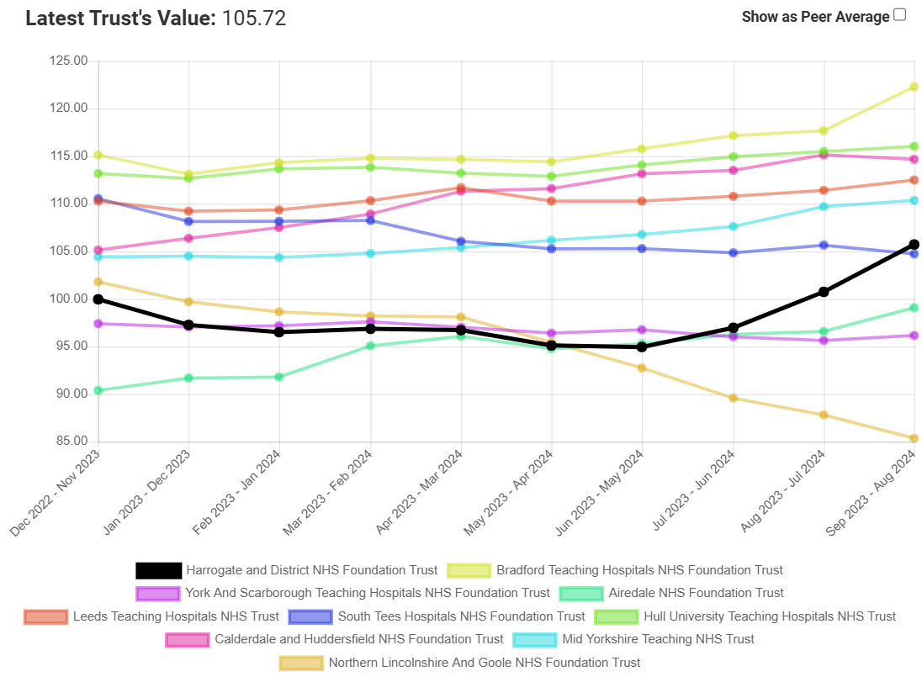

**Figure 3**: HDFT SHMI since December 2022 versus regional peers

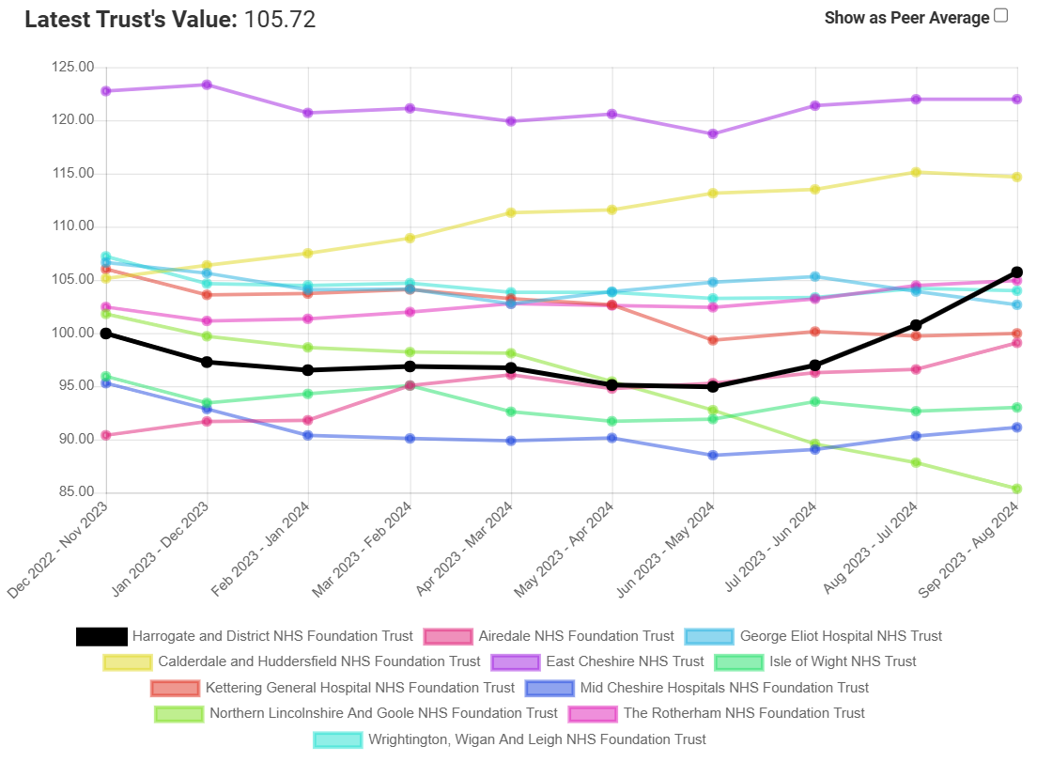 **Figure 4:** HDFT SHMI since December 2022 versus national peers

As can be seen, our SHMI has been rising since June 2024. Further interrogation of the data shows that the number of deaths has remained fairly constant (Figure 5), but the number of expected deaths has almost halved (Figure 6):

**Figure 5:** Observed number of deaths (in hospital or within 30 days of discharge)

**Figure 6:** Expected number of deaths (in hospital or within 30 days of discharge)

A significant fall in expected death numbers raises concerns of a data quality issue. Following interrogation of the data, we have identified a recent increase in patients’ diagnostic code in the category “Invalid primary diagnosis”. As can be shown in Figure 7, we normally have very few spells in this category, but it has sharply risen in 24/25 year to date. The reason behind the rise of this coding category is likely due to incomplete clinical coding by the time of SHMI generation. Working with the data analytics team, an action plan to improve turnaround for clinical coding has been agreed and is now underway. We understand from our external data processing provider (HED) that our SHMI data will remain as it is for 24/25 and cannot be retrospectively adjusted.

**Figure 7:** Number of provider spells falling into the SHMI diagnostic category of “Invalid Primary Diagnosis”

Whilst the improvement work around timeliness of our clinical coding is underway, in the interim period, our other mortality metrics such as the observed number of deaths, any Medical Examiner concerns and the Structured Judgemental Reviews (SJRs) will continue to provide further assurance of our mortality data.

* 1. **Structured judgement reviews (SJR)**

21 cases have been reviewed in this quarter with 18 relating to deaths in this period and 3 from the preceding Q2.

We received 1 “red alert” for a diagnostic category with possible excess mortality in this quarter – deaths categorised as being due to “acute cerebrovascular disease”. This related to the cumulative number of deaths up to and including August 2024. By September, this had fallen to an “amber alert”. In the next quarter, the cases from this category with the lowest predicted mortality during the red alert period will be chosen for an SJR. This is a diagnostic area which has previously between explored with no concerns identified. We are currently finalising “business rules” as to when such intermittent alerts would trigger a more in-depth exploration of clinical cases.

In addition to cases chosen at random to provide assurance, some clinical teams select cases that they have already identified as having possible lapses in care and this therefore generates a higher number of episodes of poor care than previously (where a higher proportion of cases for review were selected at random). We are looking to add an extra field to our SJR tool so we can identify why the case was chosen for review and get a clearer picture of the incidence of each quality-of-care category.

2 cases were in patients with a learning disability who will receive a second external review as part of the LeDeR process. Feedback on their findings will be provided in subsequent papers when the reports are received.

All cases in this quarter were reviewed using the Datix iCloud SJR module which uses the most up-to-date national question set. Questions include a subjective assessment of the avoidability of death – if this were deemed to be higher than 50:50 then the process to commence a Patient Safety Incident Investigation (PSII) would be triggered. We also record if there were gaps in clinical care, organisational aspects or both. In this quarter, organisational aspects noted continued to be delays in admissions from the Emergency Department and failure to be reviewed by a consultant within 14 hours of admission.

The overall assessment of the standard of care of is shown in Table 1:

|  |  |  |  |  |  |
| --- | --- | --- | --- | --- | --- |
| Date of admission | Care in First 24 hours | Ongoing Care | Avoidability of Death | Clinical/ Organisation score (NCEPOD) | Overall Care |
| 04/10/2024 | Good care | Good care | Definitely not avoidable | Good practice | Good care |
| 04/10/2024 | Adequate care | Not Applicable | Definitely not avoidable | Room for improvement in clinical care | Good care |
| 01/10/2024 | Poor care | Poor care | Slight evidence of avoidability | Room for improvement in clinical and organisational care | Poor care |
| 11/10/2024 | Good care | Good care | Definitely not avoidable | Good practice | Good care |
| 27/09/2024 | Adequate care | Not Applicable | Slight evidence of avoidability | Room for improvement in clinical care | Adequate care |
| 15/10/2024 | Excellent care | Excellent care | Definitely not avoidable | Good practice | Excellent care |
| 07/10/2024 | Good care | Poor care | Slight evidence of avoidability | Room for improvement in clinical care | Poor care |
| 25/11/2024 | Adequate care | Good care | Definitely not avoidable | Room for improvement in clinical care | Good care |
| 24/10/2024 | Adequate care | Not Applicable | Definitely not avoidable | Room for improvement in organisational care | Adequate care |
| 31/10/2024 | Good care | Not Applicable | Definitely not avoidable | Good practice | Excellent care |
| 10/10/2024 | Adequate care | Not Applicable | Definitely not avoidable | Room for improvement in clinical and organisational care | Good care |
| 14/11/2024 | Good care | Good care | Definitely not avoidable | Room for improvement in organisational care | Good care |
| 12/06/2024 | Adequate care | Adequate care | Slight evidence of avoidability | Room for improvement in organisational care | Adequate care |
| 19/11/2024 | Good care | Good care | Definitely not avoidable | Good practice | Good care |
| 31/10/2024 | Good care | Good care | Definitely not avoidable | Good practice | Good care |
| 29/11/2024 | Good care | Good care | Definitely not avoidable | Good practice | Good care |
| 26/11/2024 | Good care | Good care | Definitely not avoidable | Room for improvement in organisational care | Good care |
| 30/11/2024 | Good care | Good care | Definitely not avoidable | Good practice | Good care |
| 18/09/2024 | Poor care | Excellent care | Slight evidence of avoidability | Good practice | Good care |
| 03/09/2024 | Excellent care | Good care | Definitely not avoidable | Good practice | Good care |
| 30/11/2024 | Poor care | Poor care | Slight evidence of avoidability | Room for improvement in clinical and organisational care | Poor care |

**Table 1:** Cored details of the cases reviewed this quarter

Three cases had overall care described as “poor”. All have been highlighted for a second review by a different clinician. In all cases where poor care has been identified, the treating team will review the case in the Morbidity & Mortality review section of their regular governance meetings, with learning shared with the required colleagues.

Figure 8 below shows the breakdown of overall care this financial year:

**Figure 8:** Overall care in all cases reviewed this financial year

Tables 2 and 3 show the quality of end-of-life care and record keeping respectively:

|  |  |  |  |
| --- | --- | --- | --- |
| **End of Life Care** | | |  |
|  | 24/25 Q1 | 24/25 Q2 | 24/25 Q3 |
| Good care | 12 | 11 | 11 |
| Adequate care | 4 | 2 | 1 |
| Not Applicable | 2 | 3 | 6 |
| Poor care | 1 | 1 | 0 |
| Excellent care | 0 | 2 | 3 |

**Tables 2:** End of Life Care provided

|  |  |  |  |
| --- | --- | --- | --- |
| **Patient Record Quality** | | |  |
|  | 24/25 Q1 | 24/25 Q2 | 24/25 Q3 |
| Good | 14 | 12 | 18 |
| Adequate | 5 | 6 | 2 |
| Excellent | 0 | 1 | 1 |

**Tables 3:** Quality of Patient Records

Another new section of the Datix SJR is the ability for the review to identify any positive or negative learning points from the cases. These are shared with the clinicians via the regular Medical Directorate newsletter. Positive themes this quarter related to wider use of the whole multi-disciplinary team to enhance care, the impact of advanced care planning and the contribution from the Palliative Care Team even when a patient is not in the last days of life. Negative themes include ensuring documentation of clinical encounters is thorough and ensuring sepsis care is optimised. The latter is being addresses by the Deteriorating Patient Group.

The Medical Examiner team have not identified any emerging concerns in the last quarter.

1. **Recommendation**

The Board is asked to note the contents of this report and the processes for ensuring learning from deaths.