Patient Information
Antenatal Induction of Labour Leaflet

Please note: this leaflet will use the word “woman” throughout but applies to all women and birthing people who access maternity services.

Induction of labour (IOL) is the process we use to firstly ripen the cervix and/or start labour contractions. We use different methods (explained below), to help your cervix (the neck of the womb) soften and dilate and start contractions. This leaflet is written to help you understand what happens during the process. The rationale for your induction will be individualised and discussed with you.

Coming into hospital for induction

Once induction has been discussed and offered to you, a date will be arranged. Please note that you may not be induced on this date as high activity on the unit may require your induction to be delayed. Inductions may require prioritisation on the basis of clinical need. We do our very best to keep delays to a minimum, but we hope you will understand that these delays are for reasons of clinical safety of mothers and babies already present on the unit.

If you have not received a phone call by 09:30 on the morning of your planned induction date, please telephone Pannal Ward (01423 553157) where you will be advised about the current status for your induction or given an appointment to attend Maternity Assessment Centre for a monitoring of your baby if indicated.

How is labour induced?

Inductions are commenced on Pannal Ward and you are transferred to labour ward when you require one-to-one labour care.

We use a number of methods during the induction process which are described below. At any point during the IOL process you have the choice to decline anything that you feel uncomfortable with. Please ask your midwife or doctor if you have any questions at any point during this process, we are here to support you with your choices. You will be asked before each stage takes place for your consent.

We recommend at various stages of the IOL process to monitor your baby’s heartbeat with a cardiotocograph (CTG) and/or sonicaid. This will be explained and discussed with you on each occasion.
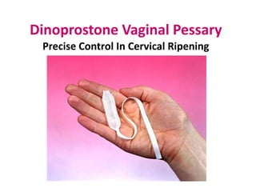
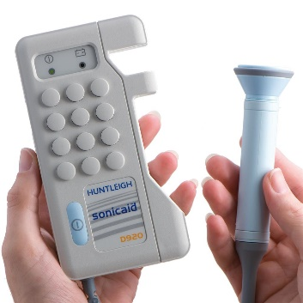
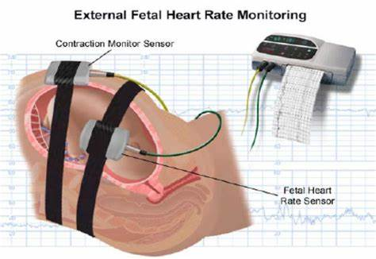
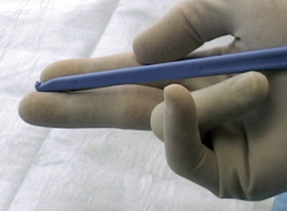

Balloon Catheter Induction

At present in Harrogate this method of induction has recently become available but is available to those who meet a certain criteria and there has been a discussion and agreement with an Obstetric Doctor. Therefore, a separate information leaflet has been developed and will be provided to those who have been offered this method of induction.

Tell your midwife if any of the following happens during your induction:

- You experience regular painful contractions (1 contraction every 5 mins)
- Severe abdominal pain
- A run of 4-5 painful contractions occurring in a 10-minute period
- Your waters break
- You have any bleeding from the vagina
- You have any concerns regarding your baby’s movements

We ask you to take special care when wiping after going to the toilet, after washing yourself and getting on and off the bed to avoid accidental removal of the propess Pessary. If you think that the propess pessary has come out, please inform your midwife immediately as the pessary may need to be reinserted.

Keeping Women and Babies Safe

Labour ward can sometimes be very busy, and this can mean that the next step in your induction can be delayed as we work to keep all women and babies in the department safe. If there are delays in your induction process, the midwife looking after you will explain why there is a delay. You will be kept updated as to when we will be able to continue with your induction.

Throughout the IOL process, regular monitoring of your baby’s heart will be advised as well as your observations.

Please bring sufficient maternity pads to wear during induction to monitor any vaginal fluids you may experience.

Pain relief

Pain-relief is available and will be discussed with you, as are birthing balls and TENS machines should you require them. Baths can also be very helpful to ease the discomfort of early labour.
If you require Entonox (gas and air) during a vaginal examination please ask.

An Information Leaflet regarding the IOL process and pain relief will be provided to you once you are on Pannal Ward and there will be opportunity to ask the midwife caring for any questions.

Frequently asked questions:

If I go into labour with the propess pessary, what happens next?

If you are contracting strongly and regularly, your midwife will ask you to remove the propess pessary and offer you a VE. If you are more than 2cm dilated your care can be transferred to labour ward, as soon as a midwife is available to provide 1:1 care. You may not need to have your waters broken or the syntocinon drip. This will be discussed with you.

How long will the induction take?

The length of time varies individually. Some people go into labour quicker than others. Please be prepared that it could take several days to get to a point that you are able to have your waters broken or get into labour. Bring plenty to read/music/things to do and be aware that walking around is helpful too.

Are there any risks?

Like any drug or medical procedure, induction carries risks, which must be balanced against the potential benefits.

Rarely, women may experience an unusual reaction to the medication and experience strong contractions without a break in between. This usually happens within the first hour after the pessary has been inserted. This is called ‘hyperstimulation’ and the propess pessary will be removed and we advise using the CTG to monitor your baby’s heartbeat. If this happens, a midwife and a doctor will come and explain what is happening and discuss your options with you. The recommendation may be for a medication injection called Terbutaline, the aim of this medication is to relax the smooth muscle of your uterus to reduce the frequency of contractions.

IOL can be associated with an increase in intervention in deliveries, such as requiring an instrumental delivery (e.g. forceps) or a Caesarean section.

Occasionally, despite trying all the induction methods, labour may not begin. If this happens to you, a doctor will discuss the next steps with you. The options might include a further stretch and sweep, resting for 24 hours and starting the propess pessary process again or a Caesarean section.

Can my Partner stay with me?

Your partner is welcome to be with you throughout the induction process. Please see current visitors policy for times. If you are wishing for a second birthing partner to be with you, they can join you once you are transferred to labour ward.

Further Information

For further information about induction of labour and all aspects of pregnancy and childbirth, please talk to your Midwife or Doctor.

References

NICE (2021) Clinical guideline – Induction of labour. For information about NICE clinical guidelines programme you can visit their website at www.nice.org.uk

If you require this information in an alternative language or format (such as Braille, audiotape or large print), please ask the staff who are looking after you.

