Patient Information
Information and Consent on the use of Anti-D Prophylaxis in Pregnancy
About being Rhesus Negative

What are blood groups?

Just as every human being is unique, so are the characteristics of your blood. People can belong to one of four blood groups, A, B, AB and O which are carried on the red blood cells.

There is another important difference in people’s blood called ‘Rhesus factor’, which is also found in the red blood cells. People who are rhesus positive have a substance known as D antigen on the surface of their red blood cells – they are said to be RhD positive.

People who are rhesus negative do not have the D antigen on their blood cells – they are RhD negative. Blood groups and rhesus factors are inherited from a parent. In Europe around 85% of people are RhD positive and 15% RhD negative.

What does this mean for me?

The fetal RhD status blood test has shown that your baby is RhD+ve. Occasionally a few of the baby’s blood cells may enter your blood stream. Because you are RhD-ve the body recognises these blood cells as a foreign substance and produces ‘antibodies’ against it. These antibodies are called anti D. This process is called sensitisation.

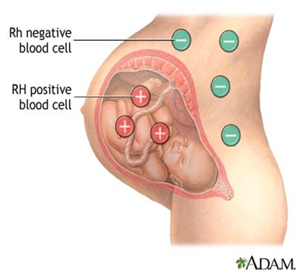
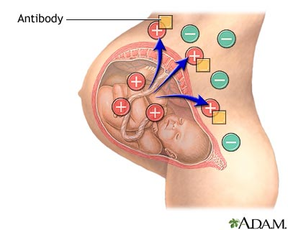

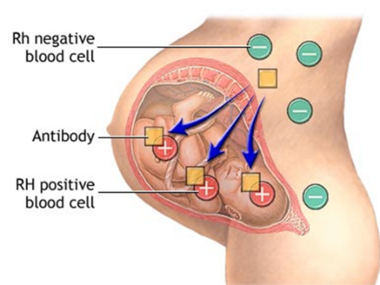
Usually antibodies help to protect the body against harmful things such as bacteria or viruses, stopping them from growing and causing harm to you. Your baby’s blood cells aren’t harmful to you but your body attacks them anyway as it is not used to them.

In future pregnancies the anti-D antibodies can pass through your placenta into the baby and break down the baby’s own blood cells. This results in the baby becoming very poorly and developing a bleeding disorder called haemolytic disease of the newborn (HDN).

The Prevention

How do I prevent these problems?

An injection of Anti-D is used to ‘mop up’ any blood cells from your baby that enter your body. This prevents your body detecting any of baby’s blood cells and means you don’t produce any of your own antibodies. As no antibodies are formed nothing crosses the placenta to affect the baby.

We give you anti-D if you have any events that may have increased the risk of baby’s blood crossing into your blood supply. These are call ‘sensitising events’ and include

- Miscarriage or ectopic pregnancy (complicated)
- Termination of pregnancy (over 12 weeks)
- Invasive tests on the baby
- Turning baby to head down position
- Injury to abdomen
- Bleeding in pregnancy
- Childbirth including Caesarean section birth

If you expereince any of these events please contact us immediately so we can treat you quickly

What is prophylactic anti-D?

The purpose of any prophylaxis is to prevent something happening.

There may be times when baby’s blood crosses into your blood that we can’t detect so it is recommended that all Rhesus negative women pregnant with a Rhesus positive baby are given anti-D prophylactically at 28 – 30 weeks. This is based on the evidence of 30,000 women, showing the reduction of sensitisation in women who received this treatment.

One injection is enough to last you 12 weeks so should protect you from any sensitisation until delivery. It is effective in 99.8 % of women and only ineffective in 0.2%, even less woman had any complications with their baby.

Are there any risks?

Anti-D is made from blood donations outside of the UK. It is made from a part of the blood called plasma that is collected from donors. As with all medicines made from blood there is a possibility of a known virus being passed from the donor to the person receiving the anti-D. However, all donors are thoroughly screened and the production of anti-D includes steps to remove and destroy viruses ensuring that the chance of passing on a virus is very low

There is a small risk of an allergic reaction but this is very rare and we monitor you for 20 minutes shortly after the injection to ensure your wellbeing.

What to expect

What happens now?

We would like to offer you routine antenatal prophylactic anti-D. At your 28 week antenatal check you midwife with take a blood test to check you don’t have any antibodies. If you do not have this blood taken and the sample successfully screened you will not be able to have your anti-D. You will then attend antenatal clinic and have an injection of anti-D.

Do all women need anti-D?

We recommend that all rhesus negative women who are pregnant with a baby who is rhesus positive are given anti-D but you may want to decline it in a few situations (such as those detailed below) but you will be made aware of the risk.

- If you have opted to be sterilised after birth and therefore do not want anti-D
- If it is certain that you will not have another child after the current pregnancy

If you do not have anti-D and you develop antibodies it may become a little more difficult to cross match your blood at any time in your life should you need a blood transfusion

After birth the baby’s blood will be sampled to confirm his/her blood group. If it is confirmed that baby is rhesus positive you will be given another injection of Anti-D known as postnatal prophylaxis.

We will also take a blood sample from you for a Kleihauer test to see how many of the baby’s blood cells are in your system so that we can give an appropriate sized dose. This will ensure that any future pregnancies are protected from you being sensitised.

Bleeding during pregnancy - what happens?

Please let any medical staff treating you during your pregnancy know that you are rhesus negative and that you may need anti-D in the case of bleeding, abdominal injury. Should you have a bleed or any other sensitising event in pregnancy please contact the Maternity Assessment Centre.

It is safer for you to have anti-D than not to have any. It is advisable if the bleed is more than ‘spotting’ to have blood taken for a Kleihauer test, this will allow us to see if any of your baby’s blood has flowed into your blood. It is important to have your blood taken to ensure you have been given enough anti-D to cover the size of bleed.

If you have any further questions about anti-D feel free to ask you midwife or any of the staff at the antenatal clinic.

