Preventing a pressure ulcer during labour and after delivery:
A guide for patients

You have been given this leaflet as you have been identified as being at an increased risk of sustaining a pressure ulcer

A pressure ulcer is an injury to the skin that can occur in anyone who has a prolonged period of immobility such as in labour when you may not mobilise as regularly, has medical devices attached to them or if their sensation is altered due medications, epidurals or anaesthetic. They can occur in a few hours for those most at risk.

Preventing pressure ulcers during labour and birth
Skin damage during labour can occur from:
- Pressure – as a result of sitting or lying for too long without moving, a device such as a catheter, IV lines, oxygen tubing.
- Shearing/friction – similar to a carpet burn, this can occur when moving around the bed on the bedsheets.
- Moisture – moisture such as amniotic fluid (your waters breaking), urine and sweat can cause moisture damage, giving a ‘chapped’ appearance.

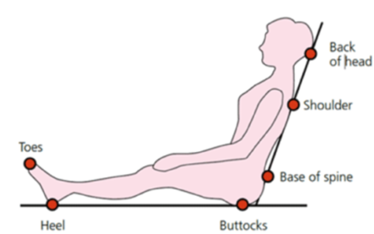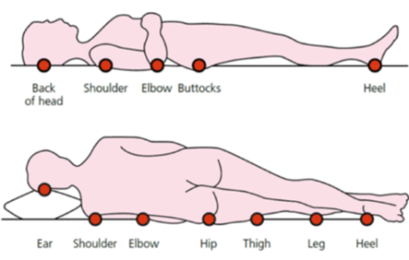

Early signs of a pressure ulcer include:
- Spot of skin becoming discoloured – this may appear red, purple or blue.
- Discoloured patches that don’t turn white when pressed.
- A patch of skin that feels warm, spongy or hard, or painful.

Later signs of a pressure ulcer include:
- An open wound or blister
- A deep wound that reaches the deeper layers of skin or eventually may reach muscle and bone

You can help by:
- Keeping as mobile as possible before labour, during and after the birth of your baby.
- If you have an epidural, it is important to move regularly, ideally every 2 hours (minimum). Ease pressure by tilting to either side and/or raise your bottom off the bed. Your midwife will help with this.
- Change pads regularly to keep your skin dry. Your midwife can support you with this and may prompt you if you have little or no sensation.
- Mobilise as soon as safe to do so (your midwife can assist you with this) following your birth. This will help to relieve the pressure and encourage circulation. You can do this even if you have a urinary catheter in place.
- Maintain hydration and a good diet.
Your midwife will:
- Carry out regular skin assessments during your stay and will advise you accordingly
- Support you to move around and change position.
- Change your pads and bedding regularly during labour and after the birth of your baby.
- Check your bedsheets are flat and you are not sitting on anything that will indent your skin.
Mattresses and Cushions
If you're particularly at risk of getting pressure ulcers or have an ulcer, your midwife or tissue viability nurse will recommend a specially designed static foam, dynamic mattress or a more sophisticated mattress/bed system after you have birthed your baby.
Diet and Nutrition
Eating a healthy, balanced diet that contains enough protein, and a good variety of vitamins and minerals can speed up the healing process. It's also important to avoid dehydration, which can slow down the healing process.
Diabetes
If you have diabetes, it is important that your blood sugar is well controlled – having high blood sugar can increase the chances of having a pressure ulcer or wound infection as this condition slows down the healing process. The heels of your feet should also be elevated to prevent prolonged pressure to them.

Please ask your midwife if you have any concerns or would like more information.
Maternity single point of access: 01423 557531

If you require this leaflet in a different language or format please speak to your Midwife.

