Perineal massage in pregnancy

Perineal massage in pregnancy aims to help soften and increase the elasticity of the perineal tissue in preparation for birth - also helping you to become familiar with your body.
The perineum is the area of tissue between the vagina and anus (back passage), consisting of skin and underlying muscles. During birth, the perineum lengthens and stretches to make room for your baby.
Tears to the vulva, vagina and perineum during birth are common – and can range from small tears of the skin to those involving the muscles of the back passage. Around 9 out of 10 first time mothers will sustain some form of perineal tear when birthing their baby, and of these, around two thirds will require repair. Smaller tears are more common than larger ones – most heal well and do not cause long term problems.
Tears to the perineum, in the majority of cases, cannot be prevented. However efforts can be made to minimise them - and perineal massage can help.

What are the benefits of perineal massage?
Research has shown that those who practice perineal massage were less likely to:
- Sustain a tear that requires stitches
- Require a cut (Episiotomy) at the time of birth
- Sustain a tear that extends to the back passage
- Report ongoing perineal pain at 3 months following birth
Evidence is clearer on these benefits for those giving birth vaginally for the first time. No difference has been shown in the likelihood of instrumental delivery or sexual satisfaction as a result of perineal massage.
Some people are not familiar or comfortable with touching their bodies in this way - and that’s ok.
Other supportive strategies to reduce the likelihood of severe perineal tears include:
- Application of a warm compress against the perineum (by the midwife) during delivery
- Birthing in an all fours, kneeling or side-lying position where possible
- Controlled delivery of your baby through communication with your midwife/obstetrician and perineal support at the time of birth
Your preferences can be discussed with your midwife in pregnancy and in labour.
How is perineal massage performed?
Massage can be performed from 35 weeks of pregnancy – a frequency of around 3-4 times per week has been shown to provide the most benefit. It can feel uncomfortable to begin with but should be stopped if you feel pain.
To begin:
Make yourself comfortable - you may wish to sit propped up with pillows for support, on the sofa or your bed.
Use an unscented oil e.g. olive oil or sweet almond oil. Water based lubricants such as K-Y Jelly are also suitable.
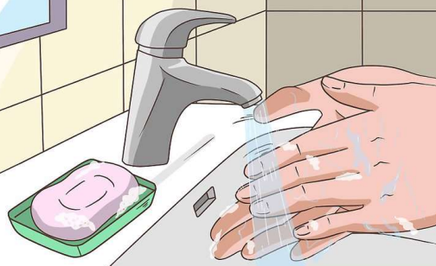
If you are massaging alone you may wish to use a mirror. Your partner can also perform the massage for you if you are both comfortable with this.
1) Wash your hands and ensure finger nails are trimmed - a warm bath can help relax you and your muscles.
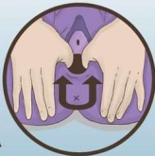
2) Place lubricated thumbs (or fingers) into the vagina, pressing downwards towards the anus and outwards into the vaginal walls. Apply sustained pressure, enough to feel a stretching sensation for around 1 minute. Remember to breathe and relax your pelvic floor muscles.
3) Moving in an upwards and outwards movement, now gently massage the perineum in a rhythmic “U” shape for up to 3 minutes.
Perineal massage is not recommended if you have; Vaginal thrush, warts, herpes or other vaginal infection. Varicose veins in or around the vulva or vagina. Low lying placenta or vaginal bleeding in the second half of pregnancy.

This can be repeated 2-3 times, with a single massage session lasting up to 10 minutes. Listen to your body and avoid continuing through pain.

Please note there is a lack of evidence for pelvic floor training devices and as such we are unable to recommend their use for perineal protection.
Further resources, including information on pelvic floor muscle exercises, postpartum wound healing and useful images:
Royal College of Obstetricians and Gynaecologists (RCOG); Perineal tears and episiotomies in childbirth (https://www.rcog.org.uk/for-the-public/perineal-tears-and-episiotomies-in-childbirth)
Harrogate Health Hub > Pelvic health physiotherapy> Obstetrics (Antenatal and Postnatal Care) (https://www.harrogatehealthhub.co.uk/wmhphysiotherapy)
Pelvic, Obstetric and Gynaecological Physiotherapy (POGP) > Patient information > Pelvic Health Advice (https://thepogp.co.uk/patient_information)
Maternity single point of access: 01423 557531

If you require this leaflet in a different language or format please speak to your Midwife.
Evidence used to support the production of this information:
Beckmann M. M., and Stock O, M (2013) Antenatal perineal massage for reducing perineal trauma. Cochrane Database of Systematic Reviews 2013(4), CD005123. Available at: https://doi.org/10.1002/14651858.CD005123.pub3.
Abdelhakim, A. M., Eldesouky, E., Elmagd, I. A., Mohammed, A., Farag, E. A., Mohammed, A. E., Hamam, K. M., Hussein, A. S., Ali, A. S., Keshta, N. H. A., Hamza, M., Samy, A., and Abdel-Latif, A. A. (2020) Antenatal perineal massage benefits in reducing perineal trauma and postpartum morbidities: a systematic review and meta-analysis of randomized controlled trials. International urogynecology journal, 31(9), pp. 1735–1745. Available at: https://doi.org/10.1007/s00192-020-04302-8

Images used in this leaflet are reproduced under the Creative Commons licence www.wikihow.com

