Brenda McKenzie: Workforce Lead

Adult Inpatient, Emergency Department and Children and Young People Inpatient Ward, Safer Nursing Care Tool (SNCT) Bi-annual Safer Staffing Review.
Safer Staffing rEPORT
May 2025

Contents
Safer Nursing Care Tool (SNCT) Adult Inpatient Wards 3
Situation 3
Background 3
Assessment 4
Oakdale 6
Lascelles 7
Granby 9
Byland 10
Jervaulx 12
Acute Frailty Unit (AFU) 13
Trinity 15
Farndale 17
Wensleydale 18
LTUCC Summary and Overall Requirements 20
Rowan 22
Fountains 24
Littondale now Bolton 25
Nidderdale 27
PSCC Summary and Overall Requirements 28
Emergency Department 29
Background 29
Department Description 29
SNCT Raw Data 30
The current staffing template for the Emergency Department: 30
Budgeted Skill Mix 30
Recruitment and Vacancies 31
Temporary Workforce 31
Discussion, Quality and Performance Data 31
Recommendations 31
Recommended Staffing Model 32
Children and Young People; Woodlands Ward 33
Background 33
Ward Description 33
SNCT Raw Data 33
The current staffing template for Woodlands 33
Budgeted Skill Mix 34
Recommendations 34
Appendix 1 35
Appendix 2 36
Appendix 3 37
Appendix 4 38
Appendix 5 39
Appendix 6 40
Appendix 7 41
Appendix 8 42
Appendix 9 43
Appendix 10 44
Appendix 11 45
Appendix 12 46
Appendix 13 47
Appendix 14 48
Appendix 15 52

Safer Nursing Care Tool (SNCT) Adult Inpatient Wards
Date of SNCT data collection: January 2025
SNCT review meetings: March/April 2025
Author: Brenda Mckenzie (Workforce Lead)

Situation
The Board of Directors are required to receive a Nurse Establishment Review twice a year. This requirement is underpinned by the direction of NHS Improvement (2018) who, in conjunction with the National Quality Board (NQB) (2016), provide a guidance framework containing the key components that should be considered as part of safe staffing review and analysis and in turn enable their nationally endorsed expectations to be met.
HDFT undertook its bi annual adult inpatient safer staffing review using the updated licenced SNCT during the month of January 2025.

Background
The NQB guidance framework (2016) is central in supporting us to develop a workforce that is fit for purpose in the context of it being safe, sustainable and productive. It comprises of a principle document which is supplemented by a suite of additional publications that collectively act as improvement resources.
The principle structure of the NQB expectations are illustrated below and together form a framework that facilitates and supports care to be underpinned by;
• delivery of the right care, first time in the right place
• minimising avoidable harm
• maximising the value of available resources
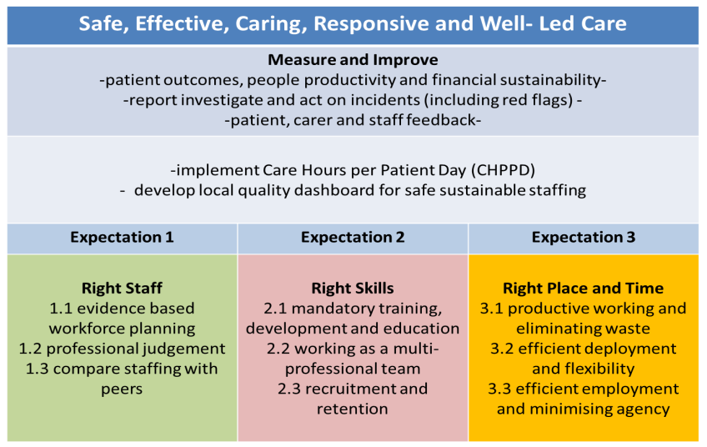

The scope for this Safer Nursing Care Tool (SNCT) data collection encompasses the adult in patient wards. This is the third set of data that has been collected using the updated SNCT which encompasses the new levels of care for patients with an increased dependency in relation to enhanced care requirements.
Teams are reporting increasing levels of enhanced care requirements on a daily basis. Enhanced care relates to; patients who require an increased level of care to prevent them harming themselves, others or absconding. NHSE together with the Shelford Group, have made adaptations to the SNCT tool to incorporate this level of dependency within our patients.
The new levels of care will breakdown the ‘Enhanced Care’ requirements, which will enable us to better monitor and manage how we care for these patients, in addition to aligning establishments to allow for this level of care. At least two data collections will need to be undertaken before the data can be used to triangulate and apply professional judgment to make changes to the ward establishments, in respect of the enhanced care requirements.
Ward budgets were increased to match the outputs of the SNCT in April 2023 and recruitment in to these registered nurse vacancies was extremely successful with many wards now recruiting to turnover. This new establishment aligns HDFT to a 60/40 skill mix ratio and has increased our Care Hours Per Patient Day (CHPPD) to above the national average when compared on Model Hospital.
The January data collection ran for the full month. Prior to these collections, the Workforce Lead facilitated an extensive training programme; an hour training session, that was conducted via MS Teams. All attendees were assessed and were required to pass the inter-rater scoring pass levels. This information is stored on the corporate nursing ‘shared drive’. It is essential that all scorers are trained to ensure that high quality, reliable data is collected. All the data was peer reviewed by the Matrons to validate and add assurance that the data was an accurate reflection of the patients on the ward and activity during the time of the audit.
The SNCT was used with a 60:40 ratio Registered Nurse (RN) to Care Support Worker (CSW) for all wards with exception of Farndale and Wensleydale, our medical admissions ward and Cardiology and Respiratory ward. For these wards a ratio of 70:30 was used to take into account the additional registered nurse input required to manage the acutely unwell patients, which is recommended by the tool with regards to these areas.

Assessment
All wards have daily safety huddles where all staff, including medical and AHP colleagues come together on the ward at a set time to discuss any patient safety risks; for example patients who are risk of falls and consider preventative measures to be put in place.
A detailed description of each ward and specific staffing, agency and quality indicators were available at the review meetings. As recommended by the SNCT; data collected must be triangulated with quality indicators and professional judgement before any changes to establishments are agreed.
The SNCT recommendation is to review the required staffing establishment for each ward bi annually at differing periods/times of the year.
As part of the SNCT process, the Deputy Director of Nursing, Midwifery and AHP’s, Associate Director of Nursing (ADoN) for Planned and Surgical Care and Long Term and Unscheduled Care, Matron and Ward Manager from each ward and the Lead for Workforce Assurance and Compliance met to review the SNCT results, quality data, patient flow information, environmental factors (including PLACE inspection results), and apply professional judgement.
The discussions have been found to be useful in identifying support roles that enhance patient care and improve the working lives of each team. Mainly, Nutritional Assistant roles and Ward Clerk hours. Complaints and concerns in relation to poor hydration and nutrition have reduced. However, most wards have highlighted the need for their Ward Clerk hours to be reviewed to meet the needs of the patients and staff. These administration requirements are being looked in to be the Directorates.
Acuity and dependency data was provided via the ward managers and all other supportive data was provided by analytics, sitereps, Tendable, finance, NHSP and ESR
All clinical areas recognised the challenges and understood the results. Where there were perceived anomalies, these were discussed and professional judgement applied. This was pertinent to some smaller wards, wards with more than 50% side rooms, those with assessment areas and those that require non-invasive ventilation (NIV) as not all patients requiring NIV are admitted to a high observation/critical care environment at HDFT.
Headroom for each ward is calculated at an overall 21% with the following breakdown:
- 14.96% Annual leave
- 1.92% Study leave
- 3.9% Sickness.

LTUCC Results by Ward

Oakdale
Oakdale is a 30 bedded General Medical, Oncology, Haematology & Endocrine ward.
SNCT Data since establishment uplift in April 2023
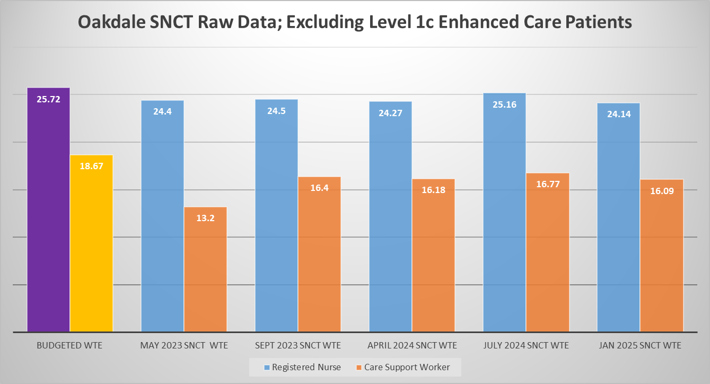
The current staffing template for Oakdale:
 | Early | Late | Night
RN | 5 | 5 | 4
CSW | 4 | 3 | 3
Nutritional Assistant | 7 days 1.4 WTE
MD | 22.5 hours (0.6 WTE)

Budgeted Skill Mix
Band | WTE
7 | 1.0
6 | 4.0
5 | 20.72
3 | 0
2 | 18.67
2 Nutritional Assistant | 1.4
2 Ward Clerk | 1.0

Discussions and data pack
See appendix 1
Recommendations
The SNCT outputs (data, quality metrics and professional judgement) indicate an accurate nursing establishment.
Any enhanced care requirements or unfilled shifts should be reviewed as part of the new safer staffing meetings using SafeCare. This is a safer staffing tool which measures the actual acuity and dependency of the patients on each ward against the availability of staff to ensure that we are deploying the right staff with the right skills at the right place and time. Once the acuity and dependency levels have been peer reviewed by the Matron and professional judgement has been applied to the information within the system, a decision is made as to whether a staff redeployment should be undertaken or additional temporary workforce is required.
Continue to collect twice yearly SNCT data, using the new levels of care SNCT tool. The next data collection will be in June 2025.

Lascelles
Lascelles is a 12 bedded Rehab ward, that is based off the main HDFT site.
SNCT Data since establishment uplift in April 2023
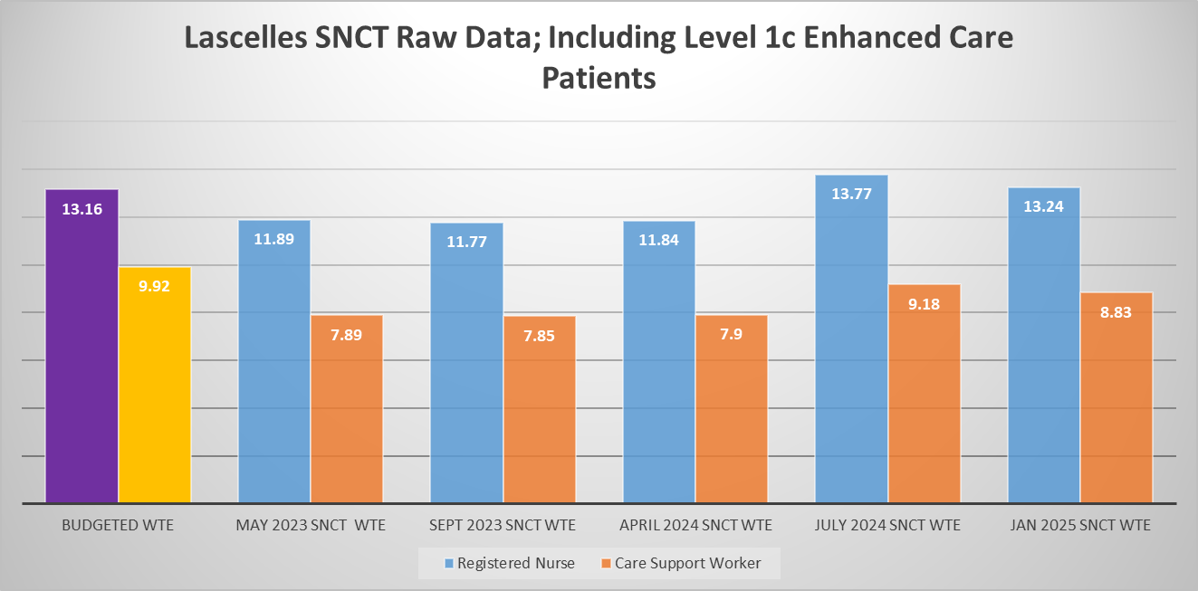

The current staffing template for Lascelles:
 | Early | Late | Night
RN | 3 | 2 | 2
CSW | 2 | 2 | 1
Nutritional Assistant | 5 days 1.0 WTE
MD | 22.5 hours (0.6 WTE)

Budgeted Skill Mix
Band | WTE
7 | 1
6 | 2
5 | 10.16
3 | 0
2 | 8.92
2 Nutritional Assistant | 1.0
2 Ward Clerk | 0.53

Discussion and data pack
See appendix 2
Recommendations
The SNCT outputs (data, quality metrics and professional judgement) indicate an accurate nursing establishment.
Ward Clerk hours were identified as a concern. Additional Ward clerk hours would assist with the administrative tasks that are currently being picked up by clinical staff. This is being picked up by the directorate as part of a wider admin support review.
Any enhanced care requirements or unfilled shifts should be reviewed as part of the new safer staffing meetings using SafeCare. This is a safer staffing tool which measures the actual acuity and dependency of the patients on each ward against the availability of staff to ensure that we are deploying the right staff with the right skills at the right place and time. Once the acuity and dependency levels have been peer reviewed by the Matron and professional judgement has been applied to the information within the system, a decision is made as to whether a staff redeployment should be undertaken or additional temporary workforce is required.
It was acknowledged that Lascelles requires additional Nutritional Assistant hours at the weekend. Currently Lascelles are only funded for a Nutritional Assistant Monday to Friday. This will be looked at as part of the overall reduction in Early/Late factors across the LTUCC wards to accommodate this additional resource.
Continue to collect twice yearly SNCT data, using the new levels of care SNCT tool. The next data collection will be in June 2025

Granby
Granby is a 22 bedded Stroke & Neurology ward.
SNCT Data since establishment uplift in April 2023
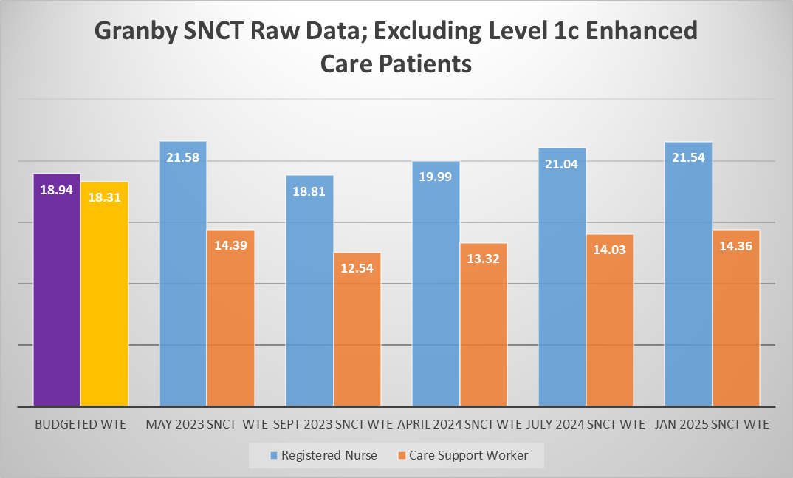
The current staffing template for Granby:
 | Early | Late | Night
RN | 3 | 3 | 3
CSW | 3 | 3 | 3
RN | Early on Mon Thurs & Fri
Nutritional Assistant | 7 days 1.4 WTE
MD | 22.5 hours (0.6 WTE)

Budgeted Skill Mix
Band | WTE
7 | 1.0
6 | 3.70
5 | 14.24
3 | 0.0
2 | 16.91
2 Nutritional Assistant | 1.4
4 Ward Clerk | 0.73
2 ward Clerk | 0.92
7 Specialist Nurse | 1.0
Discussion and data pack
See appendix 3
Recommendations
The SNCT outputs (data, quality metrics and professional judgement) indicate an accurate nursing establishment no changes are required.
Any enhanced care requirements or unfilled shifts should be reviewed as part of the new safer staffing meetings using SafeCare. This is a safer staffing tool which measures the actual acuity and dependency of the patients on each ward against the availability of staff to ensure that we are deploying the right staff with the right skills at the right place and time. Once the acuity and dependency levels have been peer reviewed by the Matron and professional judgement has been applied to the information within the system, a decision is made as to whether a staff redeployment should be undertaken or additional temporary workforce is required.
Continue to collect twice yearly SNCT data, using the new levels of care SNCT tool. The next data collection will be in June 2025.

Byland
Byland is a 30 bedded Frailty ward.
SNCT Data since establishment uplift in April 2023
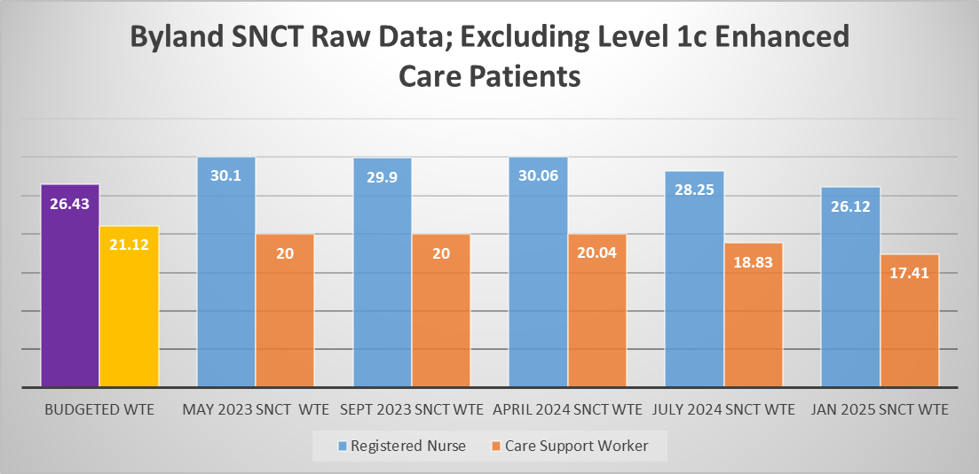

The current staffing template for Byland:
 | Early | Late | Night
RN | 5 | 5 | 4
CSW | 4 | 4 | 3
Nutritional Assistant | 7 days 1.4 WTE
MD | 22.5 hours (0.6 WTE)

Budgeted Skill Mix
Band | WTE
7 | 1.0
6 | 4.0
5 | 21.43
3 | 0.0
2 | 19.72
2 Nutritional Assistant | 1.4
2 Ward Clerk | 1.0

Discussion and data pack
See appendix 4
Recommendations
The SNCT outputs (data, quality metrics and professional judgement) indicate an accurate nursing establishment for the baseline requirements. However, the data shows that this frailty ward has been using an additional CSW on a Night shift for the past 12 months. The requirement was reported essential due to the Enhanced Care needs of the patients, which was not able to be mitigated through other means.
Any enhanced care requirements or unfilled shifts should be reviewed as part of the new safer staffing meetings using SafeCare. This is a safer staffing tool which measures the actual acuity and dependency of the patients on each ward against the availability of staff to ensure that we are deploying the right staff with the right skills at the right place and time. Once the acuity and dependency levels have been peer reviewed by the Matron and professional judgement has been applied to the information within the system, a decision is made as to whether a staff redeployment should be undertaken or additional temporary workforce is required.
It has been agreed that the overall SNCT changes within LTUCC will be taken to the Establishment Review Panel with a QIA. These changes will be within the Directorates financial envelope, using reductions in staffing within areas where the SNCT shows that the acuity and dependency is lower and moving to the areas that have highlighted additional requirements.
Continue to collect twice yearly SNCT data, using the new levels of care SNCT tool. The next data collection will be in June 2025.

Jervaulx
Jervaulx is a 30 bedded Frailty ward.
SNCT Data since establishment uplift in April 2023
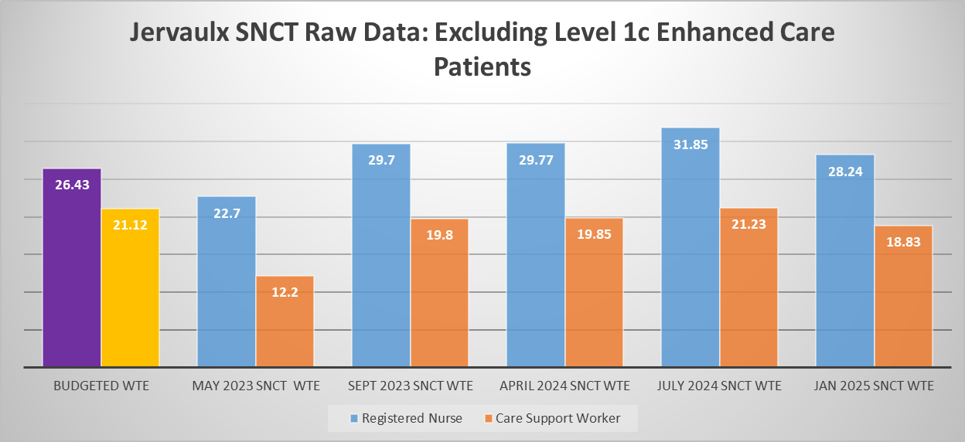

The current staffing template for Jervaulx:
 | Early | Late | Night
RN | 5 | 5 | 4
CSW | 4 | 4 | 3
Nutritional Assistant | 7 days 1.4 WTE
MD | 22.5 hours (0.6 WTE)

Budgeted Skill Mix
Band | WTE
7 | 1.0
6 | 4.0
5 | 21.43
3 | 0.0
2 | 19.72
2 Nutritional Assistant | 1.4
2 Ward Clerk | 0.6
Discussion and data pack
See appendix 5

Recommendations
The SNCT outputs (data, quality metrics and professional judgement) indicate an accurate nursing establishment for the baseline requirements. However, the data shows that this frailty ward has been using an additional CSW on a Night shift for the past 12 months. The requirement was reported essential due to the Enhanced Care needs of the patients, which was not able to be mitigated through other means.
Any enhanced care requirements or unfilled shifts should be reviewed as part of the new safer staffing meetings using SafeCare. This is a safer staffing tool which measures the actual acuity and dependency of the patients on each ward against the availability of staff to ensure that we are deploying the right staff with the right skills at the right place and time. Once the acuity and dependency levels have been peer reviewed by the Matron and professional judgement has been applied to the information within the system, a decision is made as to whether a staff redeployment should be undertaken or additional temporary workforce is required.
It has been agreed that the overall SNCT changes within LTUCC will be taken to the Establishment Review Panel with a QIA. These changes will be within the Directorates financial envelope, using reductions in staffing within areas where the SNCT shows that the acuity and dependency is lower and moving to the areas that have highlighted additional requirements.
Continue to collect twice yearly SNCT data, using the new levels of care SNCT tool. The next data collection will be in June 2025.

Acute Frailty Unit (AFU)
AFU is an 18 Frailty Admissions Ward with 2 assessment beds. However, due to the demand on Frailty beds the ward has been open at escalation since winter 23/24 at a total of 23 beds.

SNCT Data since establishment uplift in April 2023
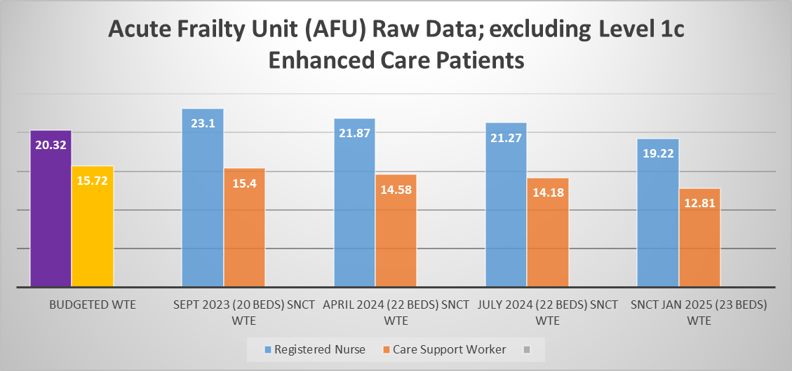
The current staffing template for AFU (not including escalation beds):
 | Early | Late | Night
RN | 4 | 4 | 3
CSW | 3 | 3 | 2
Nutritional Assistant | 7 days 1.4 WTE
MD | 22.5 hours (0.6 WTE)

Budgeted Skill Mix
Band | WTE
7 | 1.0
6 | 4.38
5 | 14.94
3 | 1.76
2 | 12.56
2 Nutritional Assistant | 1.4
2 Ward Clerk | 0.60

Discussion and data pack
See appendix 6
The SNCT outputs (data, quality metrics and professional judgement) indicate an accurate nursing establishment for the funded baseline beds (18+2). However, when open at 23 beds an additional RN and CSW is required on a night shift and CSW on the early shift.
Recommendations
The SNCT outputs (data, quality metrics and professional judgement) indicate no changes to the establishment as a result of this data collection.
The directorate should build a business case to encompass all of the wards, Ward Clerk requirements.
Any enhanced care requirements or unfilled shifts should be reviewed as part of the new safer staffing meetings using SafeCare. This is a safer staffing tool which measures the actual acuity and dependency of the patients on each ward against the availability of staff to ensure that we are deploying the right staff with the right skills at the right place and time. Once the acuity and dependency levels have been peer reviewed by the Matron and professional judgement has been applied to the information within the system, a decision is made as to whether a staff redeployment should be undertaken or additional temporary workforce is required.
Continue to collect twice yearly SNCT data, using the new levels of care SNCT tool. The next data collection will be in June 2025.

Trinity
Trinity is a 19 bedded Rehab Ward, based within Ripon Hospital (off the main HDFT Hospital site).
SNCT Data since establishment uplift in April 2023

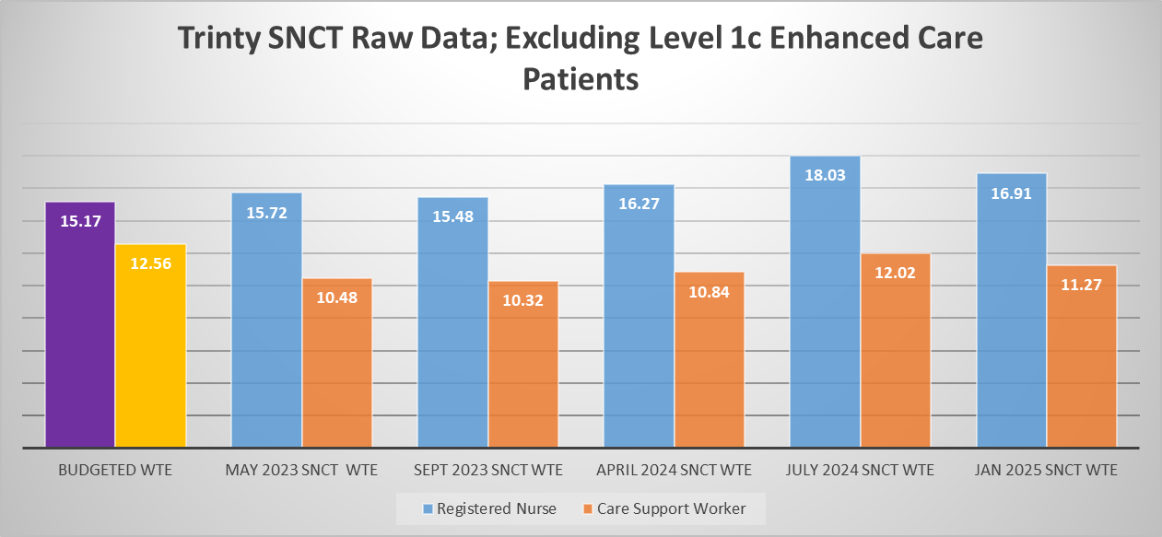

The current staffing template for Trinity
 | Early | Late | Night
RN | 3 | 3 | 2
CSW | 3 | 2 | 2
RN | Early RN every Monday (MDT)
MD | 22.5 hours (0.6 WTE)

Budgeted Skill Mix
Band | WTE
7 | 1.0
6 | 2.64
5 | 11.53
3 | 0.0
2 | 12.56
2 Nutritional Assistant | 0.0
2 Ward Clerk | 1.92

Discussion
See appendix 7
Recommendations
The SNCT outputs (data, quality metrics and professional judgement) indicate an accurate nursing establishment.
Any unfilled shifts should be reviewed as part of the new safer staffing meetings using SafeCare. This is a safer staffing tool which measures the actual acuity and dependency of the patients on each ward against the availability of staff to ensure that we are deploying the right staff with the right skills at the right place and time. Once the acuity and dependency levels have been peer reviewed by the Matron and professional judgement has been applied to the information within the system, a decision is made as to whether a staff redeployment should be undertaken or additional temporary workforce is required.
Continue to collect twice yearly SNCT data, using the new levels of care SNCT tool. The next data collection will be in June 2025.

Farndale
Farndale is a 23 bedded Medical Admissions ward.
SNCT Data and Changes in Nursing Establishment
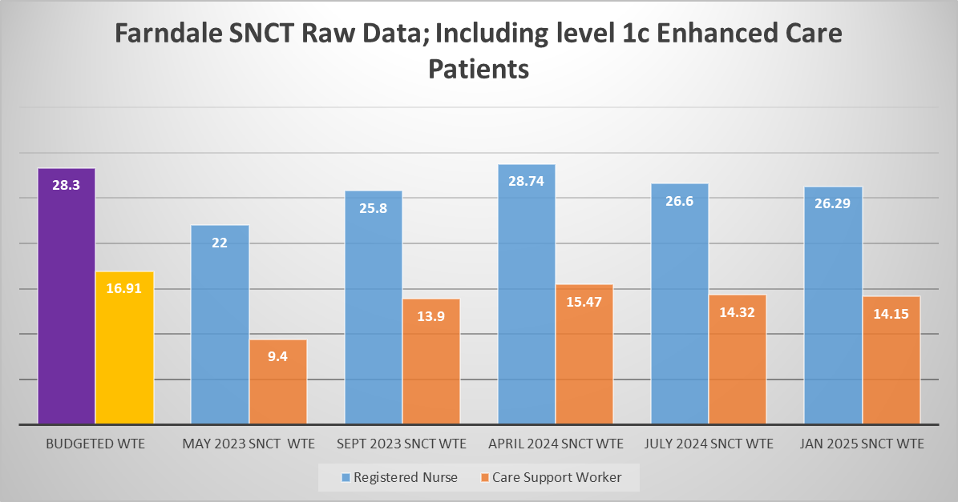
The current staffing template for Farndale:
 | Early | Late | Night
RN | 5 | 5 | 5
CSW | 3 | 3 | 3
Nutritional Assistant | 7 days 1.4 WTE
MD | 22.5 hours (0.6 WTE)

Budgeted Skill Mix
Band | WTE
7 | 1.0
6 | 6.44
5 | 20.86
3 | 0.0
2 | 16.91
2 Nutritional Assistant | 1.4
2 Ward Clerk | 2.07

Discussion and data pack
See appendix 8
Recommendations
The SNCT outputs (data, quality metrics and professional judgement) indicate an accurate nursing establishment.
Any enhanced care requirements or unfilled shifts should be reviewed as part of the new safer staffing meetings using SafeCare. This is a safer staffing tool which measures the actual acuity and dependency of the patients on each ward against the availability of staff to ensure that we are deploying the right staff with the right skills at the right place and time. Once the acuity and dependency levels have been peer reviewed by the Matron and professional judgement has been applied to the information within the system, a decision is made as to whether a staff redeployment should be undertaken or additional temporary workforce is required.
Continue to collect twice yearly SNCT data, using the new levels of care SNCT tool. The next data collection will be in June 2025.

Wensleydale
This is a new Cardio-respiratory ward with MECU beds. This is the second SNCT data collection since the ward opened.
SNCT Data since New Ward Budget Set in April 2023
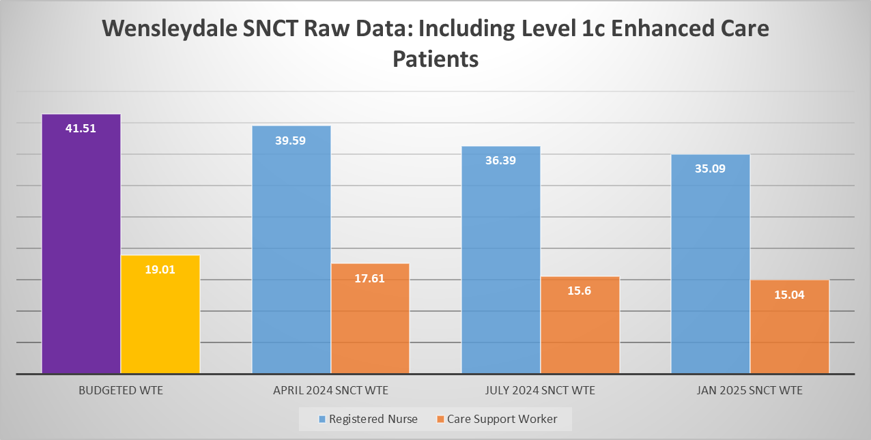
The current staffing template for Wensleydale:
 | Early | Late | Night
RN | 7 | 7 | 7
CSW | 3 | 3 | 3
Nutritional Assistant | 7 days 1.4 WTE
MD | 22.5 hours (0.6 WTE)

Budgeted Skill Mix
Band | WTE
7 | 1
6 | 12.51
5 | 28.0
3 | 0.0
2 | 17.61
2 Nutritional Assistant | 1.4
2 Ward Clerk | 1.4

Discussion
See appendix 9
Recommendations
The SNCT outputs (data, quality metrics and professional judgement) indicate a safe nursing establishment. However, the three data collections since the establishment was set suggests that there could be a reduction in Early/Late factors without a negative impact on quality, safety or performance. This will be factored as part of the LTUCC review that will be taken to the Establishment Review Panel.
Any unfilled shifts should be reviewed as part of the new safer staffing meetings using SafeCare. This is a safer staffing tool which measures the actual acuity and dependency of the patients on each ward against the availability of staff to ensure that we are deploying the right staff with the right skills at the right place and time. Once the acuity and dependency levels have been peer reviewed by the Matron and professional judgement has been applied to the information within the system, a decision is made as to whether a staff redeployment should be undertaken or additional temporary workforce is required.
Continue to collect twice yearly SNCT data, using the new levels of care SNCT tool. The next data collection will be in June 2025.

LTUCC Summary and Overall Requirements

Possible reductions in establishment are mainly due to a required reduction in the Early/Late factor, which is not being utilised during the rostering process and causing issues with assignment of shifts and accurate monitoring of key performance indicators.
Ward | Reductions | Increases
Oakdale | No Reductions | No Increases
Granby | - Remove 1 X RN Early/Late Factor (3 hours) | No Increases
Farndale | No Reductions | No Increases
Wensleydale | - Remove 2 X RN (Band 5) Early/Late Factors (6 hours)  - Remove 1 X CSW (Band 3) Early/Late Factors (3 hours) | No Increases
Byland | - Remove 1 X RN Early/Late Factor (3 hours) | Increase 1 X CSW 11 hour Night shift
Jervaulx | - Remove 1 X RN Early/Late Factor (3 hours) | Increase 1 X CSW 11 hour Night shift
Acute Frailty Unit | No Reductions | No Increases
Trinity | No Reductions | No Increases
Lascelles | No Reductions | Increase Nutritional Assistant hours to include provision for Sat and Sun (7.5 hours shifts)  Increase Ward Clerk Hours by 15 hours per week (0.4 WTE)

The changes recommended by the outputs of the review meetings are minor establishment changes, within the existing budgetary allocation. These changes are being presented to the establishment review panel on the 20th May 2025. The financial details are demonstrated below.

PSCC Results by Ward

Rowan
Rowan is an Elective Orthopaedic ward with 16 beds. As highlighted by the SNCT results, the full bed capacity is not yet being utilised. However, each data collection indicates greater usage. There is a minimum baseline staffing requirement to maintain quality, safety and performance. Therefore the Budgeted establishment in not able to be changed, but can be flexed, using professional judgement by senior nursing colleagues as part of the daily safer staffing professional judgement redeployment.

SNCT Data since New Ward Budget Set in April 2023

The current staffing template for Rowan:
 | Early | Late | Night
RN | 2 | 2 | 2
CSW | 2 | 2 | 1
MD | 22.5 hours (0.6 WTE)

Budgeted Skill Mix
Band | WTE
7 | 1.0
6 | 3.0
5 | 8.1
3 | 0.0
2 | 8.92
2 Nutritional Assistant | 0.0
2 Ward Clerk | 1.19

Discussion
See appendix 10
Recommendations
The SNCT outputs (data, quality metrics and professional judgement) indicate an accurate nursing establishment.
Any unfilled shifts should be reviewed as part of the new safer staffing meetings using SafeCare. This is a safer staffing tool which measures the actual acuity and dependency of the patients on each ward against the availability of staff to ensure that we are deploying the right staff with the right skills at the right place and time. Once the acuity and dependency levels have been peer reviewed by the Matron and professional judgement has been applied to the information within the system, a decision is made as to whether a staff redeployment should be undertaken or additional temporary workforce is required. It was agreed that Rowan would not recruit in to the remaining 2 WTE care support worker positions until activity increases. However, the budget and staffing template would remain the same.
Continue to collect continuous SNCT data, using the new levels of care SNCT tool. The next data review of this data will be in June 2025.

Fountains
Fountains is a 28 bedded Trauma and Orthopaedics ward (Non elective).
SNCT Data since New Ward Budget Set in April 2023

The current staffing template for Fountains:
 | Early | Late | Night
RN | 5 | 5 | 4
CSW | 4 | ¾ | 3
Nutritional Assistant | 7 days 1.0 WTE
MD | 22.5 hours (0.6 WTE)

Budgeted Skill Mix
Band | WTE
7 | 1.0
6 | 3.0
5 | 21.88
3 Patient Liaison | 1.0
3 CSW | 0.0
2 | 18.45
2 Nutritional Assistant | 1.0
2 Ward Clerk | 1.0

Discussion and data pack
See appendix 11
Recommendations
The SNCT data and triangulation supports the current funded nursing establishment and skill mix.
Any unfilled shifts should be reviewed as part of the new safer staffing meetings using SafeCare. This is a safer staffing tool which measures the actual acuity and dependency of the patients on each ward against the availability of staff to ensure that we are deploying the right staff with the right skills at the right place and time. Once the acuity and dependency levels have been peer reviewed by the Matron and professional judgement has been applied to the information within the system, a decision is made as to whether a staff redeployment should be undertaken or additional temporary workforce is required.
Continue to collect bi annual SNCT data, using the new levels of care SNCT tool. The next data collection will be in June 2025.

Littondale now Bolton
Littondale is a 24 bedded, male surgical and gastroenterology ward with a 8 bedded Surgical Assessment Unit.
SNCT Data since New Ward Budget Set in April 2023
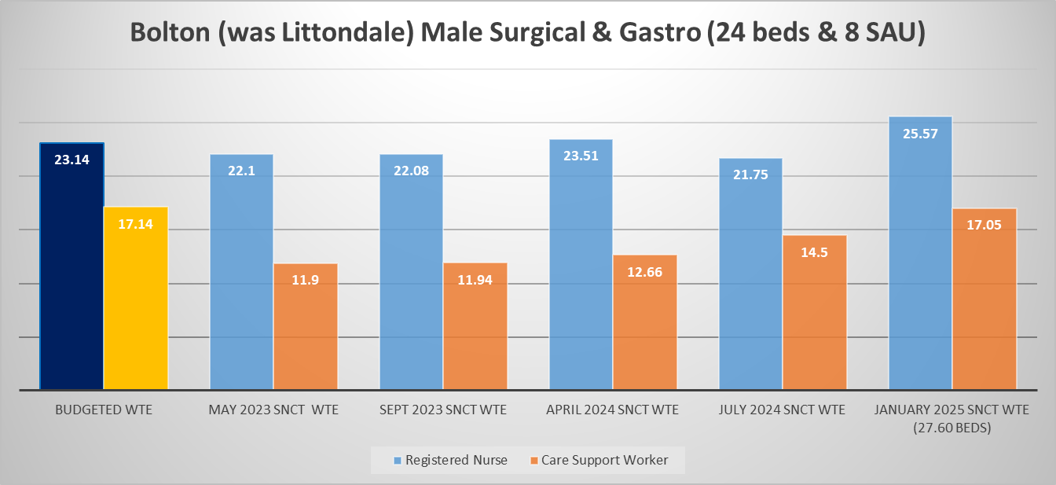

The current staffing template for Littondale. This staffing model is for the 24 beds and the 8 beds in the Surgical Assessment Unit:
 | Early | Late | Night
RN | 5 | 5 | 3
CSW | 4 | 4 | 3
Nutritional Assistant | 7 days 1.0 WTE
MD | 22.5 hours (0.6 WTE)

Budgeted Skill Mix
Band | WTE
7 | 1.0
6 | 3.15
5 | 18.99
3 CSW | 8.92
2 | 10.80
2 Nutritional Assistant | 1.0
2 Ward Clerk | 1.0

Discussion and data pack
See appendix 12
Recommendations
The SNCT data and triangulation supports the current funded nursing establishment and skill mix.
Any unfilled shifts should be reviewed as part of the new safer staffing meetings using SafeCare. This is a safer staffing tool which measures the actual acuity and dependency of the patients on each ward against the availability of staff to ensure that we are deploying the right staff with the right skills at the right place and time. Once the acuity and dependency levels have been peer reviewed by the Matron and professional judgement has been applied to the information within the system, a decision is made as to whether a staff redeployment should be undertaken or additional temporary workforce is required.
Continue to collect bi annual SNCT data, using the new levels of care SNCT tool. The next data collection will be in June 2025.

Nidderdale
Nidderdale is a 30 bedded female, multi specialist surgical ward.
SNCT Data since New Ward Budget Set in April 2023
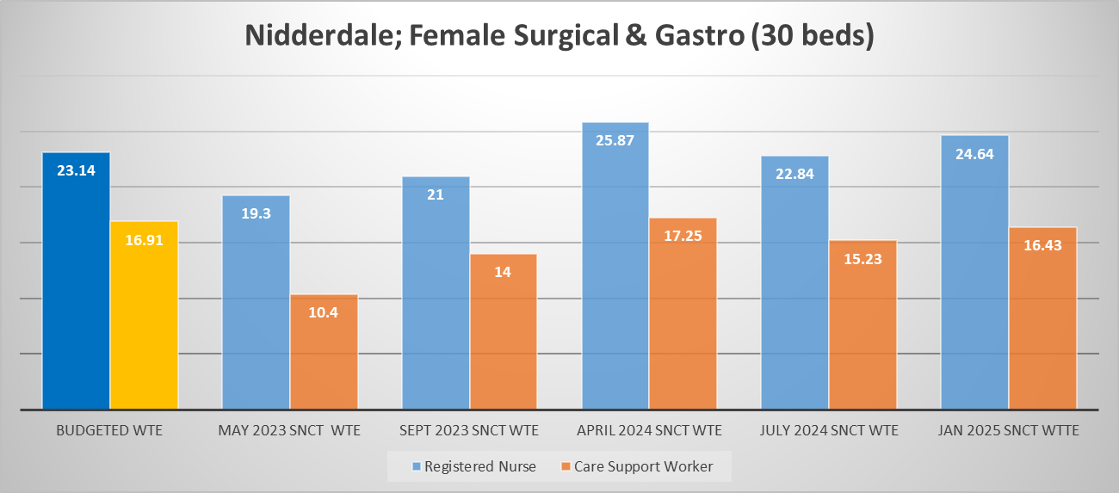

The current staffing template for Nidderdale:
 | Early | Late | Night
RN | 5 | 5 | 4
CSW | 3 | 3 | 3
Nutritional Assistant | 7 days 1.0 WTE
MD | 22.5 hours (0.6 WTE)

Budgeted Skill Mix
Band | WTE
7 | 1.0
6 | 4.0
5 | 18.14
3 | 0.0
2 | 14.32
2 Nutritional Assistant | 1.0
2 Ward Clerk | 1.0

Discussion
See appendix 13

Recommendations
The SNCT data and triangulation supports the current funded nursing establishment and skill mix.
Any enhanced care requirements or unfilled shifts should be reviewed as part of the new safer staffing meetings using SafeCare. This is a safer staffing tool which measures the actual acuity and dependency of the patients on each ward against the availability of staff to ensure that we are deploying the right staff with the right skills at the right place and time. Once the acuity and dependency levels have been peer reviewed by the Matron and professional judgement has been applied to the information within the system, a decision is made as to whether a staff redeployment should be undertaken or additional temporary workforce is required.
Continue to collect bi annual SNCT data, using the new levels of care SNCT tool. The next data collection will be in June 2025.

PSCC Summary and Overall Requirements

No Changes are required to the PSCC establishment from the outputs of this bi-annual review. Safe staffing assurance has been demonstrated.

Emergency Department

Background
Following a National Institute of Clinical Excellence (NICE) endorsed Safer Nursing Care Tool (SNCT) review in 2023, significant investment supported the recommended nurse staffing establishments within the Emergency Department. Therefore ensuring that HDFT are delivering “the right staff, with the right skills, in the right place at the right time” The National Quality Board (NQB) (2018) and addressing the quality, safety and performance issues and align to the overall trust strategy; best quality, safest care and great start in life.
The latest SNCT data collection took place in January 2025 with triangulation of the results with quality data and professional judgement in February 2025.

Department Description
The Emergency Department (ED) is open 24 hours a day, 7 days a week delivering unscheduled care for acutely ill/injured adults and children. The department consists of two areas (ED1 and ED2). ED1 manages those patients presenting with major medical conditions, ED2 manages patients presenting with Minor Illness and injuries.
Management structure: The ED is led by a Triumvirate leadership structure consisting of a Clinical Lead, Service Manager and Matron. The matron is supported by 2 WTE Band 7 Department Managers who have 45 hours management time allocated per week. The workforce model ensures that there will be a band 7 Registered Nurse ‘in charge’ of each shift.
The NIC will consider staff experience, skill and competence when allocating staff to work areas, considering skill mix, workload, clinical priorities and patient dependency. The NIC is responsible for overseeing the team of Registered Nurses and Care Support Workers, ED reception clerks, patient flow in and out of the department (supported by a non-clinical patient flow coordinator and ED senior doctor: EPIC), and having an overview of patient acuity within the department. The NIC works closely with the EPIC and can escalate any concerns regarding prioritisation of patients to be seen. The NIC of each shift allocates staff to patient care areas on a shift basis:
- Streaming
- Triage
- Resuscitation room (2 enclosed cubicles and 1 curtained cubicle)
- Cubicle areas 1 -15 & ED2
- Fit 2 Sit
- YAS Rapid Initial Assessment Treatment

SNCT Raw Data
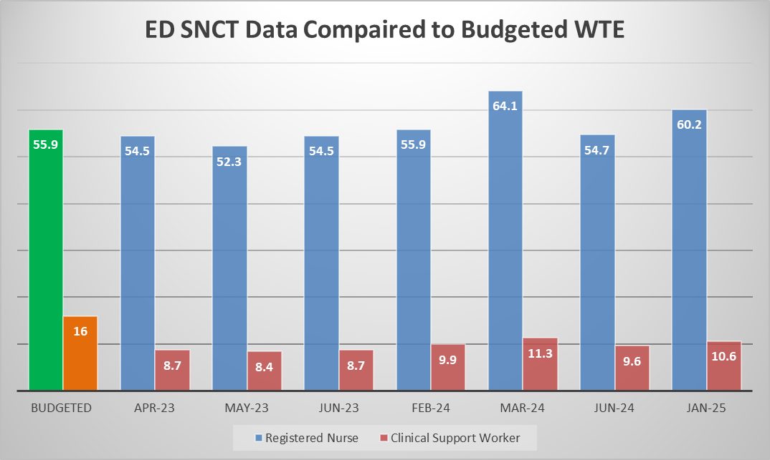

The current staffing template for the Emergency Department:
 | Early | Late | LD | Night | Twilight
RN | 3 | 3 | 7 | 10 | 0
CSW | 2 | 2 | 1 | 3 | 0
Management Days | 45 hours a week (1.2WTE)
Practice Education | 67.5 hours a week (1.8 WTE)

Budgeted Skill Mix
Band | WTE
Band 7 Manager | 2.0
Band 7 Clinical | 5.35
Band 6 Clinical | 12.4
Band 6 Practice Educator | 1.8
Band 5 Clinical | 34.35
Band 3 Support Staff | 16

Recruitment and Vacancies
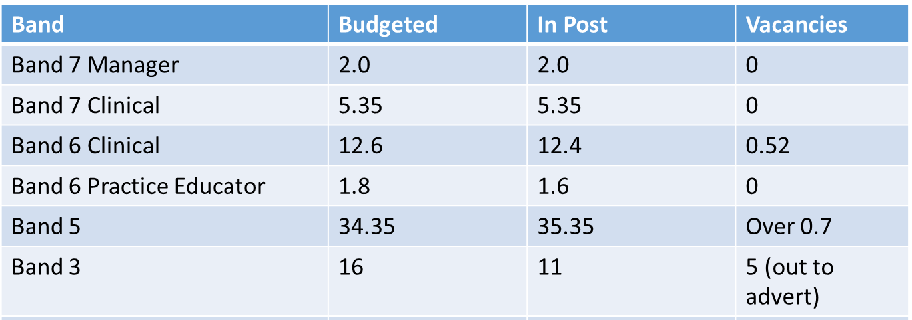
There has been some excellent work within the ED to ensure that the right people are recruited in to the vacant positions. This has assisted the reduction in temporary workforce usage and for the first time in March 2025 ED has reached a zero usage position for Agency.
The Band 2 CSW’s underwent a re-banding review and are now Band 3 CSW’s. The focus is now to recruit in to these remaining vacant Band 3 positions.

Temporary Workforce
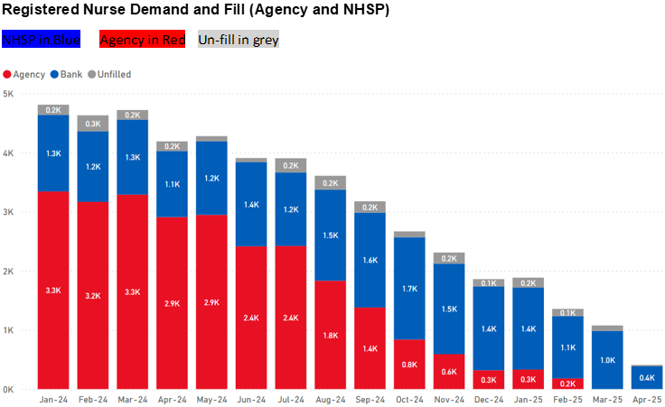

Discussion, Quality and Performance Data
See appendix 14

Recommendations
The SNCT data and triangulation supports the current funded nursing establishment and skill mix. However, the data has suggested that the ED requires a different distribution of shift times. It is recommended that One Long Day Band 5 Registered Nurse is changed to a Twilight shift. The Twilight shift would cover from 14:00hrs – 02:00hrs. This change does not incur any financial impact and is affordable within the existing ED workforce budget.

Recommended Staffing Model

 | Early | Late | LD | Night | Twilight
RN | 3 | 3 | 6 | 10 | 1
CSW | 2 | 2 | 1 | 3 | 0
Management Days | 45 hours a week (1.2WTE)
Practice Education | 67.5 hours a week (1.8 WTE)

These changes should be presented to the Establishment review panel on 20th May along with a Quality Impact Assessment.
Continue to collect bi annual SNCT data, using the SNCT tool. The next data collection will be in May 2025.
Ensure effective rostering to meet the Key Performance Indicators and workforce model outlined in the Business Case.

Children and Young People; Woodlands Ward

Background
Following a National Institute of Clinical Excellence (NICE) endorsed Safer Nursing Care Tool (SNCT) (2021) review, undertaken biannually. The scope for this SNCT data collection encompasses the Children and Young People inpatient ward. To note, there is another review of Children’s and Young People inpatient services and pathways with the Emergency Department (ED). Specifically in relation to delivering “the right staff, with the right skills, in the right place at the right time” The National Quality Board (NQB) (2018). Therefore, the results of this review are awaiting triangulation with this additional piece of work.
Data was collected in January 2025 with triangulation of the results with quality data and professional judgement in February 2025.

Ward Description
Woodlands ward is a 16 bedded general paediatric ward admitting acute and elective medical and surgical patients. A Children’s Assessment Unit (CAU) is situated within the ward which can flex the ward to a 22 bedded unit. The ward admits children and young people (CYP) from birth to 17 years old from various referral routes, general practice, emergency department, health visitors, outpatients, midwifes etc. The ward has 3 bays of 4 beds but one is the CAU and 10 side rooms, one of which acts as a high dependency unit (HDU).

SNCT Raw Data

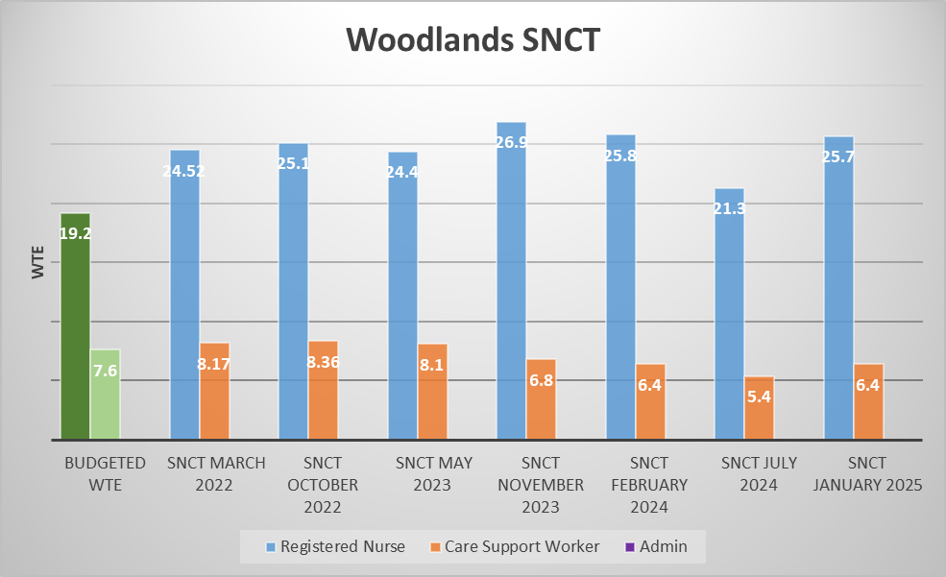

The current staffing template for Woodlands
Play Specialist  Practice Education  Admin  Management Time | 1.0 wte  0.2 wte  1.0 wte  0.8 wte
Monday to Friday
 | Early | Late | Night
RN | 4 | 3 | 3
CSW | 1 | 1 | 1

Saturday to Sunday
 | Early | Late | Night
RN | 3 | 3 | 3
CSW | 1 | 1 | 1

Budgeted Skill Mix
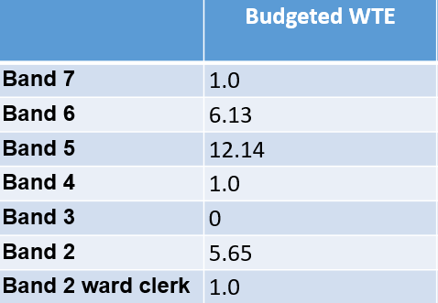
The Band 2 CSW’s are in the process of being re banded to Band 3 CSW’s. This was a part of the national Band 2 to Band 3 review.
Discussion
See appendix 15

Recommendations
The SNCT data and triangulation supports a slight increase in establishment. However, this requirement relates to the provision to support the Children’s Assessment Unit (CAU) which is still being worked through by the PSCC directorate.
The SNCT outputs (data, quality metrics and professional judgement) indicate an accurate nursing establishment for the current Woodlands Ward requirements and that no changes are proposed as a result of this review.
A separate business case is being worked up by the Ward Manager and Matron for C&YP to support the increase in Practice Education provision, in line with regional and national recommendations and an options appraisal is being undertaken regarding the most appropriate model to run the CAU in the future.
Continue to collect bi annual SNCT data, using the SNCT tool. The next data collection will be in June 2025.
Ensure effective rostering to meet the Key Performance Indicators.

Appendix 1

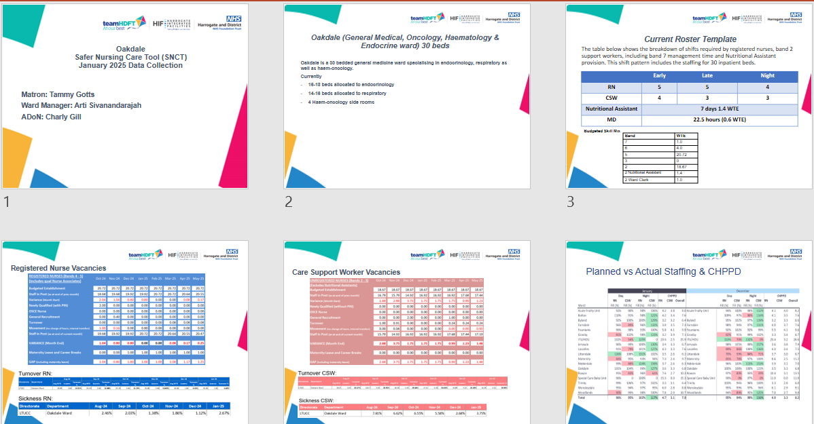

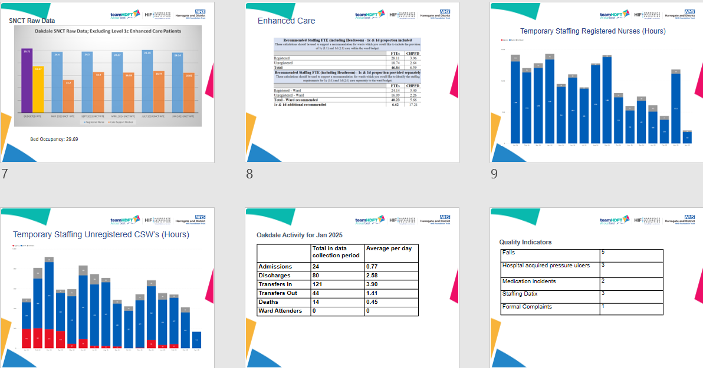

Appendix 2

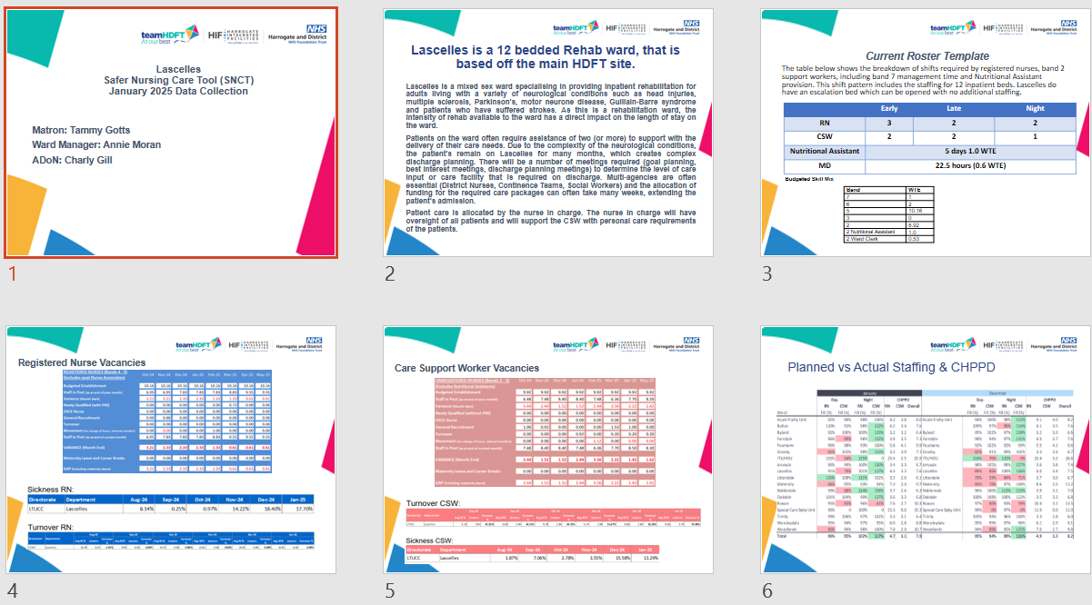
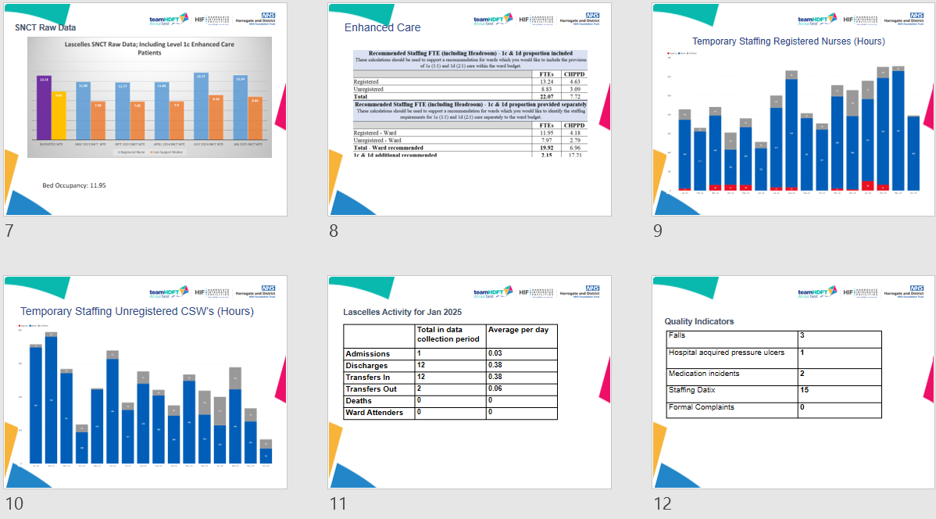

Appendix 3
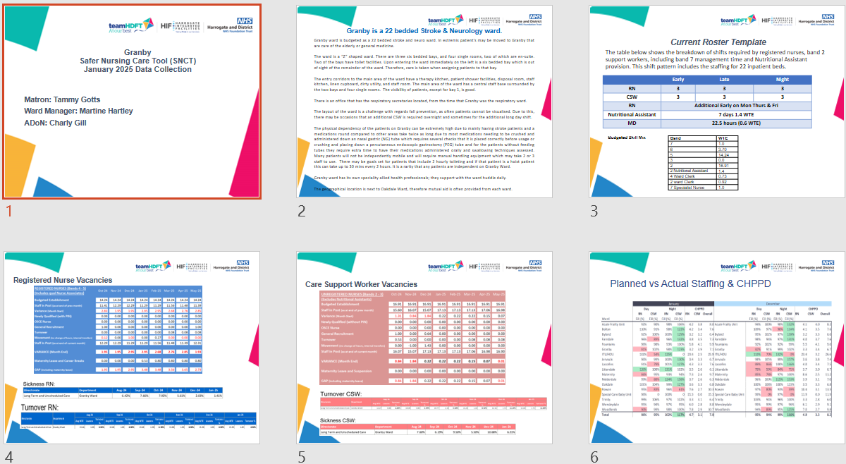
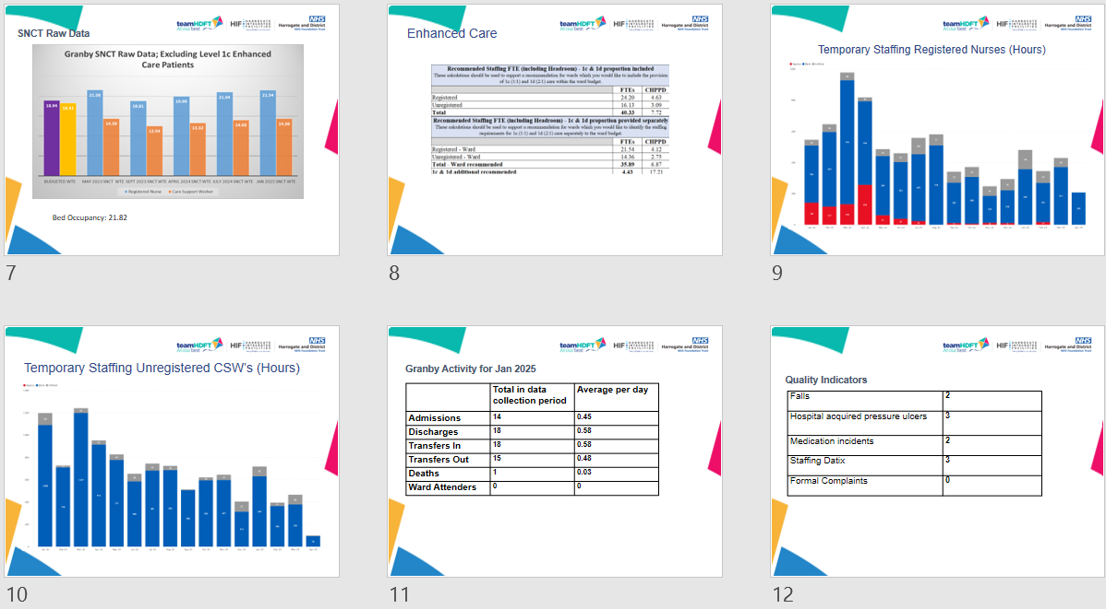

Appendix 4

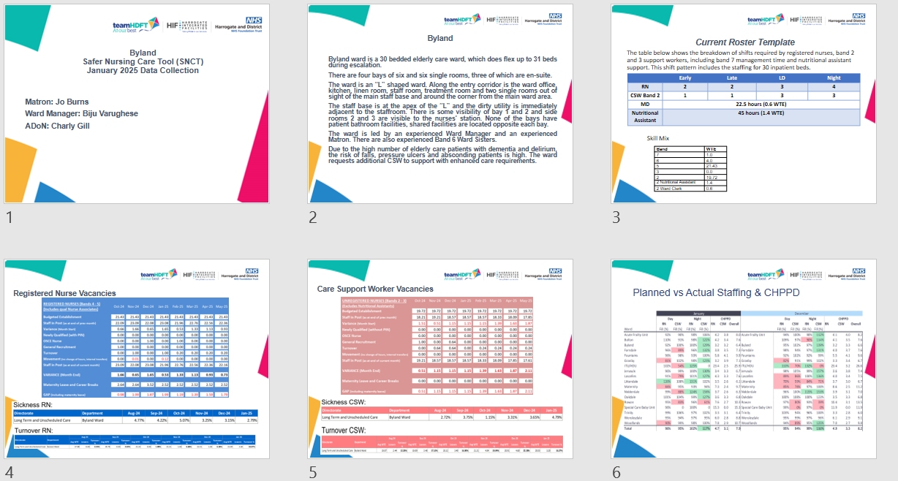
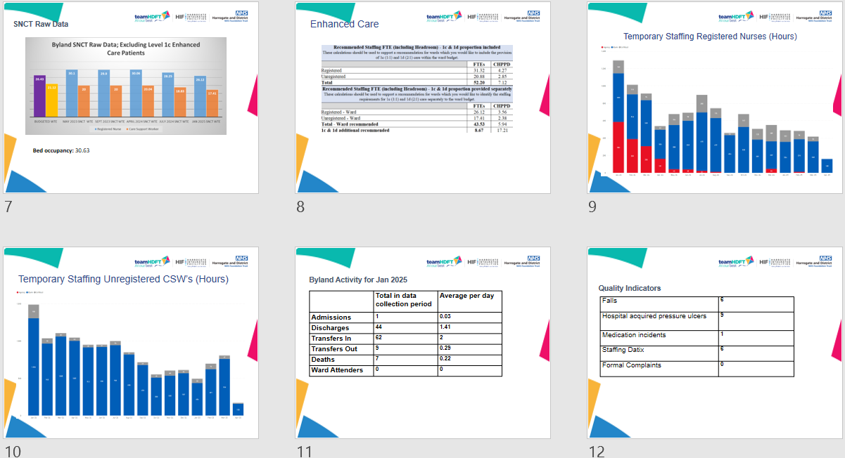

Appendix 5
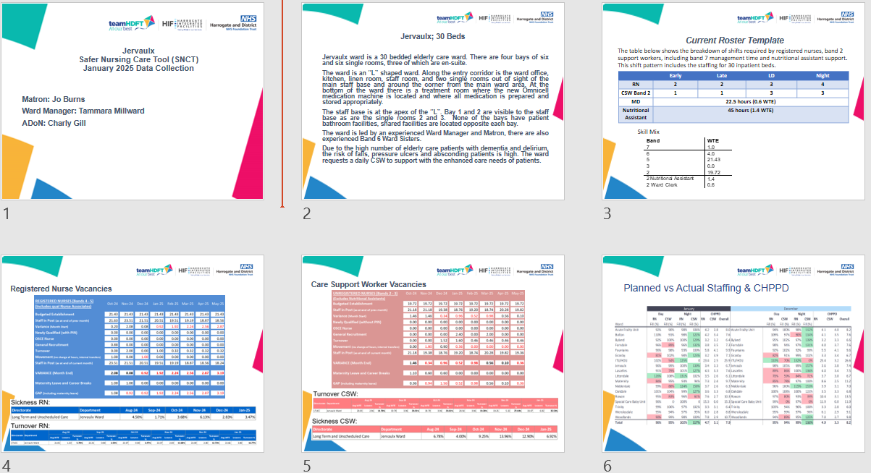
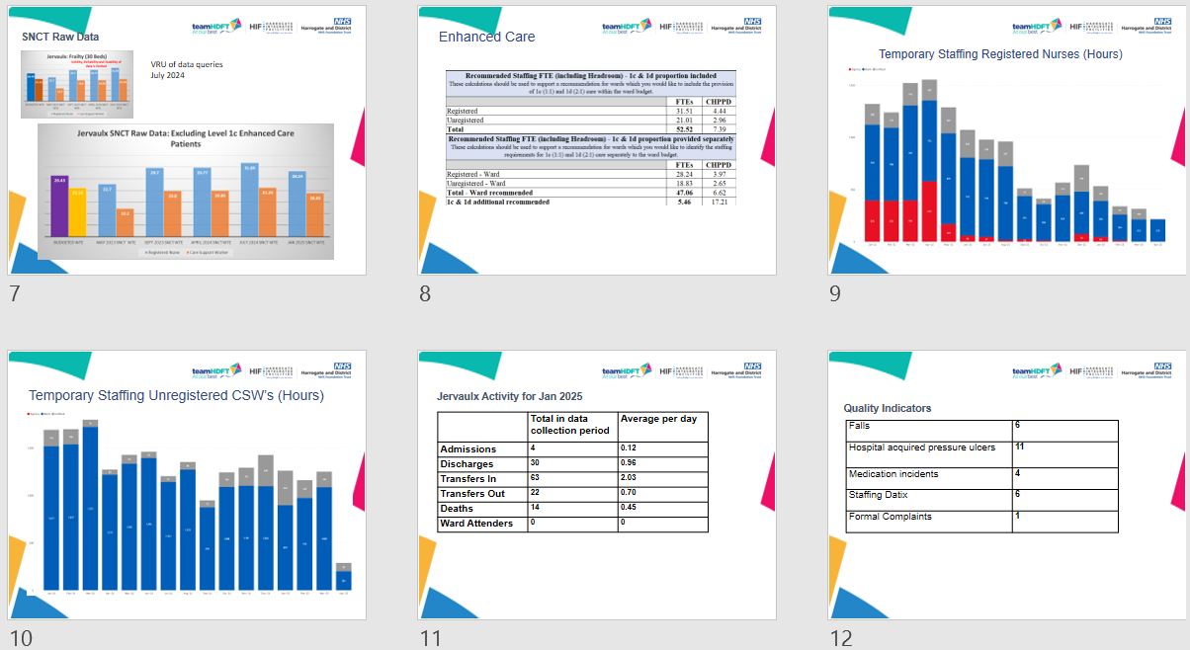

Appendix 6
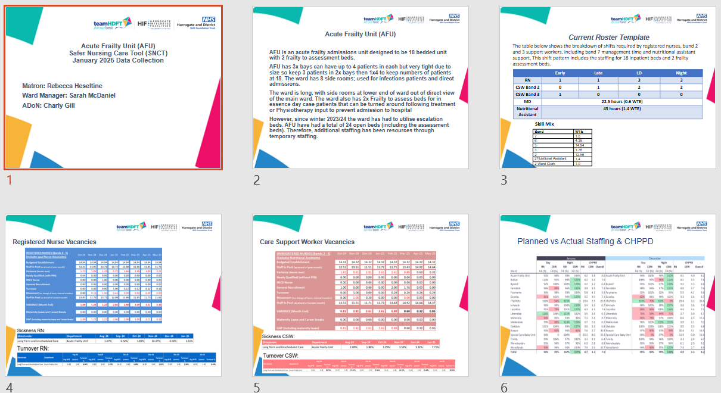
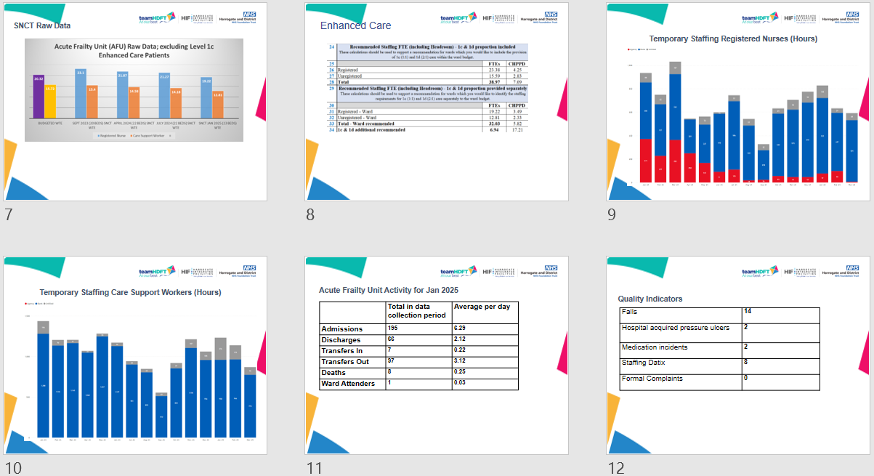

Appendix 7

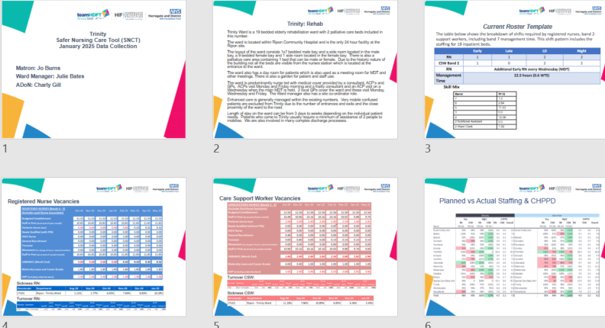
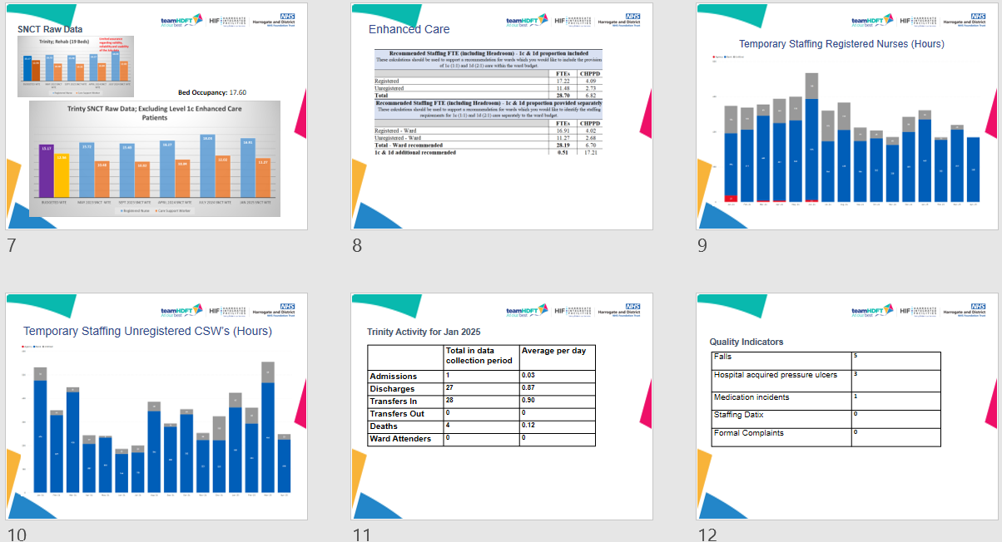

Appendix 8

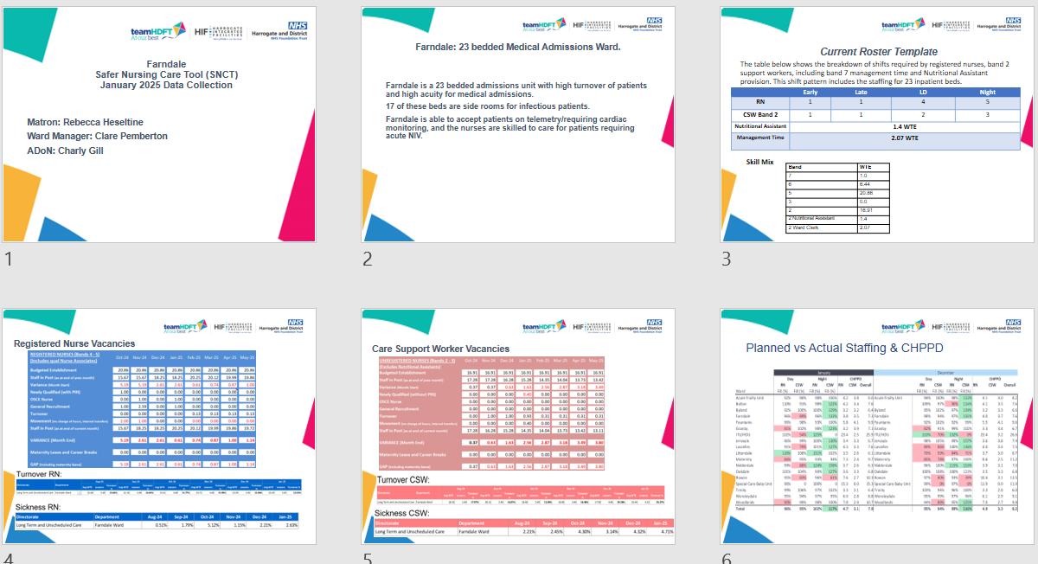
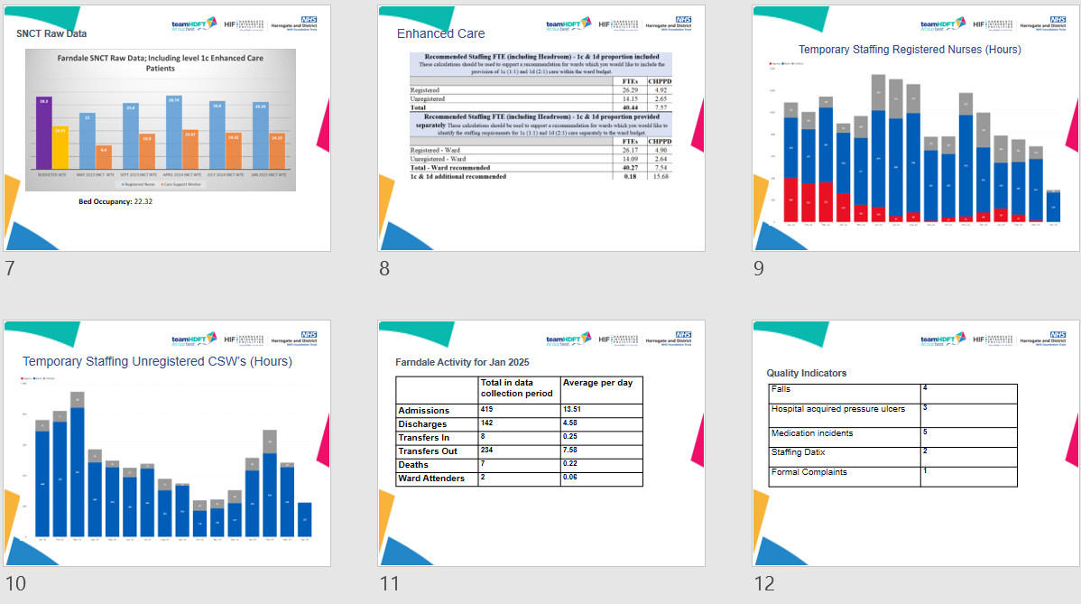

Appendix 9
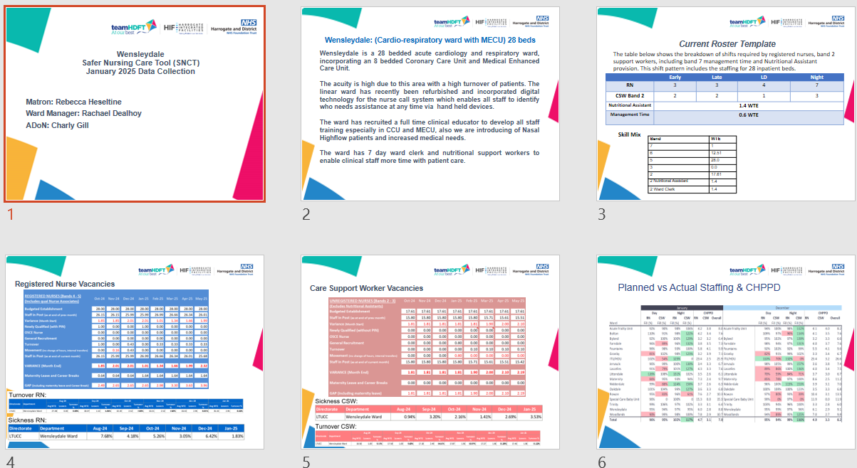
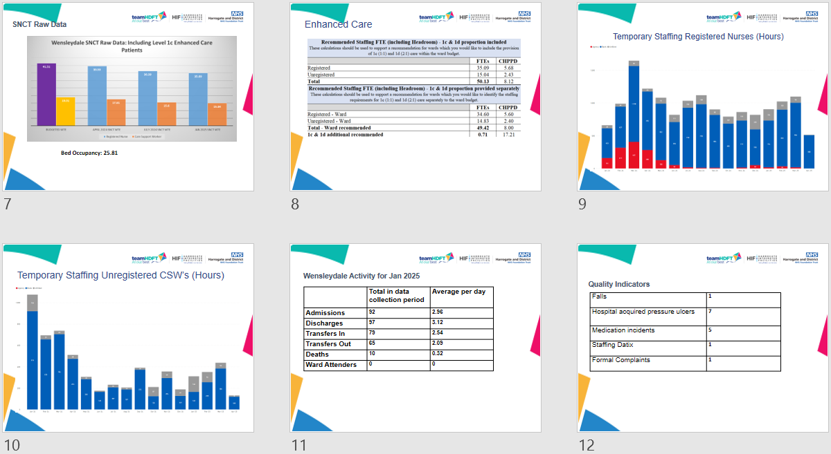

Appendix 10

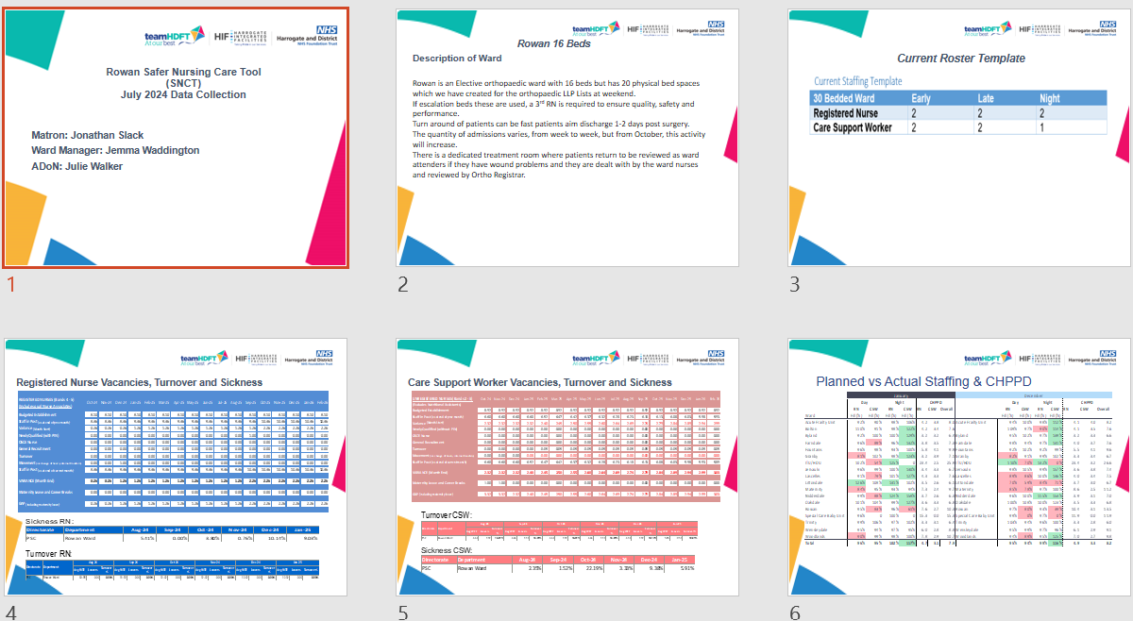
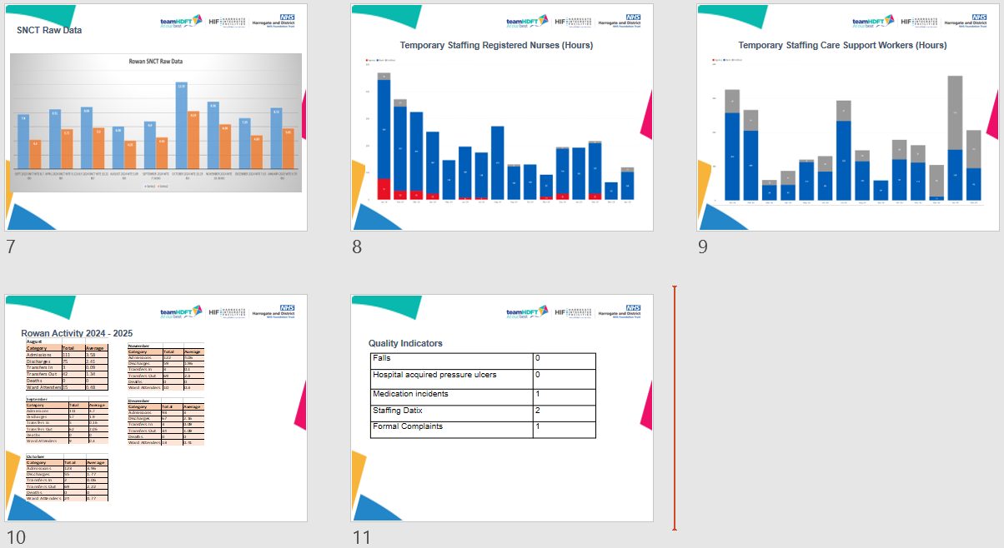

Appendix 11

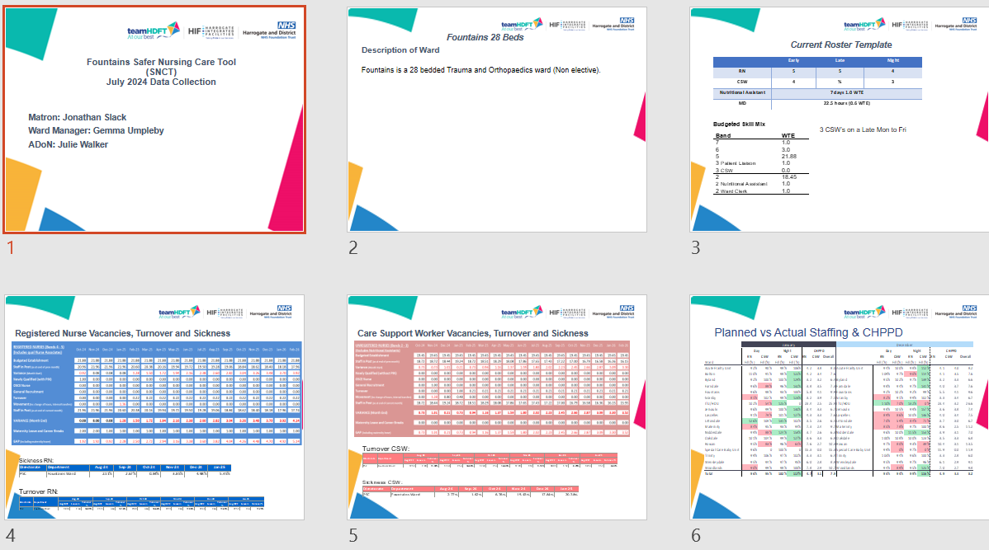
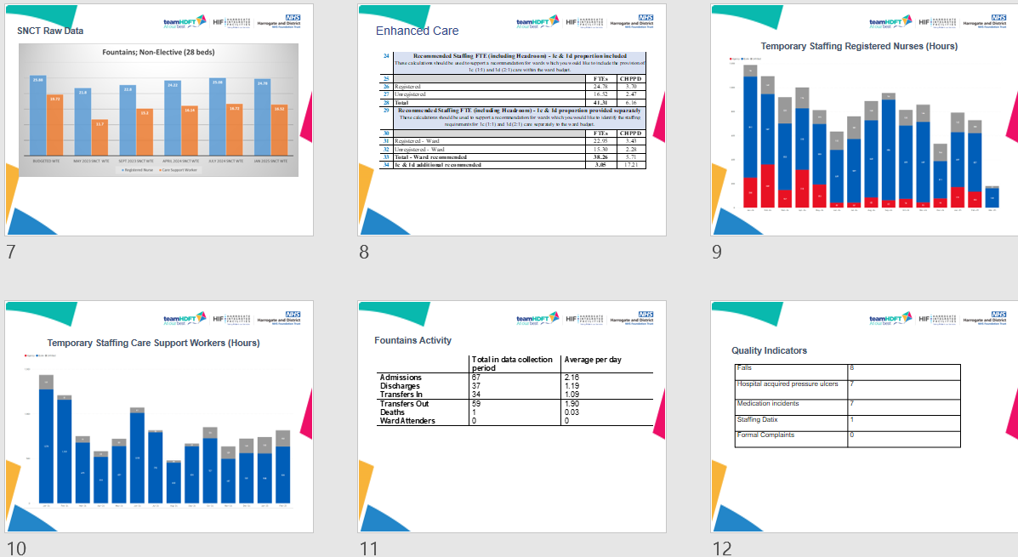

Appendix 12
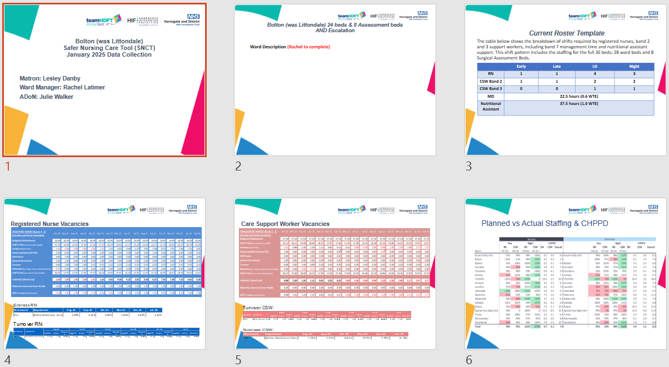
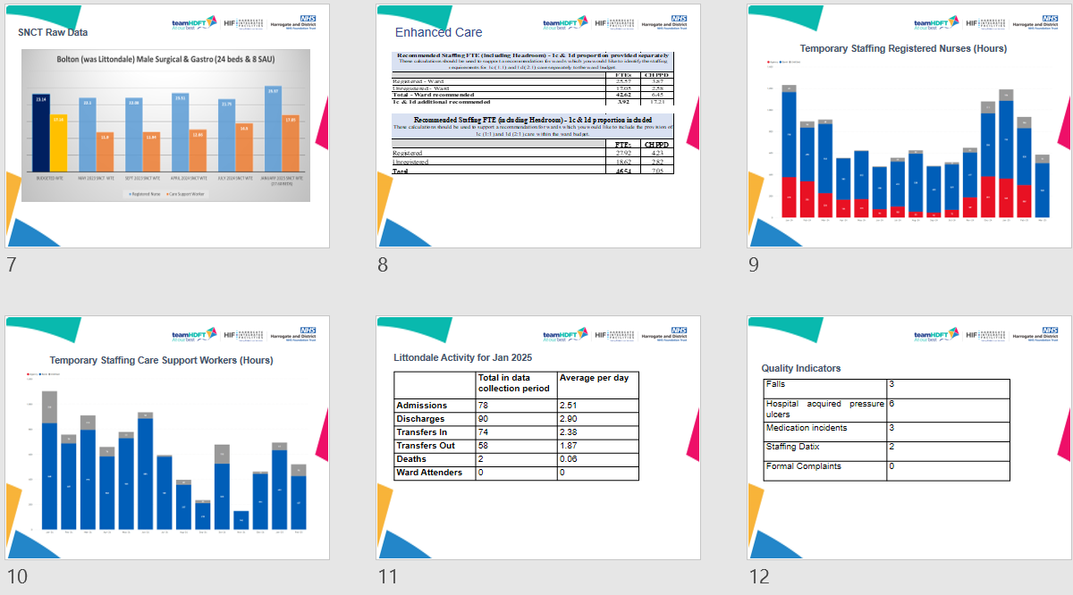

Appendix 13
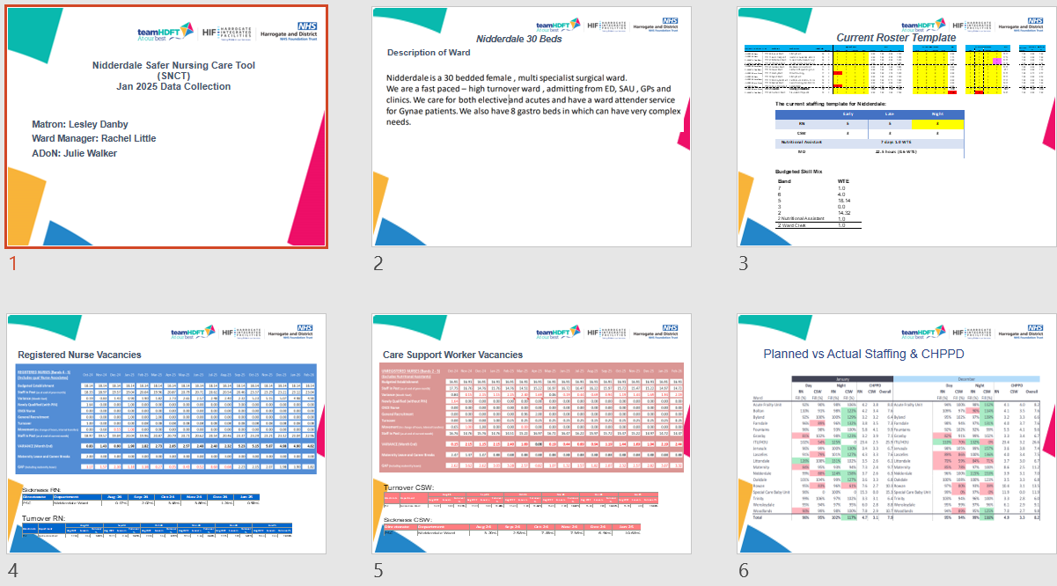
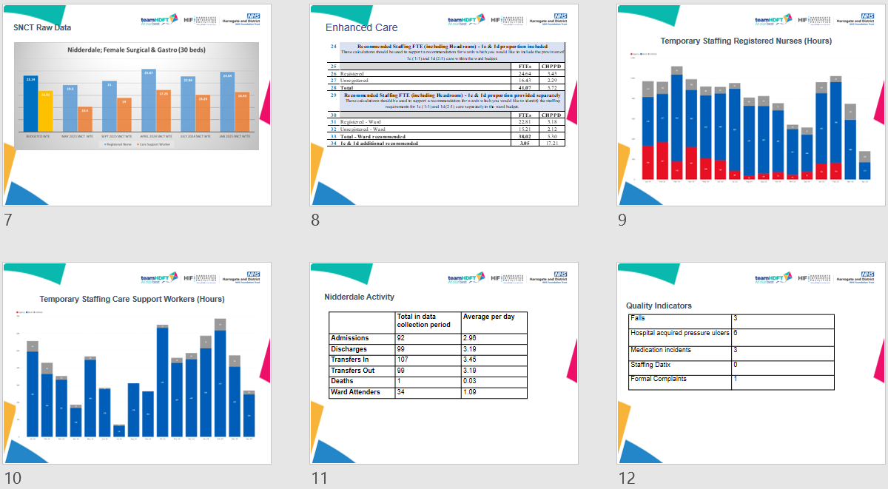

Appendix 14
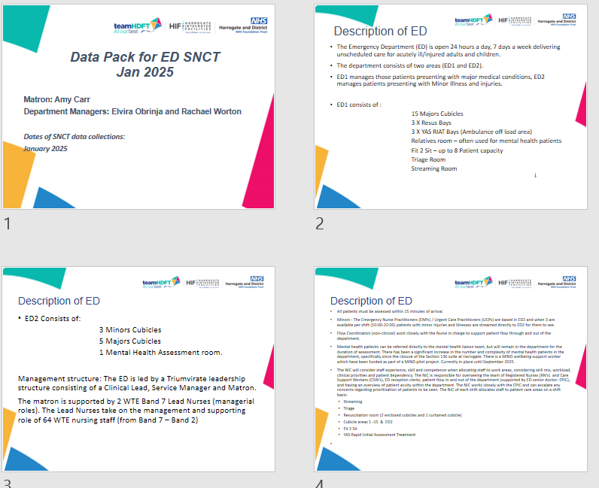
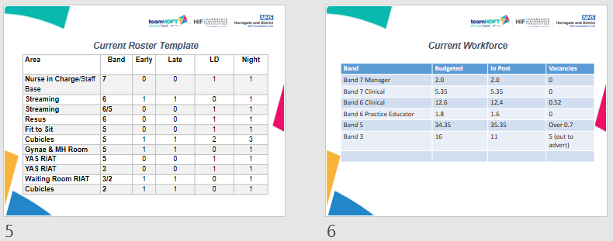

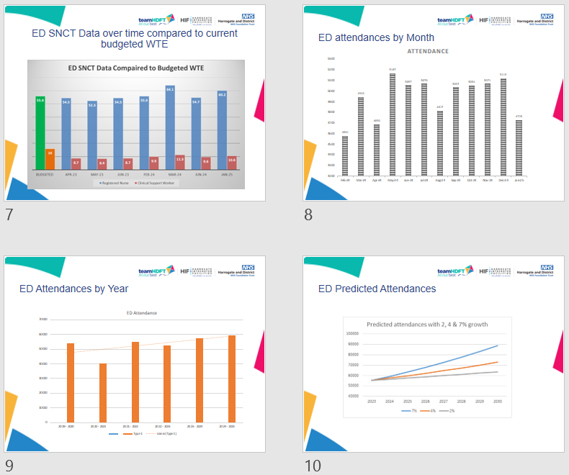
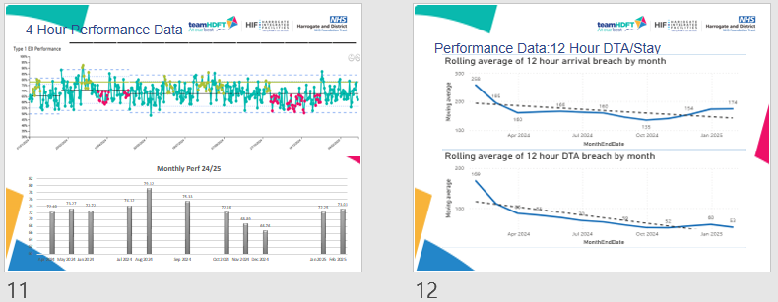

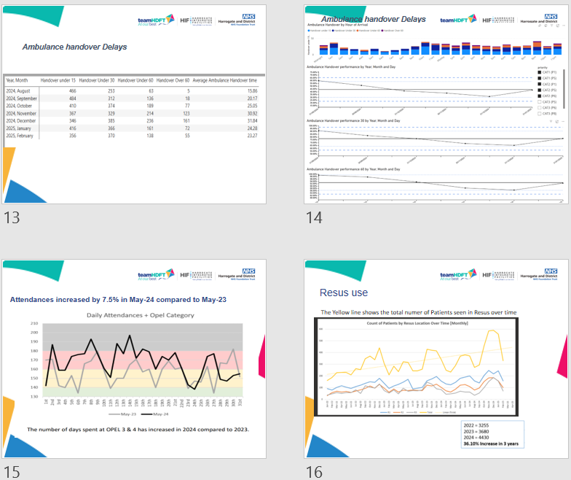
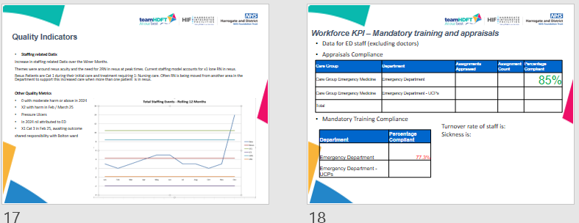

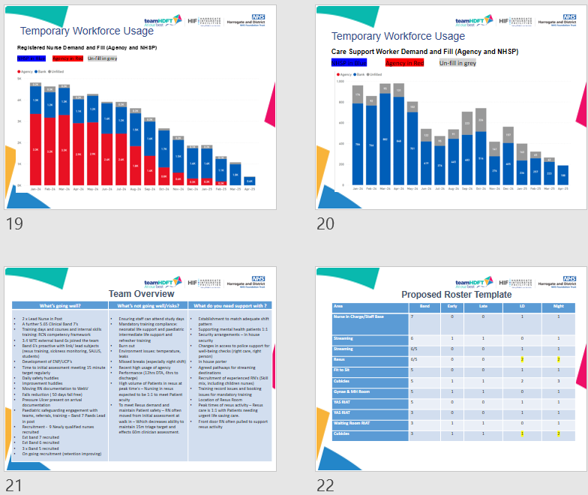
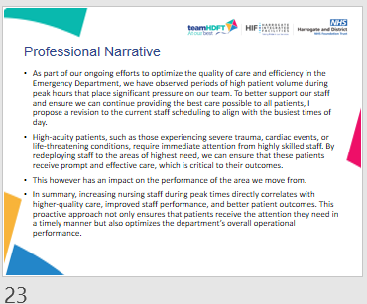

Appendix 15

